Use of remote sensing and geographic information systems in irrigation performance: a case study of atabey irrigation scheme
Parladir Karci A, Agriculture and Rural Development Support Agency, Egirdir Yolu, 32200 Isparta, Turkey
Ucar Y, Suleyman Demirel University, Faculty of Agric., Dept. of Agric. Structures and Irrigation 32260, Isparta, Turkey

Abstract
In this study, the irrigation performance of Atabey Irrigation Scheme was assessed by making use of Remote Sensing (RS) and the Geographic Information System (GIS). For this purpose, the crop pattern maps of the scheme were generated by the help of the supervised classification method with the RapidEye satellite data of 2012 concerning the study area by employing the RS techniques, whereas the channel maps of the scheme were generated by the help of the techniques of the Geographic Information System. By the help of these data, the monthly water supply ratios – one of the performance indicators – were computed. A total of 24 crop classes, 10 of which were in the irrigated area corresponding to about one-third (5,239.75 ha; 33.72%) of the total area but the remaining 14 of which were in the non-irrigated (rainfed agriculture) area corresponding to about two-thirds (10,299.74 ha; 66.28%) of the scheme area, were determined as a result of the crop pattern classification. The total irrigation water requirement for Atabey irrigation scheme was calculated as 42,618 m3 minimum and 5,647,246 m3 at the maximum between April and October. The water supply ratio in the months concerned ranged from 28.16 to 2.39 and the average water supply ratio in 2012 was calculated as 3.25. The assessment, collection, operating and maintenance expenses of the scheme and, by the help of these data, its fee collection and financial efficiency ratios were calculated. The fee collection ratio was found as 88.12% and the financial efficiency ratio as 1.42 at the scheme in 2012.

Image
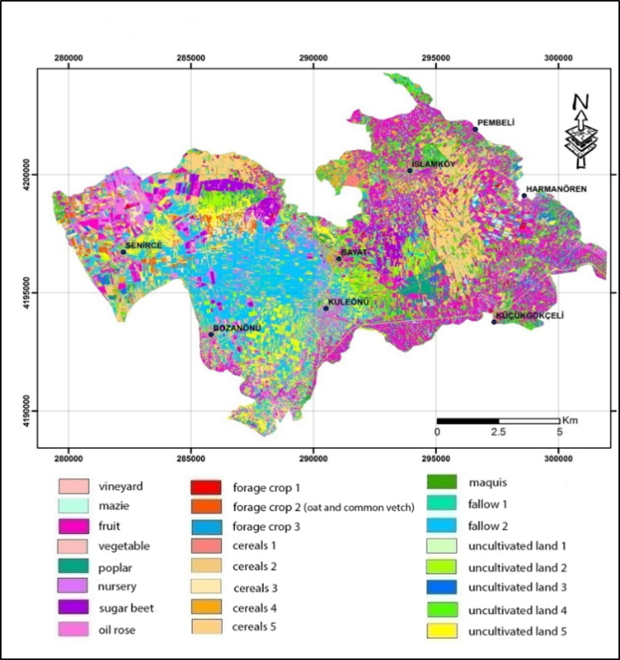
Figure 4. A map of the crop pattern obtained with supervised classification
Recent Publications
- Uçar, Y. 2011. Performance Assessment Irrigation Schemes According to Comparative Indicators: A Case Study of Isparta-Turkey. European Journal of Scientific Research, 52 (1), 82-90.
- Özdoğan, K., 2010. Güldürcek Sulamasında Sulama Performansının Değerlendirilmesi. Ege Üniversitesi Fen Bilimleri Enstitüsü Yüksek Lisans Tezi, 71s, İzmir.
- Çakmak, B., Tekiner, M., 2010. Çanakkale Kepez Kooperatifinde Sulama Performansının Değerlendirilmesi. I. Ulusal Sulama ve Tarımsal Yapılar Sempozyumu,27-29 Mayıs Kahramanmaraş, 279-290.
- Çakmak, B., Polat, E.H., Kendirli, B., Gökalp, Z., 2009. Evaluation of Irrigation Performance of Asartepe Irrigation Association: A Case Study From Turkey. Akdeniz Üniversitesi Ziraat Fakültesi Dergisi, 22(1), 1-8
- Nalbantoğlu, G., Çakmak, B., 2007. Akıncı Sulama Birliğinde Sulama Performansının Karşılaştırmalı Değerlendirilmesi. Tarım Bilimleri Dergisi,13(3), 213-223.

Biography (150 word limit)
Yusuf Ucar has his expertise in evapotranspiratrion, irrigation performance and land consolidation. He has been working in Suleyman Demirel University, Agricultural Faculty for 22 years. He has lots of paper about evapotranspiration of apple cut flowers and oil rose. Nowadays, he is working about the effects of subsurface drip irrigation on Alfalfa.
Email: yusufucar@sdu.edu.tr Contact No: +90 533 2604144

Notes/Comments:

