Suppression of clubroot (Plasmodiophora brassicae) development in Brassica campestris ssp. chinensis L. via exogenous inoculation of Piriformospora indica
Muhammad Khalid
Affiliation: School of Agriculture and Biology, Shanghai Jiao Tong University, Shanghai, 200240, P.R. China

Abstract
The goal of the current study is to contribute to basic understanding of Piriformospora indica- B. campestris ssp. chinensis interactions and to assess its impact on clubroot infection as well as the expression level of known Plasmodiophora brassicae (causal agent) genes in root of infected B. campestris ssp. chinensis. Study revealed that P.indica, plant-root-colonizing fungus of Basidiomycetes, is capable to reduce formation of clubroot in B. campestris spp. chinensis which is extremely susceptible to the root pathogen P. brassicae. Roots of the P.brassicae-infected plant were colonized with P. indica, as demonstrated by staining technique and microscopy. Like that, enhanced biomass was observed in P.indica co-inoculated pakchoi plants by comparing with Plants infected with the pathogen only. Co-inoculation of Pakchoi plant with P. indica and P.brassicae reduced gall formation up to 61.60 % by comparing plants infected with only P. brassicae as shown by the disease index (DI). In addition, higher level of flavonoids were observed in P.indica inoculated plants which has been excessively reported to contribute in enhancing the plant immune system. Thus, a hypothesis was proposed that P. brassicae development in B. campestris ssp. chinensis plants could be delayed with the inoculation of P. indica. Expression of P. brassicae genes which were expressed differentially during disease development were monitored using quantitative RT-PCR and was corroborated with delayed pathogen development. These results suggest that P. indica and perhaps other beneficial endosymbiont could be an effective tool for the management of clubroot infection.

Image
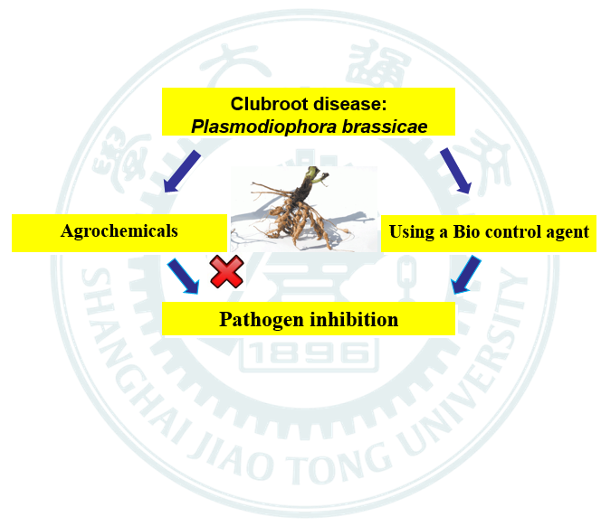
Recent Publications (minimum 5)
- Khalid, M., Hassani, D., Bilal, M., Liao, J., Huang, D., 2017. Elevation of secondary metabolites synthesis in Brassica campestris ssp. chinensis L. via exogenous inoculation of Piriformospora indica with appropriate fertilizer. PloS one 12, e0177185.
- Khalid, M., Hassani, D., Bilal, M., Butt, Z.A., Hamayun, M., Ahmad, A., Huang, D., Hussain, A., 2017. Identification of oral cavity biofilm forming bacteria and determination of their growth inhibition by Acacia arabica, Tamarix aphylla L. and Melia azedarach L. medicinal plants. Archives of oral biology 81, 175-185.
- Khalid, M., Hassani, D., Bilal, M., Asad, F., Huang, D., 2017. Influence of bio-fertilizer containing beneficial fungi and rhizospheric bacteria on health promoting compounds and antioxidant activity of Spinacia oleracea L. Botanical studies 58, 35.
- Khalid, Muhammad, Muhammad Bilal, Danial Hassani, Shah Zaman, and Danfeng Huang. "Characterization of ethno-medicinal plant resources of karamar valley Swabi, Pakistan." Journal of Radiation Research and Applied Sciences 10, no. 2 (2017): 152-163.


Biography
I am Muhammad Khalid and currently my doctoral study is in progress in Shanghai Jiao tong university, Shanghai China. My research Interests are Physiology and molecular biology, Flavonoid and secondary metabolites analysis, bio synthetic pathways molecular analysis, transcription analysis, Abiotic and Biotic stress in plants.
Email: kokub32@gmail.com Contact No: 15201790013

Notes/Comments:

