An approach to evaluate likelihood of gene flow between Saccharum hybrids and wild relatives: a case study from South Africa
D. M. Komape^{a*}, S. J. Snyman^{b,c}, J. van den Bergª, D. Cilliersª, S. Barnardª, H. Khanyiª, D. Lloyd Evans^{b,c,d}, S. J. Siebertª
ªUnit for Environmental Sciences and Management, North-West University, Potchefstroom, South Africa
^{b}Crop Biology Resource Centre, South African Sugarcane Research Institute, Mount Edgecombe, South Africa
^{c}School of Life Sciences, University of KwaZulu-Natal, Westville, South Africa
^{d}BeauSci Ltd., Waterbeach, Cambridge, CB25 9TL, United Kingdom

Abstract
South African biosafety legislation requires an assessment of gene flow before approving genetically modified (GM) crops. Proof is required that hybridization cannot occur between GM crop plants and wild relatives. This study presents an approach to assess the likelihood of gene flow using a case study done in South Africa to investigate the possibility of gene flow from sugarcane to wild relatives in the sugarcane production regions. Spatial and temporal assessments of Saccharum and wild relatives was conducted. Eleven Saccharum relatives which are common in the study area were selected from the worldwide phylogeny of grasses confirming their close relatedness. Relevant data for these species were sourced from the literature, herbaria and field surveys. Co-occurrence (spatial overlap) of all target species was confirmed in sugarcane cultivation areas. Imperata cylindrica, Sorghum species and Miscanthidium species scored the highest likelihood for prevalence, flowering and spatial overlap, and seed distribution potential. Although these species were flagged by the approach, the crossing of spatial and temporal barriers is no guarantee for gene flow to occur and needs to be considered together with relatedness. Phylogenetic analyses of the extended Internal Transcribed Sequence (ITS) cassette showed that the closest wild relatives to commercial sugarcane were Miscanthidium capense and M. junceum as they are only 3 million years divergent. Sorghum was found to be more distantly related. Gene flow likelihood was therefore narrowed down to two species using this approach which involves spatial, temporal and molecular techniques. Future work will include aspects influencing gene flow such as cytological compatibility and introgression between sugarcane and Miscanthidium species.
Recent Publications (Minimum 5)
- Gao Y-J, Liu X-H, Zhang R-H, Zhou H, Liao J-X, Duan W-X, Zhang G-M (2014) Verification of progeny from crosses between sugarcane (Saccharum spp.) and an intergeneric hybrid (Erianthus arundinaceus × Saccharum spontaneum) with molecular markers. Sugar Tech. 17:31-35.
- Hawkins JS, Ramachandran D, Henderson A, Freeman J, Carlise M, Harris A, Willison-Headly Z (2015) Phylogenetic reconstruction using four low-copy nuclear loci strongly supports a polyphyletic origin of the genus Sorghum. Annals of Botany. 116:291–299.
- Lloyd Evans D, Joshi, SV (2016a) Complete chloroplast genomes of Saccharum spontaneum, Saccharum officinarum and Miscanthus floridulus (Panicoideae: Andropogoneae) reveal the plastid view on sugarcane origins. Systematics and Biodiversity. 14:548-571.
- Melloni MLG, Melloni MNG, Scarpari, MS, Garcia JC, Landell MGA, Pinto LR (2015) Flowering of sugarcane genotypes under different artificial photoperiod conditions. American Journal of Plant Sciences. 6:456-463.
- Soreng RJ, Peterson PM, Romaschenko K, Davidse G, Zuloaga FO, Judziewicz EJ, Filgueiras TS, Davis JI, Morrone O (2015) A worldwide phylogenetic classification of the Poaceae (Gramineae). Journal of Systematics and Evolution 53:117-137.

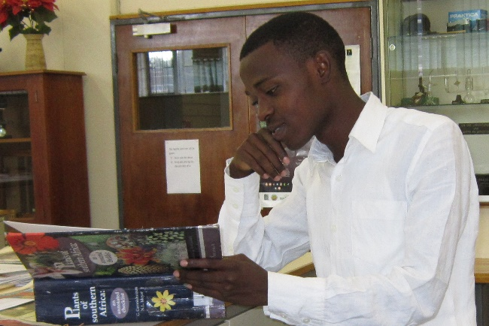
Bibliography (150 Words Max)
Dennis Mmakgabo Komape has been involved with numerous research projects which were conducted by North-West University in South Africa. His main responsibilities include designing field experiments, conducting field work, plant identification, data collection, management, analyses of data and reporting. He is having good presentation skills and he has represented his institute at various national and international conferences. His MSc research was funded by South African Sugarcane Research Institute (SASRI) to investigate the spatial assessment of Saccharum species hybrids (sugarcane) and wild relatives in eastern South Africa. He co-authored three peer-reviewed scientific articles and he is looking to present the published paper on assessing the likelihood gene flow from sugarcane to wild relatives in South Africa at the 13th International Conference on Agriculture and Horticulture. Dennis is passionate to develop himself as a scientist and he is courageous in taking opportunities that will help him achieve his goals.
Email: dmkkomape@gmail.com Contact: + 27 078 1075 697

