Effect of gibberellic acid on yield and yield attributes of canola (Brassica napus L.) varieties
Muhammad Rashid Nizamani^{1,2}, Yongqing Ma⁴, Ghulam Shah Nizamani³, Faiza Nizamani¹
¹College of Forestry, Northwest A&F University, Yangling, Shaanxi, 712100, China
²Faculty of Crop Production, Sindh Agriculture University, Tando Jam, Pakistan
³Nuclear Institute of Agriculture, Tando Jam, Pakistan
⁴Institute of Soil & Water Conservation, Northwest A&F University, Yangling, Shaanxi, 712100, China

Abstract
Gibberellic acid (GA₃) is a phytohormone that is needed in small quantities at low concentration to accelerate plant growth and development. So, favorable condition may be induced by applying growth regulators exogenously in proper concentration at a proper time in a specific crop by GA₃. Gibberellic acid is such a plant growth regulator, which can manipulate a variety of growth and development phenomena in various crops. GA₃ enhances growth activities to plant, stimulates stem elongation. The early days to flowering, plant height, number of branches plant⁻¹, siliqua plant⁻¹, siliqua length, seed siliqua⁻¹, 1000 seeds, seed yield and oil content under concentration of GA₃ 10 g ha⁻¹, while days to maturity and number of branches⁻¹ were observed under concentration of GA₃ 5 g ha⁻¹. The maximum plant height and oil content in Con-II, number of branches in Oscar, siliqua plant⁻¹ in Dunckled, siliqua length and 1000 seed in Abasin, seeds siliqua and seed yield were observed in Rainbow. The interaction of varieties and concentrations indicated that maximum plant height and siliqua plant under concentration of 10 g ha⁻¹ GA_{3,} number of branches plant⁻¹ under concentration of 20 g ha⁻¹ GA₃ in Dunckled, siliqua length, seed siliqua⁻¹, 1000 seed, seed yield and oil content were observed under concentration of 10 g ha⁻¹ GA₃. The present results concluded that Rainbow, Dunckled, Con-II and Oscar under concentration of 10 g ha⁻¹ GA₃ found the best concentration for yield and yield attributes of canola.
Nuclear Institute of Agriculture, Tando Jam Pakistan
Muhammad Rashid Nizamani, PhD Scholar, studying in College of Forestry, Northwest A&F University, Yangling China. He has published several National & International research paper as corresponding author and co-author. He has 5 Years research experience in Wheat, 2 Years in Brassica and currently working on project titled as “To find the biological control of different Orobanche spp. by using different growth regulator and sowing periods, crops and varieties.”.
He has presented his research poster titled as Impact of Gibberelic acid on maize and parasitic weed orobanche spp. seed germination in “International Symposium on Crop Roots & Rhizosphere Interactions”. angling International Conference & Exhibition Center Hotel, Yangling, Shaanxi Province, China, from 9−13 October, 2017
Email: mrnizamani@gmail.com Mob. 0086 187008729449



s
- Rashid Ali Khaskheli, Muhammad Ali Khan, Ghulam Shah Nizamani, Muhammad Rashid Nizamani, Faiza Nizamani, Abdul Hafeez Mastoi, Guo ZhenGuo, Maqsood Ahmed Khaskheli (2018). PHYSIOLOGICAL RESPONSES OF POTASSIUM EFFICIENT AND NON-EFFICIENT WHEAT GENOTYPES. Int. J of Agri, Envir & Bioresearch 3:3; 228-241
- Parvez Hussain Dahari, Ghulam Shah Nizamani, Muharam Ali, Abdullah Khatri, Muhammad Rashid Nizamani, Shafquat Yasmeen & Shah Nawaz Mari (2017). MICROPROPAGATION OF BANANA CULTIVAR BASRAI UNDER DIFFERENT CONCENTRATIONS OF N6-BENZYLAMINOPURIN FOR SHOOT AND INDOLE-3-BUTYRIC ACID FOR ROOT INDUCTION. Pak. J. Biotechnol.14 (4) 761-765
- Faiza Nizamani, Muhammad Jurial Baloch, Abdul Wahid Baloch, Mehmoda Buriro, Ghulam Shah Nizamani, Muhammad Rashid Nizamani & Irfan Ahmed Baloch (2017)GENETIC DISTANCE, HERITABILITY AND CORRELATION ANALYSIS FOR YIELD AND FIBRE QUALITY TRAITS IN UPLAND COTTON GENOTYPES. Pak. J. Biotechnol14 (1) 29-36
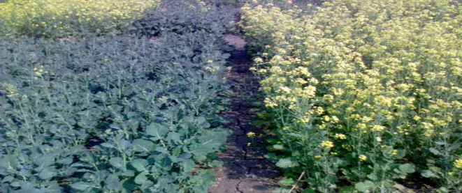
- Misbah Naz, Faiza Nizamani, Ghulam Shah Nizamani, Muhammad Rashid Nizamani (2016). Callus induction and plant regeneration from immature embryos of spring wheat varieties (Triticum aestivum L.) under different concentrations of growth regulators through tissue culture technique. Pure appl. Biol., 5(3): 378-385
- Fida Hussain, Mahmooda Buriro, Muhammad Rashid Nizamani* (2016). GROWTH AND YIELD RESPONSE OF MUNGBEAN TO DIFFERENT LEVELS OF POTASSIUM. IJAAER; 2(1):67-76

