Super Canola: Newly Developed High Yielding, Lodging and Drought Tolerant Canola Quality Cultivar of Rapeseed
(Brassica napus L.)

Hafiz Saad Bin Mustafa¹*, Tariq Mahmood¹, Ejaz-ul-Hasan¹, and Muhammad Aftab¹
¹Directorate of Oilseeds, Ayub Agricultural Research Institute Faisalabad, Pakistan.
⃰ Corresponding author’s E-mail: saadpbg@gmail.com
Phone: +92-41-9200770

Abstract
The aim of present research was to develop a high yielding Canola cultivar having good quantitative and qualitative characteristics under the scenario of climate change. The research was initiated during 2005 and successfully completed during 2018 by Oilseeds Research Institute, Faisalabad Pakistan. Super Canola (RBN-13018) is an outcome of hybridization (Rainbow x RBN-03052) in 2005-06 and subsequently following by the pedigree method of selection. Homozygous progenies from F7 were bulked in 2013-14 for yield evaluation in replicated trials. Its performance was evaluated in the station and outstation yield trials at different agro-climatic conditions. It performed well in all yield trials and gave better yield than all the existing Canola varieties. RBN-13018 showed good tolerance against diseases and also exhibited better lodging tolerance. It also performed well in Polyethylene Glycol (PEG 6000) induced drought and showed good genetic potential against drought stress. Oil quality analysis showed that it has a best fatty acid profile for human consumption and its meal is also fit for animals. Agronomic studies revealed that this variety thrives well with the prevailing rate of inputs and agronomic practices. Considering the qualitative and quantitative performance of RBN-13018 Punjab Seed Council (Pakistan) approved this strain as commercial variety for general cultivation with the name of Super Canola.
Image
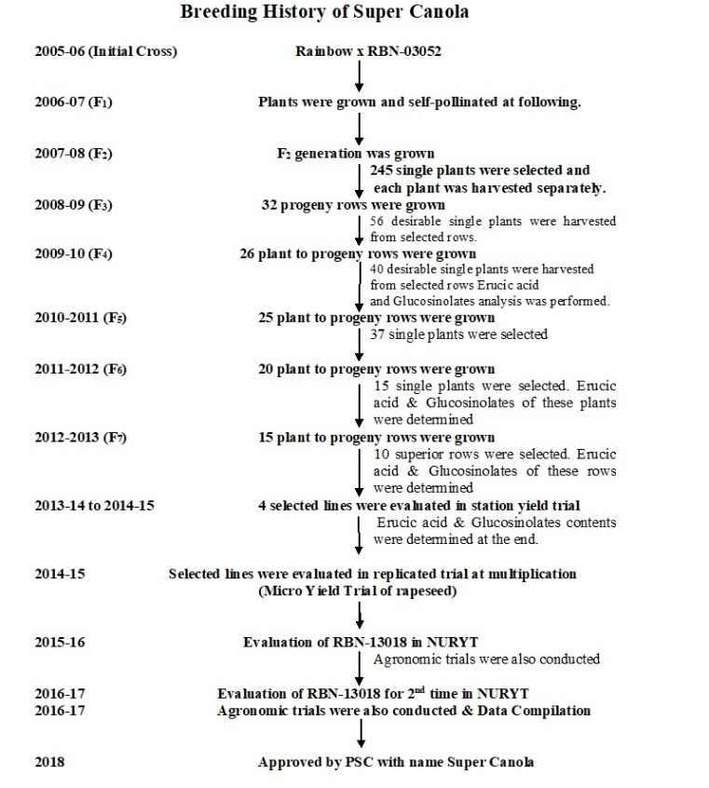
Fig. 1: Detailed breeding history of Super Canola (RBN-13018)
Recent Publications (minimum 5)
- Mustafa, H.S.B., T. Mahmood, E. Hasan, H.S. Rehman and M. Aftab. 2018. Yield Evaluation and Interrelationship between Yield Related Traits in Advance Lines of Mustard through Correlation Studies. Journal of Agricultural Sciences. 13(1), pp.66–71.
- Tahir M., M.M. Zafar, A. Imran, M.A. Hafeez, M.S. Rasheed, H.S.B. Mustafa, A. Ullah. Response of tomato genotypes against salinity stress at germination and seedling stage. Nat Sci 2018; 16(4):10-17.
- Ghias M., F.A. Khan, S. Habib, R. Qamar, F. Hussain, H.S.B. Mustafa and M. Aftab. 2018. Genetic variability studies for economically important traits in sunflower (Helianthus annuus L.). Curr Inves Agri Curr Res 2(2), pp 1-6. CIACR.MS.ID.000135.
- Mustafa, H.S.B., E. Hasan, T. Mahmood, A. Hameed and Q. Ali. 2018. Enhancing Food Security in Arid Areas of Pakistan through Newly Developed Drought Tolerant and Short Duration Mustard (Brassica juncea L.) Canola. GENETIKA. 50(1), pp. 21-31.
- Tanweer, MH, FA. Khan, F. Hussain, HSB. Mustafa. Divergence analysis and association of economical traits in Mustard (Brassica juncea L). Discovery, 2018, 54(270), 245-248.

 Biography (150 word limit)
Hafiz Saad Bin Mustafa has been working as a Brassica Scientist at Directorate of Oilseeds, Ayub Agricultural Research Institute (AARI), Faisalabad, Pakistan since 2012. Since joining the AARI, H.S.B. Mustafa has been involved in Oilseed crops breeding mainly on Rapeseed & Mustard. He developed two high yielding varieties of Rapeseed & Mustard. He also developed 5 high yielding lines of Eruca sativa L. Before joining AARI, he worked as In-charge at a Seed company. He has completed his M.Sc. (Hons.) Plant Breeding & Genetics in 2010 from University of Agriculture, Faisalabad (Pakistan).

Email: saadpbg@gmail.com Contact No: +92-300-7811601

Notes/Comments:

