Increasing cocoa yield through comprehensive good agricultural practices in cocoa (Theobroma cacao L.) cultivation
Rozita, O. PhD, Malaysian Cocoa Board

Abstract (300 word limit)
Statement of the Problem: Many researchers have reported the importance of good agriculture practices in many plants or crops plantation. Four major activities in field maintenance of cocoa plantation included pruning, fertilization, sanitation and harvesting. Cocoa yield is much depending on these factors. However, many farmers only adopted some practices and left others, especially on sanitation practices. In addition, some other farmers do all the practices such as pruning, fertilizer application and sanitation, but not in a proper way. Therefore, they did not achieve the desired yield. This study is trying to indicate the main factors that influenced the cocoa yield in field and the effect when some of those practices were not carried out properly. Methodology & Theoretical Orientation: Four different practices were adopted in 12 years old cocoa research blocks. One of the block was maintained with complete field activities which included proper pruning, proper fertilizer application and proper recommended sanitation practices. Others blocks were varied where some of block only adopted one or two good practices. Parameters for this study included harvested cocoa pod, potential yield of cocoa dry bean, infection by pest and disease and damaged by mammalian pests. All data were recorded at monthly interval for two years. Findings: The most significance practices that contributed to the yield in cocoa plantation are sanitation and pruning. Cocoa yield was not severely affected when there was no fertilizer applied might be caused by the residual left from the previous fertilizer program. Without good agriculture practices, the incidence of major cocoa pest and disease has increased. Conclusion & Significance: High yielding cocoa can be achieved through fully good agriculture practices for cocoa management. Proper sanitation, pruning and harvesting all ripe pods are very important to increase productivity.

Image
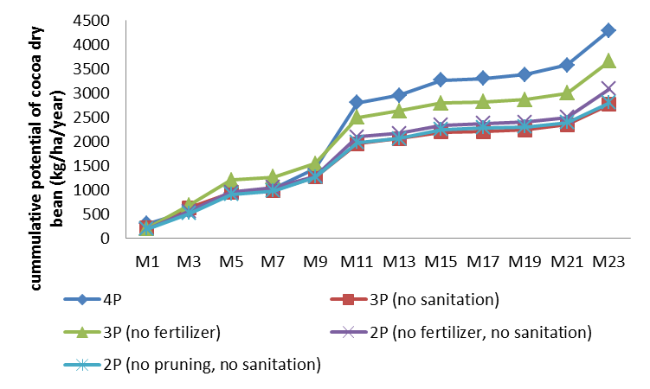
Figure 1: Effect of various management practices on cocoa potential yield
Recent Publications (minimum 5)
- Ahmad Kamil, M. J., Alias, A., Azmi, C. A., Boney, M., Harnie, H., Haya, R., Khairul Bariah, S., Lee, C. H., Meriam, M. Y., Mohd Yusoff, A. S., Mohd Zamri, A. Ghani, Mohamed Helmi, S., Navies, M., Nuraziawati, M.Y., Nurfadzilah, M., Rozita, O., Saripah, B. & Shari Fuddin, S. (2013) Cocoa Planting Manual, Sustainable Cocoa. Sabah, Malaysia: Malaysian Cocoa Board.
- Akowuh, P., Sarkodie-Addo, J. and Boa, K. (2012) Effect of some agronomic practices to increase maize yield in Ghana. Journal of Science and Technology. 32(2):1-8
- Asare, R. and David, S. (2011) Good agricultural practices for sustainable cocoa production: a guide for farmer training. University of Copenhagen.
- Oberthur, T., Samson, M., Janetski, N. and Janetski, K. (2018) Cocoa yield under good agricultural practices and 4R nutrient management in Indonesian smallholders systems. Better Crops/Vol. 102 (2018, No.1). http://doi.org/10.24047/BC10213
- Owusu Danquah, E., Ennin, S.A., Frimpong, F., Oteng-Darko, P., Yeboah, S. and Osei-Adu, J. (2015) Adoption of good agricultural practices for sustainable maize and cowpea production: The role of enabling policy. World Research Journal of Agricultural Sciences. 2(2):28-38
- Tann, H., Makhonpas, C., Utthajade, A. and Soytong, K. (2012) Effect of good agricultural practice and organic methods on rice intensification in Cambodia. Journal of Agricultural Technology. 8(1):283-303

Biography (150 word limit)
Rozita Osman has her expertise in plant agronomy, soil science and plant physiology. Her PhD was in agronomy with specialization on stress plant physiology. She also has Master of Science in soil chemistry with specialization on heavy metal contamination in cocoa soil and leaves. Her passion on cocoa research has brought her to present her works in various seminar and conferences either at national level or international level. She was also contributed at national level in preparing Second and Third National Communication report to the UNFCCC on the climate change, Evaluator of R & D & C Fund Application for Ministry of Science and Technology (MOSTI) Malaysia, member of agriculture expert group to address climate change under MOSTI, member of working group to review the Malaysian Standard for Cocoa Bean Specification and Cocoa Planting Materials. She is also a panel for evaluation of academic program in the university.
Email: orozita@koko.gov.my Contact No: +60193191128

Notes/Comments:

