Analysis of physicochemical properties and functional quality attributes of shelf available milk powders in Sri Lanka
J.K.Vidanarachchi PhD, Department of Animal Sciences, Faculty of Agriculture, University of Peradeniya, Sri Lanka
W.V.V.R. Weerasingha Department of Animal and Food Sciences, Faculty of Agriculture, Rajarata University of Sri Lanka.

Abstract (300 word limit)

Statement of the problem: Milk powder products which are available in Sri Lankan market comprise of different chemical and functional quality attributes. The objective of the current study was to investigate the physicochemical properties of shelf available milk powders which are commonly available in Sri Lankan market and compare them with the international quality standards. Methodology and Theoretical Orientation: Thirty milk powder samples were tested including two locally produced and four imported milk powder brands. Solubility was measured using insolubility index method. Microstructures of the milk powder samples were obtained using Scanning Electron Microscopic (SEM) images and compositional differences were evaluated using Fourier Transform Infra-Red (FTIR) spectroscopy. Findings: Results revealed that free fatty acid (FFA) levels in imported milk powders exist within the acceptable range (1.6-2.3 mmol/100g fat) while it is around two times higher than acceptable limits in locally produced milk powders (4.4 ±0.1 mmol/100g fat). Other chemical properties including fat, protein, ash, Ca, pH, moisture and water activity were within the acceptable standard levels in both local and imported milk powders. According to the FTIR spectra, all milk powder samples had distinct fingerprint characteristics with regard to main nutrients including lipid, protein and carbohydrates. Brand A had very clear high absorption intensities at wavenumbers 1024 cm⁻¹ and 3277 cm⁻¹ indicating the difference of aliphatic amines for C-N stretch bond and primary or secondary amides or amines for N-H stretch bond, respectively. Conclusion and Significance: According to the insolubility index values imported milk powders had higher solubility than the locally produced brands. SEM images confirmed the presence of uniformly agglomerated powder particles in imported milk powder brands while local products appeared with more fine non-agglomerated particles which can be one of the main reasons for inferior solubility of local powders.

Image

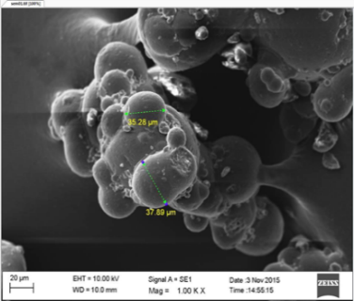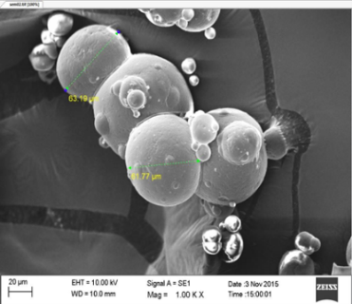
Figure 1: SEM images of two different milk powder brands. A is an imported milk powder brand and B is a locally produced milk powder brand
A
B

Recent Publications (minimum 5)
- Fang Y, Rogers S, Selomulya C, Chen XD (2012) Functionality of milk protein concentrate: Effect of spray drying temperature. Biochemical Engineering Journal 62:101-105.
- Fitzpatrick J, Iqbal T, Delaney C, Twomey T, Keogh M (2004). Effect of powder properties and storage conditions on the flowability of milk powders with different fat contents. Journal of Food Engineering 64(4), 435-444.
- Haque E, Bhandari BR, Gidley MJ, Deeth HC, Whittaker AK (2011). Ageing‐induced solubility loss in milk protein concentrates powder: effect of protein conformational modifications and interactions with water. Journal of the Science of Food and Agriculture 91(14) 2576-2581.
- Harper M, Holsinger V, Fox K, Pallansch M (1963). Factors influencing the instant solubility of milk powders. Journal of Dairy Science 46(11): 1192-1195.
- Kelly J, Kelly PM, Harrington D (2002). Influence of processing variables on the physicochemical properties of spray dried fat-based milk powders. Le Lait, 82(4): 401-412.

Biography (150 word limit)
Dr.J.K. Vidanarachchi, a well expertise in quality & safety of dairy, meat and seafood products has published lots of research findings as a dynamic researcher. Apart from these areas he is well renowned for research works on bioactive substances, nutraceuticals and cosmeceuticals in natural sources. Same time prebiotic, probiotic and symbiotic concepts are major areas he is working on. He has already been rewarded by visiting scholar fellowship and postdoctoral research fellowship from Swedish University of Agricultural Sciences, in Sweden. Due to his contribution to dairy and meat sector, he was awarded presidential award thrice. Nevertheless, he has been working as a senior lecturer in University of Peradeniya since 1997. This self-funded research work was carried out by Mr. W.V.V.R. Weerasingha for completion of his bachelor’s degree under the supervision of Dr. J.K. Vidanarachchi.
.
Email: janakvid@pdn.ac.lk Contact No: +94714430552

Notes/Comments:

