Identification of reference genes for real-time PCR gene expression studies in developing seedling of Cyamopsis tetragonoloba under nitrogen stress

Poonam S Jaiswal, M.Sc., Indian Institute of Technology Roorkee, India
Navneet Kaur, PhD, Indian Institute of Technology Roorkee, India
Gursharn Singh Randhawa, PhD, Indian Institute of Technology Roorkee, India

Abstract

Statement of the problem: Guar (Cyamopsis tetragonoloba) is an important industrial crop because of many industrial applications of galactomannan gum present in its seeds. It, being a legume crop, is able to fulfil its nitrogen requirement through biological nitrogen fixation. However, this crop usually encounters nitrogen deficiency during the initial stages of crop growth when nitrogen fixing nodules have not been fully developed. The knowledge about genes of guar involved in various processes can help in developing improved varieties of this crop. qRT-PCR is a preferred technique for accurate quantification of gene expression data. This technique requires use of appropriate reference genes from the crop to be studied. Such genes have not been yet identified in guar. Methodology & Theoretical Orientation: In the present study, expression stabilities of 10 candidate reference genes, viz., CYP, ACT 11, EF-1α, TUA, TUB, ACT 7, UBQ 10, UBC 2, GAPDH and 18S rRNA were evaluated in shoot and root tissues of guar (RGC-1066 variety) under nitrogen stress. Four different algorithms, geNorm, NormFinder, BestKeeper and ∆Ct approach were used to assess the expression stabilities of reference genes and the results obtained were integrated into comprehensive stability rankings. Findings: The study indicated that CYP, TUA and UBC 2 genes were the most stable reference genes in guar under nitrogen stress whereas EF-1α gene was the most unstable reference gene. Conclusion & Significance: The CYP, TUA and UBC 2 genes were the most suitable reference genes for accurate normalization of the gene expression data under nitrogen stress. Our findings are expected to provide a boost to gene expression studies in guar under nitrogen stress. Such studies are likely to improve our understanding of molecular mechanisms of nitrogen uptake in guar seedling and facilitate research initiatives to determine genes expressing under nitrogen stress in this industrially important crop.
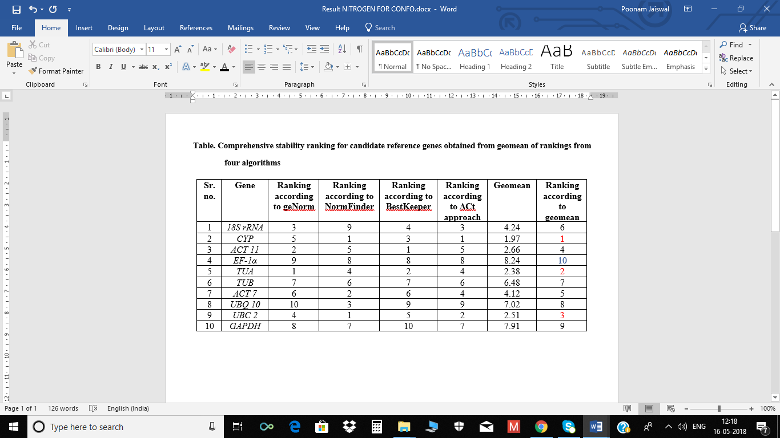

Recent Publications
- C. K. Singh, Sandeep R. Raj, V. R. Patil, P. S. Jaiswal, N. Subhash (2013). Plant regeneration from leaf explants of mature sandalwood trees under in vitro conditions. In Vitro Cell.Dev.Biol.-Plant. 49(2).216-222. DOI 10.1007/s11627-013-9495-y.
- C. K. Singh, Sandeep R. Raj, P. S. Jaiswal, V. R. Patil, B. S. Punwar, J.C. Chavda, N. Subhash (2015) Effect of plant growth regulators in in vitro plant regeneration of Sandalwood (Santalum album L.) via organogenesis. Agroforestry Systems. 90(2).281-288. DOI 10.1007/s10457-015-9853-3.


Biography
Poonam S. Jaiswal has completed her M.Sc. in Agricultural Biotechnology from Anand Agricultural University (Anand, India) through Indian council of Agricultural Research. Currently, she is pursuing her Ph.D. in Plant Biotechnology from Indian Institute of Technology-Roorkee (Roorkee, India). She is working on genomics and proteomics related research in Cyamopsis tetragonoloba. She has wide experimental skills on molecular biology techniques like microarray, bioanalyzer, Real-Time PCR, plant tissue culture techniques, plant physiological studies related tools and techniques.
.
Email: poonamjaiswal2609@gmail.com Contact No: 8791596176

Notes/Comments:

