Host-Plant influences the Food Preference and Consumption of a Predaceous Ladybird, Menochilus sexmaculatus

Ahmad Pervez, PhD
Biocontrol Laboratory, Department of Zoology, Radhey Hari Govt. P.G. College, Kashipur, US Nagar – 244713, Uttarakhand, India.

Abstract (300 word limit)
Statement of the Problem: The impact of host plant-aphid combination on the prey consumption and prey preference by adult ladybirds (Coleoptera: Coccinellidae), Menochilus sexmaculatus (Fabricius) using aphid-prey, Aphis craccivora (Koch) and Lipaphis erysimi (Kalt.) was studied in the laboratory. Monotypic aphids, A. craccivora were raised separately on Indian bean, Dolichos lablab L. and poison buttercup, Ranunculus sceleratus L., and L. erysimi cultured on radish, Raphanus sativus L. and mustard, Brassica campestris L. Adult male and female ladybird consumed significantly greater number of A. craccivora infested on D. lablab than those on R. sceleratus. Similarly, they consumed a greater number of L. erysimi raised on R. sativus than those on B. campestris. Our results indicate that host plant allelochemicals/ toxicants have a direct effect on the palatability and prey consumption, as the ladybirds treated the same aphids differently that were raised on different hosts. The prey-preference was also tested using a choice condition (cafeteria setup) by providing both the aphid species raised on toxic-hosts in a common microcosm. Results revealed that both adult male and female M. sexmaculatus preferably consumed aphid, A. craccivora infested on R. sceleratus over L. erysimi infested on B. campestris in all diet treatments. The preference indices (β and C) further skewed the results towards A. craccivora, which suggest that ladybirds preferred A. craccivora on encountering aphids raised on toxic hosts. It is concluded that dietary selection in ladybirds depends largely on the aphid-host-combination, and a suitable host may aid the augmentative rearing of both aphids and ladybirds.

Image
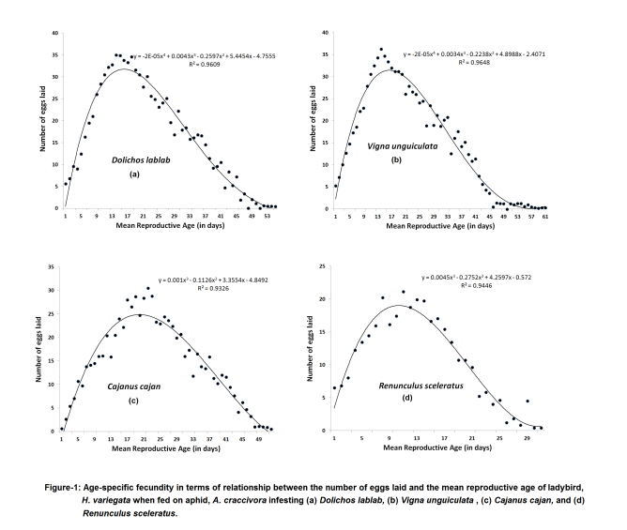
Recent Publications (minimum 5)
- Maia AHN Pazianotto RAA Luiz AJB, Prado JSM, Pervez A (2014) Inference on Arthropod Demographic Parameters: Computational Advances using R. Journal of Economical Entomology. 107 (1): 432-439.
- Guroo MA, Pervez A , Gupta RK, Srivastava K (2017) Effect of nutritious and toxic prey on food preference of a predaceous ladybird, Coccinella septempunctata. European Journal of Entomology 114: 400-406. doi: 10.14411/eje.2017.051.
- Pervez A, Kumar R (2017) Preference of the aphidophagous ladybird, Propylea dissecta for two species of aphids reared on toxic host plants. European Journal of Environmental Sciences. 7(2): 130-134. ISSN: 1805-0174
- Pervez A, Kumar R (2017) Intraguild Predation of Eggs by Predaceous Ladybirds, Propylea dissecta and Menochilus sexmaculatus. Journal of Mountain Research 12: 19-23.
- Pervez A, Pooja and Hakan Bozdogan (2018). Predation potential of a Biocontrol agent, Hippodamia variegata against the aphid, Aphis gossypii. Journal of Bioinnovation. 7(2): 185-192.
- Pervez A (2018) Termite Biology and Social Behaviour. In: M.A. Khan & W. Ahmad (Eds.), Sustainable Termite Management, Sustainability in Plant and Crop Protection Vol. I. Springer International Publisher. Chapter 6. 119-143.

Biography (150 word limit)
Dr. Ahmad Pervez is an Associate Professor of Zoology, who has been awarded as Young Scientist in 2008 in India. He has written a book on Toxicology and also published more than eighty research papers, review article and many chapters in the book. He has completed five research projects and currently investigating a Major research project and two project fellows are working under him. Five research scholars are currently pursuing their Ph.D. under him. He has presented his findings in more than forty conferences/ symposia/ seminars/ workshops, etc. and visited two countries to present his research papers, including prestigious Ecology of Aphidophaga 11 held at Perugia, Italy. He is currently working on the diets, intraguild predation, host plant influences and tritrophic interactions in predaceous ladybirds.

.
Email: ahmadpervez@gmail.com Contact No: 0091-8954095390

Notes/Comments:

