Alien introgression: a rich source of genes for bread wheat improvement and sustainable agriculture
Niaz Ali, PhD, Hazara University Mansehra, Pakistan/
University of Leicester, UK
Pat Heslop-Harrison, PhD, University of Leicester, UK
Trude Schwarzacher, PhD, University of Leicester, UK

Abstract (300 word limit)

Abstract

(Oral presentation)

Pyramiding of alien-derived Wheat streak mosaic virus (WSMV) resistance genes in wheat is a cost-effective and environmentally safe strategy for disease control. PCR-based markers and genomic in situ hybridization (GISH) were applied to identify alien chromatin in four genetically diverse populations of wheat lines incorporating chromosome segments from Thinopyrum intermedium and Secale cereale (rye). Out of twenty experimental lines, ten carried Th. intermedium chromatin as 4Ai#2S.4DL translocation, one carried Th. intermedium chromatin on another D-genome chromosome, while seven lines were positive for alien chromatin (Th. intermedium or rye) on chromosome 1B. The newly described rye 1RS chromatin was associated with WSMV-resistance and has recombined with the 1BS arm. Under field conditions, 1RS chromatin alone showed some resistance, while 1RS chromatin together with the Th. intermedium 4Ai#2S offered superior resistance. Three translocation breakpoints between 1BS and alien chromatin of 1RS were recovered. Repetitive DNA probes proved excellent cytological markers for the detection of Th. intermedium 4Ai#2S arm in both alien-wheat lines and Th. intermedium genome. Labelled genomic Th. intermedium DNA hybridized to the rye 1RS chromatin under high stringency conditions, indicating micro-collinearity of the cereals group-1 and presence of potentially novel orthologous resistance and quality genes on Th. intermedium group-1. The presence of cryptic 1RS alien fragments may explain the difficulty of developing well-adapted lines carrying Wsm1. The results will facilitate development of agronomically desirable WSMV-resistant germplasm.

Recent Publications (minimum 5)
- Muhammad N, Wadood SF, Khan W, Ali N, Nisar M (2018). Intra-species profiling of Cleome viscosa growing in district Swat Khyber Pakhtunkhwa (Pakistan). Biosystems Diversity, 26(1):52-55.
- Tariq MJ, Shah MKN, Hassan MU, Sajjad M, Jamil M, Ali N, Mujeeb-Kazi A (2018). Prevalence of higher glutenin variation in primary synthetic wheat germplasm. The Journal of Animal & Plant Sciences, 28(2): 568-575.
- Qadir A, Jan S.A, Ali N, Rabbani M. A, Ibrahim MI, Khan A and Khurshid H (2017). Assessment of genetic variability in Trigonella foenum-graecum L. germplasm by SDS-PAGE analysis. Genetika, 49(3): 1071-1080.
- Mujeeb-Kazi A, Ali N, Ibrahim A, Napar AA, Jamil M, Hussain S, Mahmood Z, Delgado R, Rosas V, Cortes A, Rajaram S (2017). Tissue culture mediated allelic diversification and genomic enrichment of wheat to combat production constraints and address food security. Plant Tissue Culture and Biotechnology, 27(1): 89-140.
- Masood R, Ali N, Jamil M, Bibi K, Rudd J, Kazi AM (2016). Novel genetic diversity of the alien D-genome synthetic hexaploid wheat (2n=6x=42, AABBDD) germplasm for various phenology traits. Pakistan Journal of Botany, 48(5): 2017-2024.
- Ali N, Heslop-Harrison JS, Ahmad H, Grayboch RA, Hein G L, Schwarzacher T (2016). Introgression of chromosome segments from multiple alien species in wheat breeding lines with wheat streak mosaic virus resistance. Heredity 117, 114-123.
- Schwarzacher T, Ali N, Chaudhary HK, Graybosch R, Kapalande HV, Kinski E, Heslop-Harrison JS (2011). Fluorescent in situ hybridization as a genetic technology to analyzing chromosomal organization of alien wheat recombinant lines. International Atomic Energy Agency (IAEA) IAEA-TECDOC-1664, 121-128.

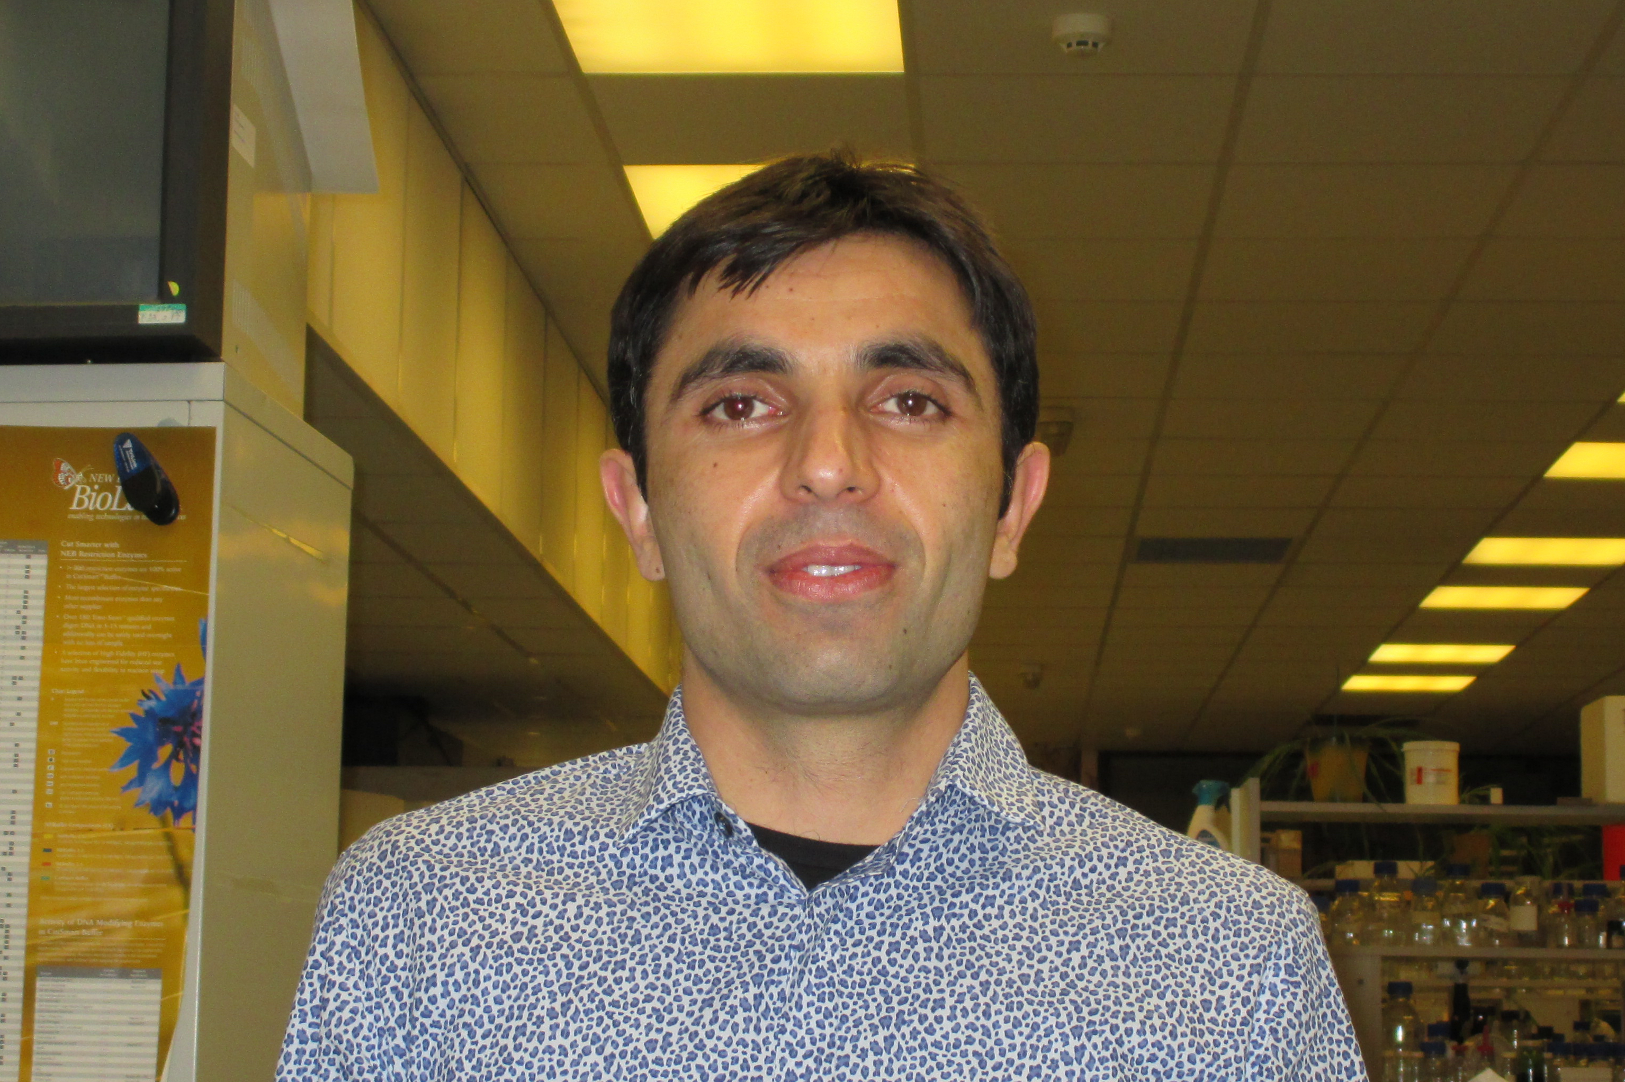Biography (150 word limit)
Niaz Ali has got his PhD from the Department of Genetics (formerly Biology), University of Leicester, UK with Dr. Trude Schwarzacher. Dr. Ali is keen to discover the secrets of chromatin organization and genome evolution with particular emphasis on wide hybridization and alien gene transfers that leads to crop improvement. Recently his research has been focusing on the use diverse genetic resources including released Pakistani wheat varieties, land races as well as wild relatives to increase the genetic base of wheat against biotic and abiotic stresses. To accomplish these aims, he has been closely pursuing field screening coupled with cytogenetic technologies as well as PCR-based markers approaches.
Email: niazalitk25@gmail.com Contact No: +92-3139435319

