Farmer and Researcher Methodology Trade-Offs in Large N Trials: The Case Bean Adaptation Trials in Western Kenya

Hannington O. Ochieng, Maseno University, Kenya

Abstract (300 word limit)
Researchers testing new technologies have interest in increasing farmer participation in terms of sample size and decision-making in order to address the heterogeneous conditions existing in smallholder systems. Increased number of farmers has led to challenges in input acquisition and distribution, trial management, and data collection. Involvement of farmers may benefit researchers in reducing some of the implementation costs. However, data collection for such research with an objective of reducing implementation cost and maintaining data quality still pauses a greater challenge. This is because there are two interested parties (farmers and researchers) with different methodologies in addition to many data points. It is expensive to employ more data collectors to allow for timely and accurate data collection using researcher methodology. The alternative is to source farmers’ assistance. Researcher data collection methodology is intensive and time-consuming making it difficult for most farmers to assist since they are busy attending to other daily duties and/or are semi- or illiterate. However, farmers can use their methodology which is much easier and less time consuming, which involves rating of the performance of the technologies being tested rather than taking the exact measurements. Most researchers are comfortable using exact measurement values and are therefore left in suspense on the methodology to use.
With the aim of determining the trade-offs and their impact on the conclusions drawn from data collected using farmers and researchers methodologies, data was collected for two seasons from a bean adaptation trial. The data was then analyzed and the outputs from related variables were correlated and regressed to establish the strength of their relationship. Related variables were on emergence, pest and diseases, maturity, and grain yield. The outputs from the two methodologies were highly related with lowest r=0.8 and R²=0.66 at p=0.05. We can therefore conclude that with proper guidance from the researcher, farmer methodology can be used to collect data in large N trials with minimal trade-offs. Furthermore, farmer methodology provides opportunity to collect more variables that are relevant and are otherwise difficult to collect, analyze and interpret using researcher methodology.

Image

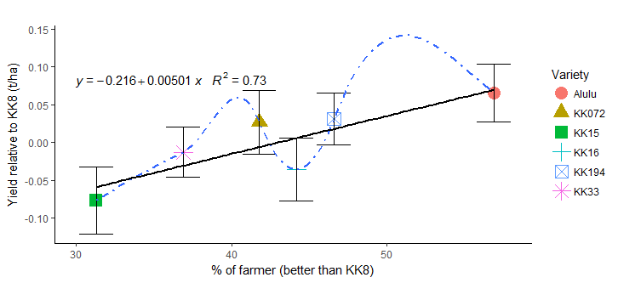
Figure 4.2. Scatterplot of the percentage of farmers rating other varieties better than KK8 and researcher grain yield data expressed relative to KK8 with Regression line

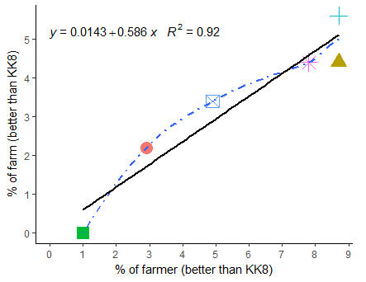 | 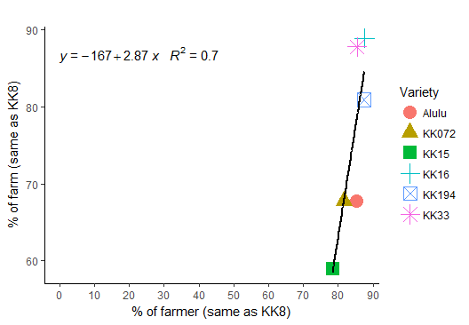
Figure 4.6 Percentage farmer rating of pests resistance of bean varieties
tested in Nandi County
Recent Publications
- Ojiem, J.O., *H.O. Ochieng, S.M. Kamwana, J. W. Nyongesa & J.C. Mutai (2016) Legume Varietal Diversity: A necessity for improved smallholder productivity? Paper presented at the 3rd International Interdisciplinary Conference (IIC-2016) held at University of Eldoret from 7th to 9th September, 2016.
- Ochieng, H.O.*, J.O. Ojiem, S.M. Kamwana, J. W. Nyongesa & J.C. Mutai (2017) Multipurpose Legumes Project’s approaches, activities, and achievements. Posters presented in the Ninth Meeting of Eastern Africa Community of Practice (EAf CoP9) organized by Collaborative Crop Research Program (CCRP), Vic Hotel, Kisumu.
- Ochieng, H.O., & M. Mudeheri (2017) Data processing and analysis using Excel, SAS, and Stata. A four-week training of researcher and field technicians at KALRO Kibos, in January 2017.
- Ochieng, H.O. (2016) Data collection Using ODK. Training at the Web mapping/GIS training workshop organized by McKnight GIS-Kenya Project (KALRO Kabete Research Centre) from 29th February – 4th March 2016.


Biography
Hannington Ochieng is a master student at Maseno University, Kenya, taking Research Methodology. He is also an intern at Kenya Agricultural and Livestock Research Organization. He has vast experience in research and community development having previously worked with Climate Change, Agriculture and Food Security (CCAFS) program under SAMPLES (Standard Assessment of Mitigation Potential and Livelihoods in Smallholder Systems) project as Research Assistant, and with African Maths Initiative as a Volunteer. He has been involved in research design, farmer mobilization, development and implementation of appropriate data collection and management strategies, including providing training on digital data collection devices and tools, such as Open Data Kit (ODK). In addition, he is knowledgeable in a number of statistical packages (including Stata, Ms Excel, R, and CSpro for data processing and analysis. This exposure has enabled him garner interdisciplinary knowledge and use it to improve technology dissemination, research and community development.

Email: hannywillis2@gmail.com Contact No: +254722139278

Notes/Comments:

