Sea buckthorn; Resource for Health and Food Security in Climatic Change Perspectives

Asad Hussain Shah, PhD, Department of Biotechnology, University of Kotli, Azad Jammu and Kashmir
Farhat Batool, Ph.D, Department of Biochemistry, University of Karachi, Karachi, Pakistan

Abstract:
A bulk of Pakistani population is under nourished. Stunted growth of children and anemic women in their reproductive age is the manifestations of nutritional deficiencies. The climate change is an alarming scenario and has put question mark on food security in South East Asia. The choice of plant species is an imperative strategy to combat with concern of food security and human health. Sea buckthorn, a popular multipurpose magic shrub distributed throughout the world being used from centuries for human health and nutrition. The plant has been enriched with nutritional profile of immense value including minerals, vitamins, seed/pulp oil and amino acids. Pakistan has been blessed with three thousand hectares of wild Sea buckthorn populations distributed in Gilgit Baltistan. We have conducted series of experiments for genetic characterization of Pakistani Sea bucktkhorn populations using morphological, biochemical and molecular markers. The phylogenetic relationship among the genotypes expressed significant diversity in AFLP profile for breeding high yielding Sea buckthorn crop variety. The nutritional profile of Sea buckthorn expressed promising prospects for exploitation to address the issues related food security and human health. We have characterized the nutraceutical profile form Sea buckthorn at different harvesting stages and have performed molecular cloning transcript profiling of ascorbate oxidase gene for future biofortification of cereals. We have evaluated the antidepressant-like effects of aqueous extract of fruits in experimental models of depression. It was found that oral supplementation of Sea Buckthorn fruit extract modifies haloperidol induced behavioral deficits and increases brain serotonin metabolism. Research and development on Sea buckthorn and prospects of value addition in local industry associated with this plant will be discussed in the presentation.

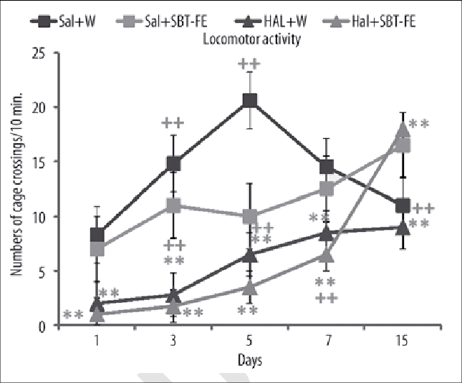

Recent Publications

- S.Arif, MR Khan, SDA Gardezi, MF Khan, A Hamid, AH Shah, GM Ali Molecular cloning and transcript profiling of ascorbate oxidase gene at different growth developmental stages from therapeutically important plant Sea buckthorn (Hippophae rhamnoides L) Pakistan Journal of Botany; 49 (3), 1143-1154- 2017
- Rehmat Zaman, Wajid Rehman, Mukhtiyar Hussain, Muhammad Mumtaz Khan, Zeeshn Anjum, Syed Asad Hussain Shah and Syed Rizwwan Abbbas. 2016Synthesis,Charaterization and Biological activities of sepholosporin metal complexes. International Journal of Biosciences Vol. 9 No.5 Pages: 163-172
- Asad Husain Shah, Syed Dilnawaz Ahmad, 2015, Research and Development of Sea buctkhorn for Himalayna Mountains in Pakistan. International Conference on “Sea buctkhorn emerging technologies for health protection and environmental conservation 24-26 Nov. 2015 held in New Dehli India.
- Syed Mubasher Sabir, Rashid Hussain Shah and Asad Hussain Shah, 2015. Total Phenolics and ascorbic acid and anti oxidant activities of twelve different ecotypes of Phyllunths umblica from Pakistan. Chiang Mae J. Science 42, (X) 1-9 I.F: 0.37
- F Batool, A H Shah and D A Halem 2015. Effects of high fat diet and repeated resistant stress on food intake and energy metabolismin 5-H2TC mutant mice. Proceedings of British Pharmacological society (I.F) 4.3

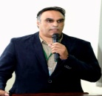
Dr. Asad Hussain Shah has been working as chairman department of Biotechnology, University of Kotli, Azad Jammu and Kashmir. His area of expertise is plant breeding and molecular genetics. He is working on medicinal flora of Himalyan region for genetic and phytochemical potentials. Dr. Shah has been working on Sea buckthorn in Pakistan from more than a decade and has evaluated the Pakistani germplasm of Sea buckthorn for its nutritional and biochemical properties along with its impact on human health. He has also been working on Sea buckthorn genetic improvement. In addition to that Dr. Shah is supervising research on drought and heat stress in wheat. Dr. Shah has vast experience of working on crop improvement projects

Email: syedasadhamdani@gmail.com Contact No: 00923455153375

Notes/Comments:
Since I need financial support to attend and present my work in conference, I have to apply in Higher Education Commission Pakistan for financial assistance. They support only for oral presentations. It is therefore requested that kindly accept my abstract for oral presentation please.

Regards

