Induction of cold tolerance by priming and stress memory in crops
Xiangnan Li, Professor PhD, Northeast Institute of Geography and Agroecology, Chinese Academy of Sciences, China
Xiancan Zhu, Associate professor PhD, Northeast Institute of Geography and Agroecology, Chinese Academy of Sciences, China
Fengbin Song*, Professor PhD, Northeast Institute of Geography and Agroecology, Chinese Academy of Sciences, China

Abstract

Cold is one of the major environmental factors limiting plant growth and development. The increased climatic variability and more frequent episodes of extreme conditions also result in plants being exposed to not only one single cold event but also multiple abiotic stresses at different periods. Although the abiotic stresses occurring at different stages result in a higher risk of injury, earlier stress events may prime the plant to protect it against later stresses. A large body of evidence has shown that a previous exposure to different types of stress can affect the subsequent responses and eventually prepare the plants to more quickly or actively respond to future stresses. Cold stress tolerance in plants involves diverse and multiple physiological and molecular mechanisms. Priming and stress memory are key processes, by which plant may increase the tolerance to subsequent drought events. Stress memory involves multiple modifications at physiological, proteomic, transcriptional levels and epigenetic mechanisms. We summarized recent advancements in physiological, biochemical, and molecular studies related to drought priming and its effect on drought tolerance in plants. The mechanisms of drought stress memory and the possible priming induced cross-tolerance to other abiotic stresses are discussed. As one of main focuses in plant-abiotic stress research, studies on plant drought priming and stress memory is still rare. To date, most of results on plant drought priming were obtained in controlled lab experiments, which might be different from the natural conditions. Thus, in future studies, a combination of experiments from controlled lab evaluations with observations and simulation under field conditions should be performed. Collectively, to further understanding the processes and mechanisms of priming effects, eco-physiologists and molecular biologists should work together in order to reveal the complete regulation network at different levels and scales, such that management strategies could be developed to sustain crop productivity under future climate changes scenarios.
Image
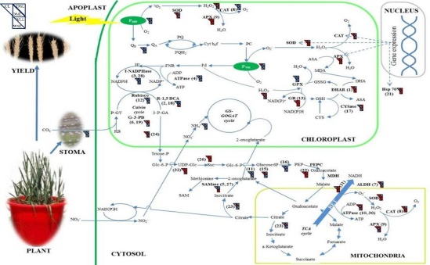
Recent Publications
- Li X*, Brestic M, Tan D, Zivcak M, Zhu X, Liu S, Song F, Reiter RJ, Liu F*, Melatonin alleviates low PS I limited carbon assimilation under elevated CO2 and enhances the cold tolerance of offsprings in chlorophyll b-deficient mutant wheat, Journal of Pineal Research, 2018, 64, e12453.
- Liu S, Li X*, Larsen DH, Zhu X, Song F, Liu F*, Drought priming at vegetative growth stage enhances nitrogen use efficiency under post-anthesis drought and heat stress in wheat, Journal of Agronomy and Crop Science, 2017, 203, 29-40.
- 10. Liu N, Song F, Zhu X*, You J, Yang Z*, Li X*, Salicylic acid alleviates aluminum toxicity in soybean roots through modulation of reactive oxygen species metabolism, Frontiers in Chemistry, 2017, 5, 96.
4. Zuo Z, Sun L, Wang T, Peng M, Zhu X, Liu S, Song F, Mao H, Li X*, Melatonin improves the photosynthetic carbon assimilation and antioxidant capacity in wheat exposed to nano-ZnO stress, Molecules, 2017, 22, 1543.5.
5. Zhu X, Sun L, Song F*, Liu S, Liu F, Li X*, Integrated agricultural practice alter soil microbial community and activity in Northeast China, European Journal of Soil Science, 2018, published online.

Fengbin Song
Fengbin Song currently is member of the party committee, secretary and group leader of agroecology for advisory committee in IGA; vice director of Harbin Center for Agricultural Research; member of academic degree committee and recruitment committee in IGA; adjunct professor in Northeast Agriculture University and Changchun Normal University. He received his B.S. and M.S. degree from Jilin Agricultural University and Ph.D. from Shenyang Agricultural University. Prior to joining IGA, Dr. Song had worked as Postdoc in Japan. He is a recipient of 2003 JSPS postdoc scholarship. He also worked at Max Planck Society, Germany and University of Massachusetts as visiting scholar supported by CAS in September of 2006 and March of 2008, respectively.
Email: songfb@iga.ac.cn Contact No: 86602966

Notes/Comments:

