The preliminary exposition of soil biological activity, microbial diversity and morpho-physiological indexes of cucumber under interactive effect of allelopathic garlic stalk; a short-term dynamic response in replanted alkaline soil.

Ahmad Ali, Zhihui Cheng*
College of Horticulture, Northwest A&F University, Yangling, Shaanxi 712100, China.
*Corresponding Author: Zhihui Cheng

Abstract
Background and aims: Long-term continuous cropping spans with excessive synthetic fertilizers inputs sponsor the continuous cropping obstacles under under plastic greenhouse vegetable cropping (PGVC) system, which have greatly threatened the regional soil eco-sustainability and further impose the continuous assault on soil ecological diversity leading to the exhaustion of agriculture productivity. The aim of this study was to develop new allelopathic insights by exploiting available biological resources in the favor of sustainable PGVC to illuminate the continuous obstacle factors in plastic greenhouse. Method: A greenhouse study was executed under plastic tunnel located at the Horticulture Experimental Station of the College of Horticulture, Northwest A&F University, Yangling, Shaanxi Province, one of the prominent regions for intensive commercial PGVC in China. Post-harvest garlic residues (stalk, leaves) mechanically smashed, homogenized into powder size and incorporated at the ratio of 1:100; 3:100; 5:100 as a soil amendment in a replanted soil that have been used for continuous cucumber monoculture for 7 years (annually double cropping system in a greenhouse). Results: Incorporated C-rich garlic stalk significantly influenced the soil condition through various ways; organic matter decomposition and mineralization, moderately adjusted the soil pH, enhanced the soil nutrient availability, increased enzymatic activities, and promoted 20% more cucumber yield in short-time. Using Illumina MiSeq sequencing analysis of bacterial 16S rRNA and fungal 18S rDNA genes, the current study revealed that addition of garlic stalk/residue could also improve the microbial abundance and community composition in extensively exploited soil, and contributed in soil functionality, caused prosper changes in soil characteristics, reinforced to good crop yield. Conclusion: Our study provided evidence that addition of garlic stalk as soil fertility amendment is a feasible, cost-effective and efficient resource utilization way for renovation of degraded soil health, ameliorate soil quality components and improve ecological environment in short duration. Our study may provide a better scientific understanding for efficient crop residue management typically from allelopathic source.
Keywords: Garlic stalk, microbial community dynamics, plant growth, soil amendment, soil-plant system.

Graphical illustration of experiment
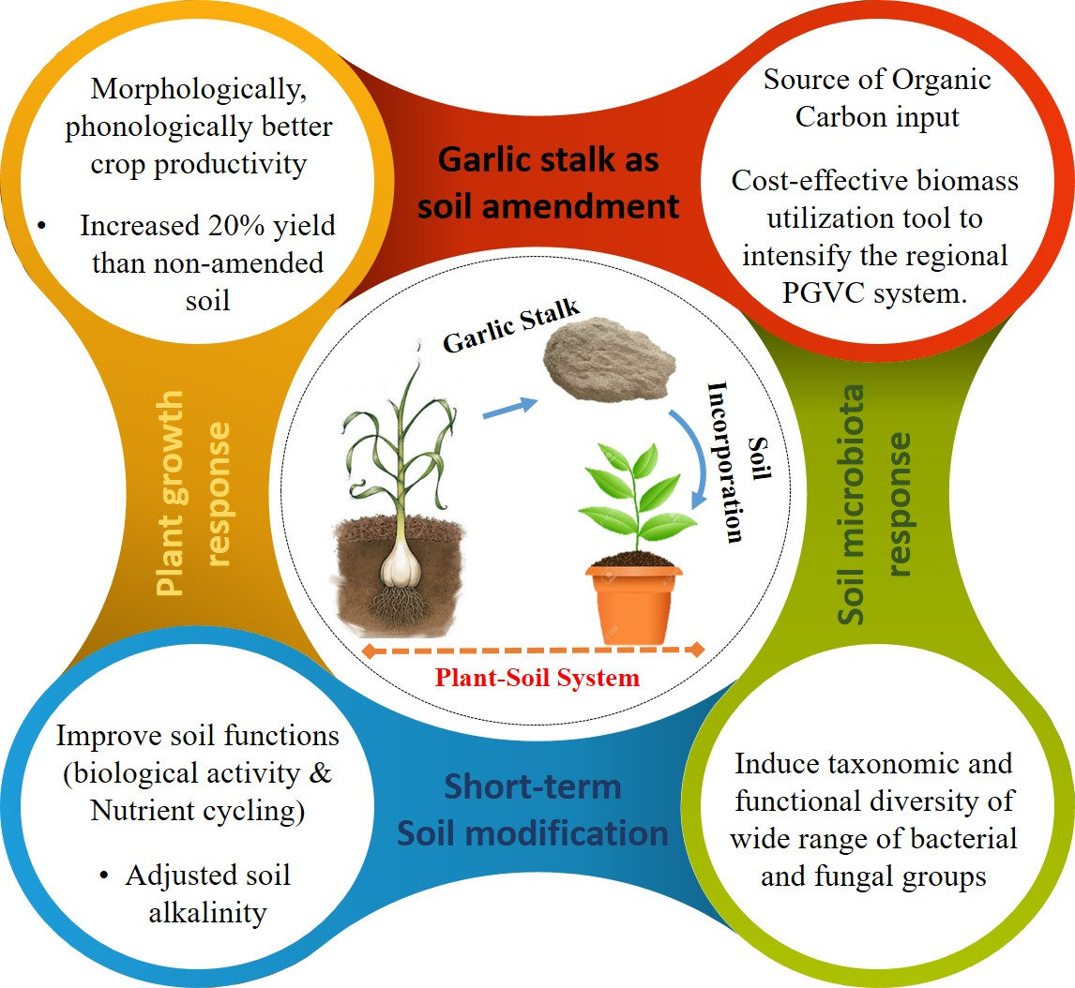

  Author’s formal photo | Ahmad Ali is a researcher and doctoral student in college of horticulture, Northwest Agriculture and Forestry University, China. He recently working on the project of “sustainable vegetable production system under green-house environment by eliminating the continuous cropping obstacles through available biological resources”. Under this project, our goal is to improve the soil sustainability and crop productivity by adopting sustainable agronomic measures. He has presented papers at conferences both home and abroad, published articles and papers in various journals.  Presenting author details  Full name: Ahmad Ali  E-mail: ahmadhort87@nwafu.edu.cn Contact No: 008615829792534  Category: (Oral presentation/ Poster presentation)

