Quality characteristics of sweetpotato varieties according to storage conditions
Gyeong-Dan Yu, Hyeong-Un Lee, Jung-Wook Yang, Seungyong Lee, San Ko, Sang-Sik Nam, Kyeong-Bo Lee
Bioenergy Crop Institute, National Institute of Crop Science, RDA, Republic of Korea

Abstract

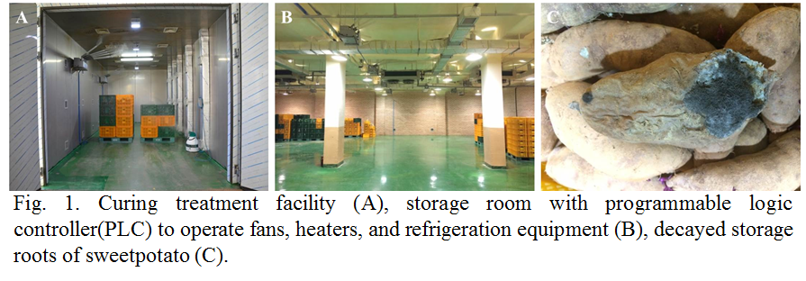
Sweetpotato (Ipomoea batatas L.) is one of the important food crops and is widely cultivated around the world. However, the quality of sweet potato decreased due to the decay and incorrect handling practices after harvest. Curing and storage temperature of sweetpotato storage roots has been recognized as one of the most effective ways of reducing the risk of postharvest infection and decay. In the present study, we investigated the difference of storability and quality in sweetpotato varieties according to curing treatment, storage temperature and storage period. The materials were four varieties that dry type ('Daeyumi', 'Jinhongmi'), medium moist type ('Pungwonmi'), and moist type ('Hogammi'). Tuberous roots were stored in temperature (10±1, 13±1℃), humidity (90±3%) during 28 weeks after curing and non-curing treatment. During the storage period, root decay rate in all cultivars was lowered in the curing treatment than non-curing treatment. In addition, storage temperature showed a higher decay rate in 10℃ than 13℃. These results suggested that curing method and storage temperature are important factors to store sweetpotato for a longtime safely. The dry matter content at postharvest were higher ‘Daeyumi’ and ‘Hogammi’ by more than 30%, and ‘Pungwonmi’ was lower by 26~27%, and all varieties decreased during the storage period. There was no clear tendency to change the hardness according to the curing and the storage temperature treatment and the tendency of the storage of the sweetpotato hardness in all varieties tended to decrease at the later stage of storage rather than at the initial stage. As the storage period of 'Hogammi' and 'Pungwonmi' was longer, the sugar content increased. Especially, the sugar content was the highest in the 10℃ treatment. These results will be useful as a basic data for better storage condition of sweetpotato.

Image
Recent Publications
- Van Oirschot Q.E.A., Rees D, Aked J, Kihurani A (2006) Sweetpotato cultivars differ in efficiency of wound healing. Postharvest Biol Technol, 42, 65-74.
- Song JH, Kim SK, Chun CH (2011) Application of simplified curing unit for the extension of storage life and improvement of physicochemical qulity of sweet potatoes during long-term storage. J Bio Environ Cont, 20, 304-310.
- Rees D, Van Oirschot QEA, Aked J (2008) The role of carbohydrates in wound-healing of sweetpotato roots at low humidity. Postharvest Biol Technol, 50, 79-86.
- Tomlilns KI, Ndunguru GT, Rwiza E (2002) Influence of pre-harvest curing and mechanical injury on the quality and shelf-life of sweet potato(Ipomoea batatas (L.) Lam) in east africa. J Hortic Sci Biotech, 77, 399.
5. Zhitian Z, Christopher C. W, Harold C (2002) Biochemical changes during storage of sweet potato roots differing in dry matter content. Postharvest Biology and Technology 24:317-325.


Gyeong-Dan Yu works at National Institute of Crop Science, Rural Development Administration in South Korea since 2012. Her major is agriculture biotechnology and she had studied haploid breeding of Miscanthus, bioenergy crop, 2012 to 2015. Now she researches about post-harvest management and is working to reduce the economic losses of sweetpotato farmers caused by post-harvest management problems. She is also interested in clarifying mechanisms related to changes of components in sweetpotato during storage.

Email: gyeongdan@korea.kr Contact No: +82-10-2639-2327

Notes/Comments:

