Effects of water stresses on the growth of Miscanthus sacchariflorus ‘Geodea-Uksae 1’ during reproductive growth stage
Ji-Eun Lee, In-Seong Choi, Young-Lok Cha, Kwang-Soo Kim, Youn-Ho Moon, Da-Eun Kwon, and Yong-Ku Kang
Bioenergy Crop Research Institute, NICS, RDA, Republic of Korea

Abstract
The Geodea-Uksae 1(GU1) is new Miscanthus sacchariflourus cultivar and its height is higher than that of conventional M. sacchariflourus, so it can produce a large amount biomass. However, GU1 has a lower heading rate compared to other M. sacchariflourus and the mechanism is largely unknown. The GU1 treated with three water conditions (control, drought and flooding) in the reproductive growth period (July). The water condition of the control was a conventional irrigation and them of drought was one third of the conventional irrigation. Them of flooding maintained 100% soil moisture. After 4 months of treatment, height of GU1 increased by 30% at flooding stress. Notably, heading of GU1 at only flooding stress treatment emerged and its heading rate was 48%. Nutrients of GU1 showed different tendency according to each nutrient. Total N and P₂O₂ contents were the highest in GU1 grown under drought stress, while P₂O₅, K, Ca and Mg contents were the lowest in GU1 grown under flooding stress. It is considered that the nutrients are exhausted due to the vigorous growth of the GU1 under the influence of flooding stress. Particularly, P is consumed much during the period when the growth is vigorous such as early stage of growth, flowering period. These results suggest that the growth of the GU1 is promoted by flooding stress. On the other hand, nutrient content was high due to poor growth of the GU1 under the influence of drought stress. Free sugar content also supports these results. Result of free sugar content measurement showed that sucrose was the highest in GU1 at drought stress. In conclusion, drought stress in the reproductive stage inhibited the growth of GU1, while flooding stress promoted the growth of GU1.

Image
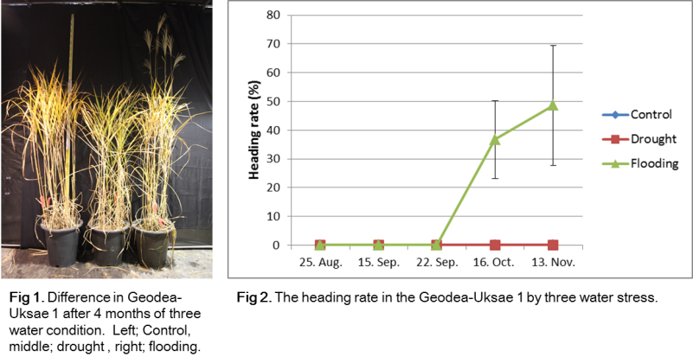
Recent Publications
- Cosentino SL, Patane C, Sanzone E, Copani V, Foti S. (2007) Effects of soil water content and nitrogen supply on the productivity of MiscanthusXgiganteusGreef et Deu. in a Mediterranean environment. Industrial Crop and Products 25(1):75-88.
- Clifton-Brown JC, Lewandowski I (2000) Water use efficiency and biomass partitioning of three different Miscanthus genotypes with limited and unlimited water supply. Annals of Botany 86(1):191-200
- Clifton-Brown JC, Lewandowski I. Bangerth F, Jones MB (2002) Comparative responses to water stress in stay green, rapid-and slow senescing genotypes of the biomass crop, Miscanthus. New Phytologist 154:335-345.
- Weijde T, Huxley LM, Hawkins S, Sembiring EH, Farrer K, Dolstra OD, Visser RGF, Trindade LM (2017) Impact of drought stress on growth and quality of miscanthus for biofuel production. Gcb Bioenergy 9(4)770-782.
- Ings J, Mur LA, Robson PR, Bosch M (2013) Physiological and growth responses to water deficit in the bioenergy crop MiscanthusXgiganteus. Frontiers in Plant Science 4:468

Biography
Ji-Eun Lee has been studying the physiological response of bioenergy crops. In the past, she studied small membrane protein induced by salt stress and cold stresses in the bioenergy crop Camelina. Now, she has been researching the mechanisms by which its respond to poor environments in two bioenergy crops, Rapeseed and Miscanthus. In particular, she is interested in temperature and water stresses responses in two crops, and would like to study response signals for this.
These studies suggest a cultivation method in which crop can adapt to unexpected environmental conditions and it will be used as basic data for crop breeding which is resistant to poor environment.
Email: leejins212@korea.kr,Contact No: +82-10-3166-0819

Notes/Comments

