Development of upland rice plants as affected by potassium fertilization and diazotrophic bacteria strain of Serratia spp.

Adriano Stephan Nascente, PhD, Embrapa Arroz e Feijao, BRAZIL

Abstract (300 word limit)
The proper use of nutrients is a key for increasing sustainable agricultural production. Potassium is the second most uptake nutrient by rice crops. Rizhobacteria can be used to stimulate plant development and could allow for increasing nutrient uptake. However, there are no virtual studies about the use of bacteria and K fertilization in the development of upland rice. The objective was to determine the effect of the rhizobacteria Serratia spp. strain R-235 and doses of K at sowing fertilization on the production of biomass, gas exchange, nutrient content in leaves and grain, yield components and grain yield of upland rice. The field experiments were conducted in two growing seasons, 2015/16 and 2016/17, under no-tillage systems in the Brazilian Cerrado. The experimental design was a complete randomized block in a factorial 4x2 scheme, with four replications. The treatments consisted of four K2O doses (0, 20, 40 and 60 kg ha-1) with or without rhizobacteria seed inoculation and plant/soil spray pulverization. The use of Rhizobacterium Serratia spp. strain R-235 in soil with high levels of K, allowed not to use K fertilization in rice crop. The use of Rhizobacterium Serratia spp. strain R-235 provided increases in content of P, Ca, Mg, Fe and Zn in rice leaves; plant biomass, number of panicles per plant, number of grains per panicle and grain yield of upland rice. Grain yield of rice treated with Rhizobacterium Serratia spp. isolated R-235 was 16.3% higher than no treated plants. The use of bioagent was effective to provide better plant upland rice development under field conditions and showed promising to be incorporated into crop systems.

Image
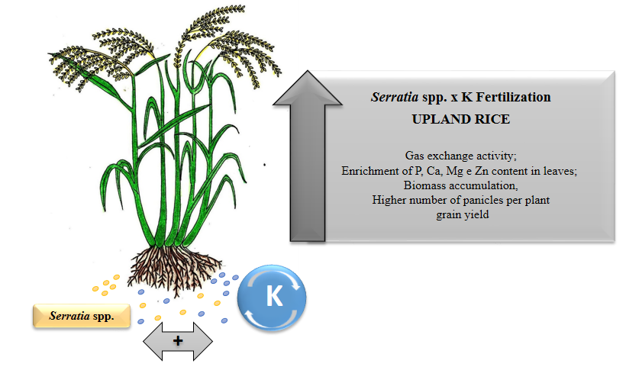
Recent Publications (minimum 5)
- CARMEIS FILHO, ANTONIO C.A. ; CRUSCIOL, CARLOS A.C. ; Nascente, A.S. ; MAUAD, M. ; GARCIA, R. A. . INFLUENCE OF POTASSIUM LEVELS ON ROOT GROWTH AND NUTRIENT UPTAKE OF UPLAND RICE CULTIVARS. Revista Caatinga, v. 30, p. 32-44, 2017.
- Nascente, A.S.; CARVALHO, M. C. S. ; MELO, L. C. ; ROSA, P. H. . Nitrogen management effects on soil mineral nitrogen, plant nutrition and yield of super early cycle common bean genotypes. ACTA SCIENTIARUM-AGRONOMY, v. 39, p. 369-378, 2017.
- REIS, A. F. B. ; ALMEIDA, R. E. M. ; CHAGAS JUNIOR, A. F. ; Nascente, A.S. . EFFECT OF COVER CROPS ON SOIL ATTRIBUTES, PLANT NUTRITION, AND IRRIGATED TROPICAL RICE YIELD. Revista Caatinga, v. 30, p. 837-846, 2017.
- Nascente, A.S; KROMOKARDY, R.. Genotype selection and addition of fertilizer increases grain yield in upland rice in Suriname. ACTA AMAZONICA, v. 47, p. 185-194, 2017.
- Nascente, Adriano Stephan; DE FILIPPI, MARTA CRISTINA CORSI ; LANNA, ANNA CRISTINA ; DE SOUZA, ALAN CARLOS ALVES ; DA SILVA LOBO, VALÁCIA LEMES ; DA SILVA, GISELE BARATA . Biomass, gas exchange, and nutrient contents in upland rice plants affected by application forms of microorganism growth promoters. Environmental Science and Pollution Research, v. 24, p. 2956-2965, 2017.
- Nascente, Adriano Stephan; DE FILIPPI, MARTA CRISTINA CORSI ; LANNA, ANNA CRISTINA ; DE SOUSA, THATYANE PEREIRA ; DE SOUZA, ALAN CARLOS ALVES ; DA SILVA LOBO, VALÁCIA LEMES ; DA SILVA, GISELE BARATA . Effects of beneficial microorganisms on lowland rice development. Environmental Science and Pollution Research, v. 24, p. 25233-25242, 2017

Biography (150 word limit)
Adriano Stephan Nascente has completed his PhD at the age of 42 years from Sao Paulo State University and University of Florida. He is researcher scientist of rice and beans plant management at the Brazilian Agricultural Research Corporation, at the Rice and Beans Research Center. He has published more than 100 papers in reputed journals and has been serving as an editorial board member of four journals.

Email: adriano.nascente@embrapa.br Contact No: 00556235332179

Notes/Comments:

