Screening of Mungbean (Vigna radiata) Genotypes for Nutrient Stress Tolerance
Mohammad Altaf Hossain

Abstract (300 word limit)
Generally nutrient deficiency of a soil is corrected through application of chemical fertilizers. Fertilizers on one hand are costly and on the other hand it may lead to water pollution by nitrogen and phosphorus from agricultural land. Screening of genotypes for nutrient stress tolerance could be the best alternative to overcome the situation. The present study evaluates the plant growth characters with emphasis on root growth and nutrient uptake of selected mungbean genotypes and examines the efficiency of certain growth parameters for predicting their adaptation in sub-optimal nutrient environment. Some genotypes (VC 6153B, GK3 & VC 6144A) were found to be high nutrient acquiring genotypes and some (PDM 54, IPSA 25 & VO 1443 A-G) were low nutrient acquiring genotypes.
Key words: Mungbean, genotypes, nutrient stress.

Image

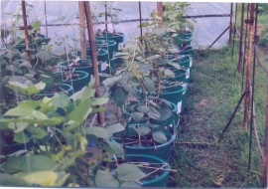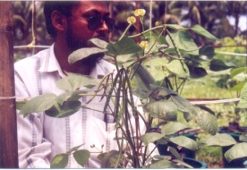

Recent Publications (minimum 5)
1. Hossain et al., 2018. Introduction of Quesungual Slash and Mulch Agro-forestry System (QSMAS) for Enhancing Crop Yields and Soil Quality in Chittagong Hill Tracts. Agricultural Studies, page135-145 www.itspoa.com/journal/as
2. Hossain and Ahmad, 2017. Livelihood status of hill dwellers in Bandarban, Bangladesh. IJBMSR 03 (01):154-161. (https://doi.org/10.18801/ijbmsr.030117.18)
3.Hossain and Siddique, 2015. Water-A limiting resource for sustainable agriculture in Bangladesh, EC Agriculture 1:2 (2015):124-137.
4. Hossain and Dewan, 2015. Land Zoning: concept and its urgency in Bangladesh, EC Agriculture 1:1 (2015):57-72.
5. M. A. Hossain, 2011. Land Resources Appraisal and Crop Management in Bangladesh, CROP & ENVIRONMENT 2012, 3(1-2): 67-70 ISSN :2221-0237 (PRINT) ISSN :2221-0245 (ON LINE)
6. M. A. Hossain, 2011. An overview on shifting cultivation with reference to Bangladesh, Scientific Research and Essays Vol. 6(31), pp. 6509-6514, 16 December, 2011 Available online at http://www.academicjournals.org/SRE
7. M.A.Hossain, 2011. Global Warming induced Sea Level Rise on Soil, Land and Crop Production Loss in Bangladesh, Journal of Agricultural Science and Technology (ISSN 1939-1250), USA June, 2011.

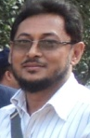
Biography (150 word limit)
The author was born on February 1963 in Gazipur, Bangladesh. He was graduated from Bangladesh Agricultural University, Mymensingh in 1984 and obtained his PhD in Agronomy degree in 2004 from Bangabandhu Sheikh Mujibur Rahman Agricultural University, Gazipur. He has published 20 papers in reputed journals of home and abroad. He has two monographs in his credit. He attended international seminar in Australia, Pakistan and also in Bangladesh as oral presenter. He has successfully implemented 6 research projects under the auspices of Bangladesh Agricultural Research Council capacity of Principal Investigator (PI) and Co-PI. He acted as a member of working groups for formulating Good Agricultural Practices Policy and Land Degradation Neutrality–Target setting for Bangladesh. He is involved in peer review of articles of some reputed online journals. He is the founder board member of BiNet (www.binet.bd.com) and editorial board member of journalbinet.bd.comHe is presently serving as Principal Scientific Officer in the Soil Resource Development Institute (SRDI) under Ministry of Agriculture, Govt. of Bangladesh.
Email: altajolly63@yahoo.com Contact No: 88-01871039481

Notes/Comments:

