Field Optimization of the attractiveness of brown cocoa mirid Sahlbergella singularis Haglund (Hemiptera: Miridae), by different colorless sex pheromone sticky traps in the Centre and South-West Regions of Cameroon
Mahot H.C.^{1,2,3}, Mahob R.J. ³, Hall D.⁴, Bilong B.C.F.³ and Hanna R.²

Abstract (300 word limit)

Field tests were conducted to ascertain a possible role of visual aptitude and relative effect of visual stimuli of adult Sahlbergella singularis the most economically important mirid bugs in Central Africa. The attractiveness of three colors white, violet and green was evaluated in the Centre and South-West regions of Cameroon during two periods from September 2014 to August 2015 and from September 2015 to September 2016 using rectangular pheromone traps coated with Tanglefoot adhesive. A population dynamics in 2015 showed two demarcated equal peak in Ayos while in Konye population fluctuated with one small then one high peaks. Our investigation suggested that adult mirids bugs are influenced by visual cues present in their habitat. More mirids were caught by Green trap (47.4%) following by Violet (32.5%). White trap captured lowest number of mirids (20.0%).

Image

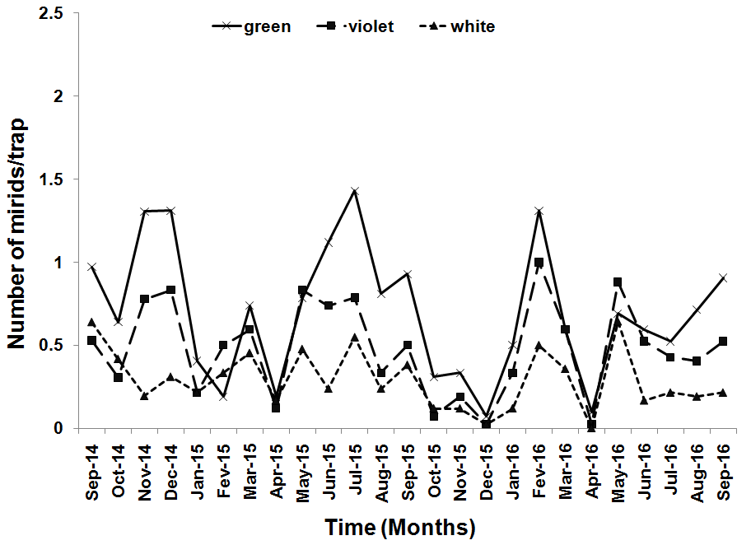
Figure 1: Annual mean variation in the number of mirids caught by traps in Konye (Cameroon south-west) for the both study years


Biography (150 word limit)
Hermine Claudine MAHOT is an entomopathologist researcher. She has proven experience in pest that is harmful to cocoa farming. She is a specialist in the analysis of the damage caused by these pests. She has great interest in the biological control of cocoa pests, especially the Hemipteran Sahlbergella singularis. She works on the development of a biopesticide using entomopathogens fungi and on the promotion of implementation of pheromones traps
Email: h.mahot@cgiar.org Contact No: 00237 677398454

Notes/Comments:

