Effect of plant growth regulators on in vitro regeneration from mature wheat (Triticum aestivum L.) embryo explants.
Doriana (Bode) Xhulaj, Dr, A U Tirana, ALBANIA
Doriana (Bode) Xhulaj, Dr, A U Tirana, ALBANIA

Abstract
The experiment was carried in the laboratory of plant tissue cultures, of the Institute on Plant Genetic Resources, Agriculture University of Tirana during 2016. An efficient method was developed for multiple shoot regeneration of wheat from mature embryos without callus formation, for a short period of time (2.5 months). Direct shoot regeneration is important since fewer somaclonal variations are likely to arise in indirect regeneration method. The effect of explants, cutted shoot embryonic meristem and shoot embryonic meristem with scutellum and various combinations of plant growth regulators in MS media on direct shoot regeneration of wheat was investigated. Among different combination of 2,4-D, IBA, NAA and BAP tested, embryo explants cultured in MS medium supplemented with 2 mg/L BAP, 0.6 mg/L 2,4- D resulted in the most efficient direct shoot regeneration and produces a max of 2.5 shoot per explants and 3.4 cm shoot length. Plantlets were successfully transferred to rooting medium. The greatest mean numbers of roots were obtained on MS media supplemented with 0.5 mg/L NAA, and the best mean value of root length (8.2cm) at 0.5 mg/L IBA. In this paper by simple manipulating the concentrations of BAP, 2,4-D, IBA and NAA in the culture medium, is described a method rapidly obtaining whole plants without the subculture of wheat using embryo explants.
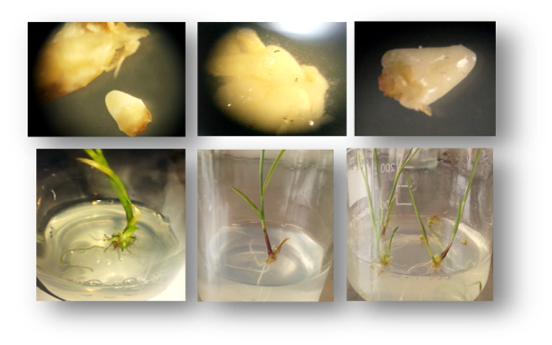
Figure 1. Embryo and meristem explants excised from mature seeds. Wheat multiple shoot regeneration in MS medium supplemented with supplemented with 2 mg/L BAP, 0.6 mg/L 2,4-D.

Image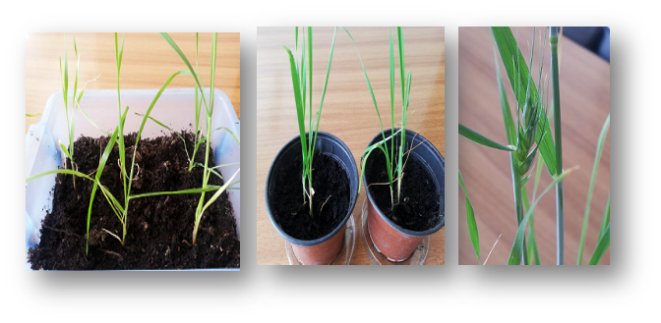
Figure 2. Wheat plants grown normally after transferred in the soil
Recent Publications
- Hamid K, Sadaf K (2014) Study of Plant Tissue Culture Technology: J. Biol. Chem. Research 31(2): 1236-1244.
- Mahmood I, Razzaq A, Khan Z.U (2012) Evaluation of tissue culture responses of promising wheat (Triticum awstivum L.) cultivars and development of efficient regeneration system: Pak. J. Bot., 44(1): 277-284.
- Raziuddin J, Bakht , Swati A, Shafi M, Ullah F, Akmal M (2010) Effect of cultivars and culture medium on callus formation and plant regeneration from mature embryos of wheat (Triticum aestivum L.): Pak. J. Bot., 42(1): 639-652.
- Schulze J (2007) Improvements in Cereal Tissue Culture by Thidiazuron: Review. Fruit, Vegetable and Cereal Science and Biotechnology. Global Science Books: 70.
5. Yu Y.J. W, Zhu M.L, Wei Z.M (2008) Optimization of mature embryo-based high frequency callus induction and plant regeneration from elite wheat cultivars grown in China: Plant Breed 1-7.

Biography
Doriana (Bode) Xhulaj is a researcher at Institute of Plant Genetic Resources, part of Agricultural University of Tirana, Albania. She has a doctorate degree in Plant Biology Conservation from the Faculty of Natural Science of Tirana, and is author of several papers in this field. Currently is involved in different project on plant breeding program.
Email: d.xhulaj@yahoo.com Contact No: 0355692172731

Notes/Comments:

