SHELF LIFE INCREMENT OF FOOD BY GAMMA IRRADIATION IN AGRICULTURE PRODUCTION (Review Paper)
Navita, PhD research scholar in Physics department, GBPUAT Pantnagar India
Sushma Tamta, PhD research scholar in SWCE department, GBPUAT Pantnagar, India
Bhawna Pandey, Assistant Professor, GBPUAT Pantnagar, India

Abstract (300 word limit)

Within the past decade, food safety has been an increasing concern for consumers, retailers and all production and processing areas of the food industry. Food safety is also of crucial importance to a nation’s economy and health system. In modern society, irradiation is routinely used to sterilize medical equipment, including most of the disposable items used in hospitals every day. Nor is irradiation of food itself a new development. FDA has approved irradiation of food for limited purposes since 1963, and NASA has used irradiated food on its space missions for decades as a precaution against foodborne pathogens. But it is only within the last 20 years that irradiation has been approved for the types of usage that would have a substantial impact of the presence of foodborne pathogens. During storage, food may undergo chemicals biological and physical deteriorative reaction that cause changes in food color, appearance and flavor, significantly impacting the overall quality and consumer acceptability of food. Food irradiation is the treatment of food by a certain type of energy. The process involves exposing the food, either package or in bulk, to carefully controlled amount of ionizing radiation for a specific time to achieve certain desirable objectives. Scientists have data from direct observation of the food products themselves, as well as theoretical analyses and experimental verification through animal testing. Antaryami Singh et al. in 2016 used Gamma rays to increase the shelf life of tomatoes and concluded that irradiation at 0.75-1.0 kGy can improve the shelf life of tomatoes without adverse effects on quality and sensory attributes. And there are so many scientists who has already worked in this area and found that gamma radiation has a significant role in the shelf life increment of food for increase agricultural production.

Image

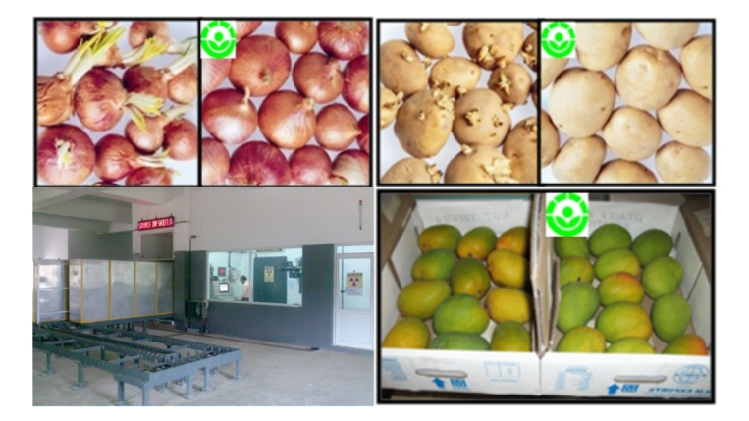

Effect of gamma radiation in Agriculture
Recent Publications (minimum 5)
1.Antaryami Singh, Durgeshwer Singh, Rita Singh 2016. Shelf Life Extension of Tomatoes by Gamma Radiation. Radiation Science and Technology. Vol. 2, No. 2, pp. 17-24.
2.Majeed, A., Muhammad, Z., Majid, A., Shah, A.H. and Hussain, M., 2014. Impact of low doses of gamma irradiation on shelf life and chemical quality of strawberry (Fragaria x ananassa) cv.‘Corona’. Journal of Animal and Plant Sciences, 24(5), pp.1531-1536.
3.Prejean, J., 2001. Food Irradiation: Why Aren't We Using It?

4.Zaman, W., Paul, D., Alam, K., Ibrahim, M. and Hassan, P., 2007. Shelf life extension of banana (Musa sapientum) by gamma radiation. Journal of Bio-Science, 15, pp.47-53.
5.http://moreira.tamu.edu/BAEN625/TOC_files/foodirradiation.pdf

Email: navitakanyal@gmail.com Contact No: 8859261678

