Sewage water effects on Okra (Abelmoschus esculentus) growth affected by organic matter, and Pseudomonas fluorescens
Abdul Khalil Gardezi PhD, Postgraduate College, Mexico Sergio R. Marquez-Berber PhD, Chapingo Autonomous University, Mexico
Hector Flores-Magdaleno PhD, Postgraduate College, Mexico
Gabriel Haro Aguilar MSc, Postgraduate College, Mexico
Eduardo Valdes-Velarde PhD, Chapingo Autonomous University, Mexico
Miguel J. Escalona-Maurice PhD, Postgraduate College, Mexico
Mario U. Larque-Saavedra MSc, Metropolitan Autonomous University, Mexico

Abstract
Statement of the Problem: Okra (Abelmoschus esculentus) is a tropical crop, member of the Malvaceae family. Its fruits are grown and widely used in many countries of Asia and Africa. India is the main producer. It is cultivated in Mexico in small plots with scarce know-how. A sustainable and low-cost technology is needed to increase the profits of the farmers. Pseudomonas fluorecens have been used to increase germination and for biological control of pathogenic fungus. Materials & Methods: The study was done under greenhouse conditions. Two soils were used. One came from a parcel irrigated with sewage water and the other one was irrigated with clean water from a well. Half of the treatments were inoculated with Pseudomonas fluorecens. Four doses of vermicompost were applied as a source of organic matter. Findings: There were significant differences (p≤0.05) in most variables recorded due to the treatments. The soil irrigated with contaminated water only affected root length and fruit number. The plants inoculated with Pseudomonas fluorescens had better shoot and root growth, and fruit number, but it had no effect on fruit weight (p≤0.05). Vermicompost, as source of organic matter, also had a positive effect on Okra growth. Fruit number, and their dry weight augmented with the application of the lowest quantity of organic matter used (25 t ha⁻¹). Conclusion & Significance: Irrigation with sewage water, inoculation with Pseudomonas fluorescens, and lower quantities of vermicompost can be used to increase the yields of Okra. The use of Pseudomonas fluorescens can help to overcome the negative effects of contaminated waters, and other environmental and biological stresses. Recommendations are made to validate this results under field conditions.

Image
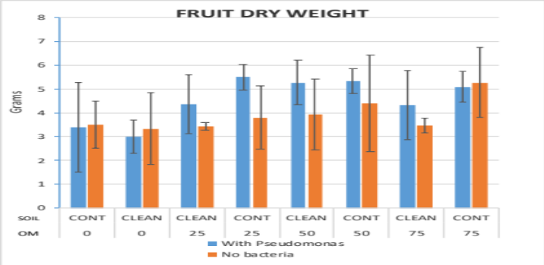
Figure 1. Effect of the inoculation with Pseudomonas fluorescens, soil contamination and organic matter on Okra fruit dry weight.
Recent Publications
- Afzal S, S Tariq, V Sultana, J Ara, and S Ehteshamul-Haque (2013) Managing the root diseases of okra with endo-root plant growth promoting Pseudomonas and Trichoderma viride associated with healthy okra roots. Pak. J. Bot., 45(4): 1455-1460.
- Adesemoye A O, M Obini, E O Ugoji (2008) Comparison of plant growth-promotion with Pseudomonas aeruginosa and Bacillus subtilis in three vegetables. Brazilian Journal of Microbiology 39:423-426.
- Darake M S (2015) Effect of inoculation of VAM fungi on enhancement of biomass and yield in Okra. IJSET 2 (8): 859-865.
- Senthilkumar T, Ramakrishnan S (2004) Studies on Compatibility of Pseudomonas fluorescens, Trichoderma viride and Carbofuran 3G and Their Influences on Meloidogyne incognita in Okra. Annals of Plant Protection Sciences, 12(1): 140-142.
5. Shafique H A, R Noreen, V Sultana, J Ara and S Ehteshamul-Haque (2015) Effect of endophytic Pseudomonas aeruginosa and Trichoderma harzianum on soil-borne diseases, mycorrhizae and induction of systemic resistance in okra grown in soil amended with Vernonia anthelmintica (L.) seed’s powder. Pak. J. Bot., 47(6): 2421-2426.

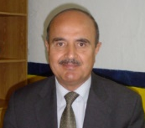Biography
Dr Abdul Khalil Gardezi is a distinguished scientist and academic member of the Hydro Science Center, Postgraduate College in Agriculture Science in Mexico, since 1981. He has received distinctions for teaching, research and service from 1988 until 2017. He has been selected for the originality of his research, presented as the best paper and oral presentation from 2003 to 2017 in international congresses in Australia, Canada. China, Great Britain, Italy, Mexico and USA. He has published more than 190 papers national and internationally. He has been honored among 2000 outstanding intellectuals of the 21st century by the International Biographical Center Cambridge, England.
Email: kabdul@colpos.mx Contact No: +525959313805

Notes/Comments:

