Physical and Mechanical Behavior of various Timbers Species for Agriculture utility from different localities of Uttarakhand, India for Doubling Farmers’ income
Annu Rani, Ph.D scholar, Dept. of Farm machinery and power engineering, GBPUAT Pantnagar, Uttarakhand, India
Jayant Singh, Professor, Dept. of Farm machinery and power engineering, GBPUAT Pantnagar, Uttarakhand, India

Abstract
This study was conducted to determine the effect of Physical and Mechanical Behavior of various Timbers Species for Agriculture utility from different localities of Uttarakhand, India for Doubling Farmers’ income. Ten timber species namely Teak, Sal, Mango, Yellow teak, JavaPulm, Margosa, Eucalyptus, Lebbeck, Red cedar and North Indian rosewood were tested for density, Water absorption and thickness swelling test compressive, tensile bending, hardness and impact strength following ASTM and IS standards. Wood is light weighted, durable and economical. Various samples have been prepared in different proportion considering different properties of wood thereafter tested for different physical and Mechanical properties and compare which one has best strength sample among the all sample. Wood is a natural polymer and its molecular structure is established on the cellulose chain whose cell wall comprises cellulose fibers which were laterally arranged to its axis. The test results revealed that Sal, Teak and North Indian rosewood were the best species of using as compression member while Sal and North Indian rosewod showed the best performance in tension. In static bending Sal, North Indian rosewood, Teak and Javapulm have been found suitable. The test of selected wood species shows that strength of a timber depends on its species and hence different wood species have different strength characteristics. The results obtained in this study has provided quantitative information on the physical and mechanical properties of selected timber species which can be used in determining the application of these wood for Agricultural implements as well as tools or for other purposes such as the manufacture of furniture and the observations made in this study suggest that for a particular work and in a particular environment timber should be used accordingly to their properties in order to obtain fuller benefits and better services.

Image

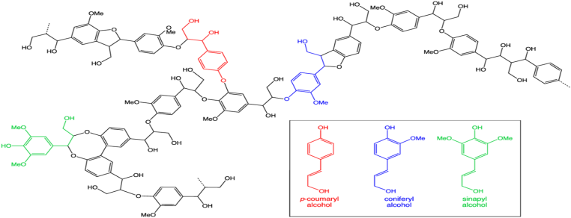
Figure 1: Chemical structure of lignin, which comprises approximately 30% of wood and is responsible for many of its properties
Recent Publications
ASTM D256 (1992) Standard test methods for determining impact strength the Izod pendulum impact.

ASTM D1037 (1999) Standard test methods for evaluating properties of wood-base fiber and particle panel materials.

ISI (Indian Standards Institution) (1986) Indian standards method of testing small clear specimens of timber. IS: 1708, Bureau of Indian Standards (BIS), New Delhi. 36, 6-10.
M. Bella, Hossain, A.S.M. Abdul Awal (2012) Mechanical properties and durability of some selected timber species”. Malaysian Journal of Civil Engineering, 24:67-84

Shanavas, Kumar, B.M. (2006) Physical and Mechanical properties of three agro forestry tree species from Kerala, India”. Journal of Tropical Agriculture, 44: 23-30.

Biography
Annu Rani Researcher scholar at Govind Ballabh Pant University Agiculture and Technology. Pantnagar which is first Agriculture University. She earned her M.Tech. Degree in Agricultural Engineering from, Govind Ballabh Pant University Agriculture and Technology.Pantnagar (U.K) in July 2016. She took admission in Ph.D program in Department of Farm Machinery and Power Engineering, College of Technology, G.B.P.U.A.T. Pantnagar in July 2017.
Email: annuchaudhary39@gmail.comContact No: 9756521753

