Evaporation estimation in hilly area by Multiple Linear Regression, Artificial Neural Network and Co-active Neuro Fuzzy Inference system based models

Sushma Tamta, PhD Scholar, Department of SWCE (Agricultural Engineering) GBPUA & T Pantnagar, Uttarakhna, India
P. S. Kashyap, Associate Professor, Department of SWCE, GBPUA & T Pantnagar, Uttarakhna, India
Pankaj Kumar, Assistant Professor, Department of SWCE, GBPUA& T Pantnagar, Uttarakhna, India

Abstract
Evaporation is the process by which liquid water is converted into the water vapor and removed from the evaporating surface by using solar radiation. It is essential component of hydrological cycle. Evaporation refers to water losses from the surface of a water body. Precise estimation of evaporation is crucial for the management of water resources, irrigation and water balance and soil conversation. It is also used to estimate potential or reference evapotranspiration. Evaporation is the most difficult and complicated parameter to estimate among all component of the hydrological cycle. In present study the Multiple Linear Regression (MLR), Artificial Neural Network (ANN) and Co-Active Neuro Fuzzy Inference System (CANFIS) models were developed for estimating evaporation. The data set consisted of four years of daily records from 2010 to 2013. The daily data of temperature, relative humidity, wind speed, sunshine hour were used as input and the evaporation was used as the output. For estimation of evaporation 70% data was used for training and 30% for testing of models. ANN and CANFIS were used for designing of models based on activation function; Sigmoid Axon and Tanh Axon and learning rule; Levenberg Marquardt and delta bar delta with 1000 number of epochs, three hidden layers (1, 2, 3) with 1, 2, 3...8 neuron in each hidden layers. Generalized Bell shaped membership function was used in CANFIS. The performance of MLR, ANN and CANFIS models was compared on the basis of statistical functions such as RMSE, R2, and CE. The results indicate that the ANN performed superior to the MLR and CANFIS. It was concluded that the ANN model can be successfully employed for the estimate on of daily evaporation at Hawalbagh, Almora, Uttarakhand (India).
Image
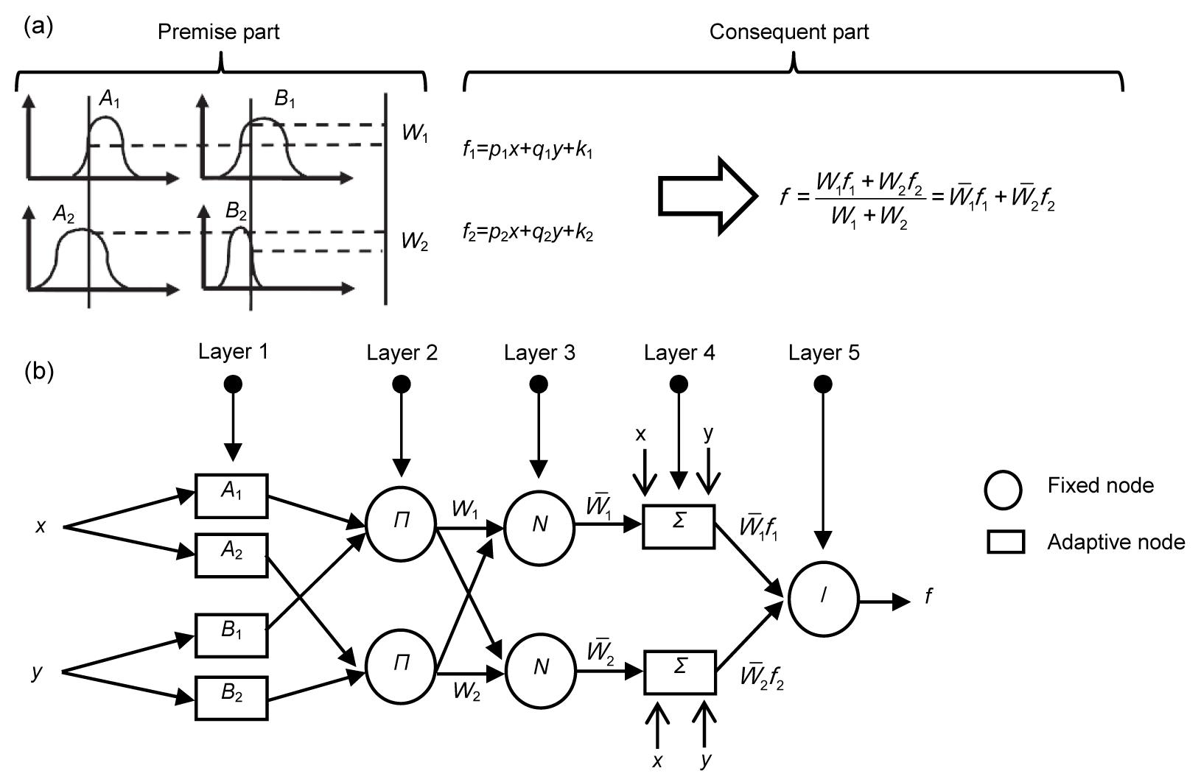
Fig.1 Architecture of CANFIS

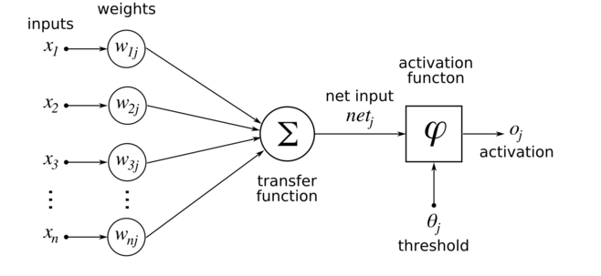
Fig. 2 Graphical presentation of ANN

Publications
- Dogan E, Gumrukcuoglu M, Sandalci M, Opan M (2010) Modelling of evaporation from the reservoir of Yuvacik dam using adaptive neuro-fuzzy inference systems. Eng. Appl. Artif.Intell.23: 961-967.
- Kisi O (2006) Daily pan evaporation modelling using a neuro-fuzzy computing technique. Journal of Hydrology, 329: 636– 646.
- Keskin M E, & Terzi O (2006) Artificial neural network models of daily pan evaporation. Journal of Hydrologic Engineering, 11: 65-70.
- Singh, A Jain, V K Dutta J (2012) Comparison of artificial neural network models and regression model for prediction of evaporation for Malwa region of Madhya Pradesh in India. International Agricultural Engineering Journal, 21: 96-104.
- Sanikhani H, Kisi O, Nikpour M R, Dinpashoh Y (2012) Estimation of daily pan evaporation using two different adaptive neuro-fuzzy computing techniques. Water resources management, 26: 4347-4365.
- Terzi O, Kayser M, & Keskin M E (2009) Evaporation Modeling for Lake Eğirdir Using Artificial Neural Networks Approach. INISTA 2009, 257.


Biography
Sushma Tamta, Research Scholar at Govind Ballabh Pant University of Agricultural and Technology, Pantnagar, Uttarakhand (India), which is India’s first Agricultural university. She completed Master degree from G.B. Pant University of Agriculture and Technology, Pantnagar, in 2015 with major in Soil and Water Conservation Engineering. She is doing research work on Effects of plant roots and shoots characteristics on runoff and sediment outflow under simulated rainfall conditions.

Email: sushmatamta91@gmail.com Contact No: 9458960977

