Identification and diversity of the causal organism of shot hole disease of stone fruits in Korea
Chang-Gi Back, PhD, NIHHS, South Korea
Mi-Jeong Park, PhD, NIHHS, South Korea
Jong-Han Park, PhD, NIHHS, South Korea

Abstract (300 word limit)
Various stone fruits such as peach, plum, apricot, Japanese apricot, cherry and plumcot are widely cultivated in South Korea. The cultivation areas of these stone fruits are increasing every year. In South Korea, bacterial shot hole disease caused by Xanthomonas arboricola pv. pruni is a major and destructive plant disease in stone fruit cultivation areas(Fgure 1). The symptoms of shot hole disease appear as water-soaked spots and these spots turns into small black spots. Eventually, the spot areas turn brown and shot holes appear. In this study, shot hole symptoms on leaves and black spots on fruits were observed in stone fruits such as peach, plum, apricot, and cherry cultivated in Naju, Yeongcheon, Yeonggi, Janghowon and Wanju, Korea. We isolated the pathogenic bacteria and determined the cause of shot hole and black spot in stone fruits and identified the causal agent. Over 20 isolates were obtained from diseased fruits and leaves of stone fruit trees. These isolates were tested for pathogenicity on host plants and analyzed using molecular markers as partial of 16S rDNA gene and gyrase b gene. All isolates exhibited water-soaked symptoms on leaves within 3-5 days after inoculation. The artificially inoculated areas turned into brown spots and appeared as shot hole symptoms. So, these isolates were identified as the causal agents of the shot hole disease in the stone fruits. The molecular markers were sequenced and phylogenetic trees were constructed. All isolates were identified as Xanthomonas arboricola pv. pruni. In addition, all isolates were clustered in the same clade, which suggests that the Korean isolates of bacterial shot hole pathogens are similar to each other. The identification of the causal organism of shot hole disease in stone fruits in Korea will help in the implementation of proper prevention and control methods which may lead to increased production.

Image

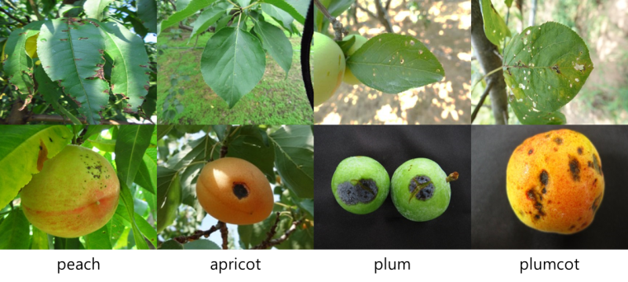
Figure 1. Shot hole disease caused by Xanthomonas arboricola pv. pruni
in various stone fruits
Recent Publications (minimum 5)
- Back C-G, Hwang S-K, Park M-J, Kwon Y-S, Jung H-Y, Park J-H (2017) Phylogenetic analysis of downy mildew caused by Peronospora destructor and a method of detection by PCR. The Korean Journal of Mycology 45:386-393.
- Back C-G, Park M-J, You Y-H, Yi P-H, Han K-S, Park J-H, Kim H-G, Lee Y-S (2016) First report of bacterial black spot disease in cucumber caused by Acidovorax konjaci in Korea. Plant Disease 100:1492.
- Back C-G, Lee S-Y, Lee B-J, Yea M-C, Kim S-M, Kang I-K, Cha J-S, Jung H-Y (2015) Development of a species-specific PCR assay for three Xanthomonas species, causing bulb and flower diseases, based on their genome sequences. Plant Pathology Journal 31:1-7.
- Back C-G, Lee S-Y, Kang I-K, Yoon T-M, Jung H-Y (2015) Occurrence and analysis of apple blotch-like symptoms on apple leaves. Korean Journal of Horticultural Science & Technology 33:429-434.
5. Back C-G, Jung H-Y (2014) Biological characterization of Marssonina coronaria infecting apple trees in Korea. The Korean Journal of Mycology 42:183-190.

 Biography (150 word limit)
Dr. Chang-Gi Back graduated from Kyungpook National University in South Korea. He worked on fruit fungal pathogen, Marssonina coronaria causing apple blotch disease in his PhD.. Currently, he works in the National Institute of Horticultural and Herbal Science, a branch of the Rural Development Administration of Korea. His current research focuses on the development of detection methods and environmental friendly control methods for fruit fungal pathogens. His research project is ‘Development of technique to improve control efficiency for major disease and pests occurring on stone fruit trees’.
Email: plantdoctor7@korea.kr Contact No: +82-10-2363-4250

Notes/Comments:

