Effects of high temperature stress on active oxygen metabolism, anthocyanin contents and its synthase of eggplant peel
CHA Dingshi, Professor, Shanghai Academy of Agricultural Sciences, China
WU Xuexia, Professor, Shanghai Academy of Agricultural Sciences, China
ZHANG Yongping，Associate Professor, Shanghai Academy of Agricultural Sciences, China
CHEN Youyuan, Professor, Shanghai Academy of Agricultural Sciences, China

Abstract：
This paper studied the effects of high temperature stress (HT) on the active oxygen metabolism, anthocyanin contents and its synthase of the eggplant (Tewangda) seedlings. The results showed that HT could increase the malonadehyd (MDA) contents, superoxide radica production rate (O₂•¯) and hydrogen peroxide (H₂O₂) contents, the activities of superoxide radical (SOD), perxidase (POD), catalase (CAT) and ascorbate peroxidase (APX), contents of proline and soluble protein. And HT could decrease the anthocyanin contents, CHS, DFR, ANS and 3GT activities, while increase the PAL activity. The above results illustrated that HT could increase the reactive oxygen species, raise the antioxidative enzyme activities and osmotic adjustment substance, and decrease anthocyanin contents and its synthase to alleviate the damage of high temperature stress to the eggplant peels.
Image
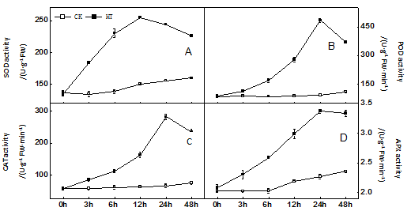
Fig.1 Effects of high temperature stress on the activities of SOD, POD, CAT and APX of eggplant peel

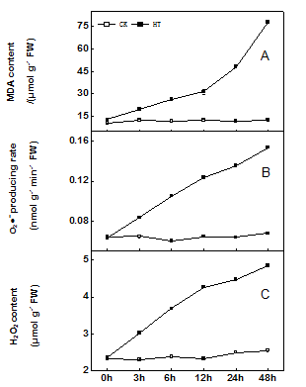
Fig.2 Effects of high temperature stress on the MDA content, O₂•¯ producing rate and H₂O₂ content of eggplant peel
D
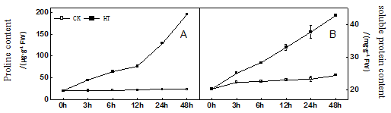
Fig.3 Effects of high temperature stress on the contents of proline and soluble protein of eggplant peel
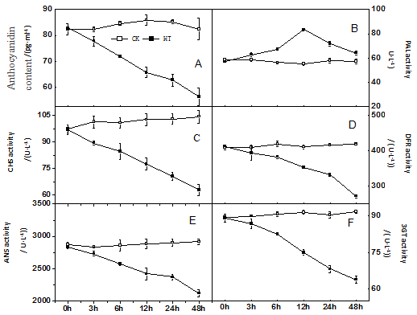
Fig.4 Effects of high temperature stress on the contents of anthocyanidin and anthocyanidin synthase
of eggplant peel

Recent Publications
- Bartwal A, Mall R, Lohani P, et al (2012) Role of secondary metabolites and brassinosteroids in plant defense against environmental stresses. J Plant Growth Regul 32: 216–232
- Janeczko A, Oklestkova J, Pociecha E, et al (2011) Physiological effects and transport of 24-epibrassinolide in heat-stressed barley. Acta Physiol Plant 33: 1249–1259
- Fang HH, Jing T, Liu ZQ, et al (2014) Hydrogen sulfide interacts with calcium signaling to enhance the chromium tolerance in Setaria italic. Cell Calcium 56: 472–481
- Sun N, Wu Q, Liu YY, et al (2014) Hydrogen-rich water reestablishes ROS homeostasis but exerts differential effects on anthocyanin synthesis in two varieties of radish sprouts under UV-A irradiation [J]. Journal of Agricultural and Food Chemistry 62: 6454–6462
- Huh E J, Shin H K, Choi S Y, et al (2008) Thermo susceptible developmental stage in anthocyanin accumulation and color response to high temperature in red chrysanthemum cultivars. Korean Journal of Horticultural Science & Technology 26: 357–361

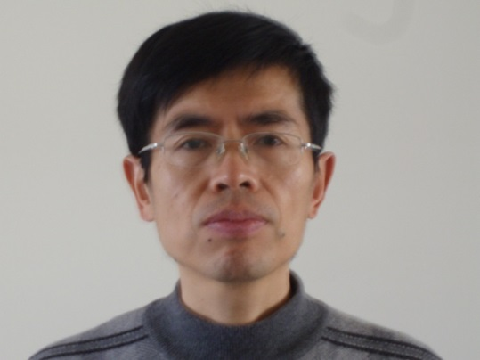

CHA Dingshi has working on Shanghai Academy of Agricultural Sciences since 1984. Now he has his expertise in eggplant cultivation and breeding. He has chosen 5 eggplant varieties that have large area.
Email: dingshizha@aliyun.com Contact No: 13764156765

