Biochemical mechanisms of insecticide resistance to dimethoate in cabbage aphid, Brevicoryne brassicae L. (Hemiptera. : Aphididae) in five regions of Iran
Kimia hamedani Raja ¹, *Azam Mikani ¹, and Hadi Mosallanejad². 1. Department of Entomology, Faculty of Agriculture, Tarbiat Modares University, P. O. Box 14115-336, Tehran, Iran. 2. Iranian Research Institute of Plant Protection, Tehran, Iran Deanna L Mulvihill, RN PhD, TLI Foundation, USA

Abstract (300 word limit)
Statement of the Problem: Cabbage aphid Brevicoryne brassicae is an important pest of crucifers in Iran and is controlled mainly with dimethoate. Some populations of B. brassicae have become resistant to dimethoate due to intensive use of this insecticide. Up to now, there is no information about the mechanisms of resistance in B. brassicae populations to this insecticide which can help to resistance management of this serious pest. Methodology & Theoretical Orientation: The toxicity of dimethoate in five populations of the pest from different provinces was assayed using insect-dip method. The synergistic effects of triphenyl phosphate (TPP), piperonyl butoxide (PBO) and diethyl maleate (DEM) were evaluated on the most resistant and the susceptible population to find the involvement of esterases, mixed function oxidases and glutathione S-transferases (GSTs) in resistance mechanisms, respectively. In order to determine esterase, GSTs, and cytochrome P450 monooxygenase activities the methods of Asperen (1962),Van Habig et al. (1976) and De Sousa et al. (1995) were used respectively. Findings: The bioassay results showed significant difference in susceptibility to dimethoate among the populations. Resistance ratio of the populations to the susceptible population ranged from 2.1 to 12.2. The level of resistance to dimethoate in the resistant population was suppressed by TPP, PBO and DEM, suggesting that the resistance to dimethoate is caused by detoxification enzymes mainly by mixed function oxidases. Up to 2.5, 3.6 and 10.5-fold increase in esterase, GSTs and cytochrome P450 monooxygenases activities in resistant strains compared with the susceptible one was observed respectively. Conclusion & Significance: Biochemical enzyme assays showed that GSTs, esterase and cytochrome P450 monooxygenase activities in the resistant population was clearly higher than that in the susceptible one. This data help us to detect the mechanisms involved in resistance of B. brassicae to dimethoate and subsequently resistance management of this important pest.

Image
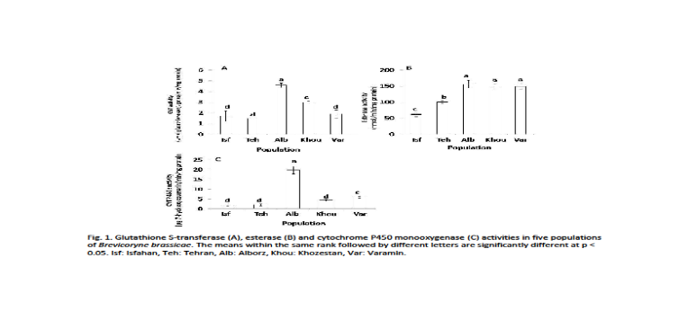Recent Publications (minimum 5)
- H Mikani A, Wang QS, Takeda M (2012) Brain-midgut short neuropeptide F mechanism that inhibits digestive activity of the Ametican cockroach, Periplaneta americana upon starvation. Peptides 34: 135-144.
- Mikani A, Watari Y, Takeda M (2015) Brain-midgut cross-talk and autocrine metabolastat via the sNPF/CCAP negative feedback loop in the American cockroach, Periplaneta americana. Cell and Tissue Research 362: 481-496.
- Saeidi F, Moharramipour S, Mikani A (2017) Rapid Cold Hardening Capacity and Its Impact on Performance of Russian Wheat Aphid (Hemiptera: Aphididae). Environmental Entomology 46: 954–959.
- Mohammadi Gisour V, Mikani A, Moharramipour S (2017) Effect of Silybum marianum methanolic extract on nutritional indices, crustacean cardioactive peptide, á-amylase and protease activities of Helicoverpa armigera (Lep.: Noctuidae). Journal of Entomological Society of Iran 37: 169-180.
- Saeidi F, Moharramipour S, Mikani A (2017) Effect of cold acclimation and rapid cold hardiness on cold tolerance and cryoprotectants of the greenbug Schizaphis graminum(Hemiptera: Aphididae). Journal of Entomological Society of Iran 37: 193-205.

Biography (150 word limit)
Azam Mikani has her expertise in entomology and crop protection. Her researches are about mechanism of insecticide resistance. She also investigate about the effect of biopesticides, insect growth regulators (IGRs) and neuropeptides and their potential application for controlling pests.
Email: a.mikani@modares.ac.ir Contact No: 00989128068494.

Notes/Comments:

