Biochemical mechanisms of insecticide resistance to fenvalerate in diamondback moth, Plutella xylostella L. (Lep. : Plutellidae) in four regions of Iran.

Zahra Sayani¹, Azam Mikani ^{*1}, Hadi Mosalanejad ²,
1 Department of Entomology, Faculty of Agriculture, Tarbiat Modares University, P. O. Box 14115-336, Tehran, Iran
2 Iranian Research Institute of Plant Protection, Tehran, Iran

Abstract (300 word limit)

Statement of the Problem: Plutella xylostella is the most important pest of cruciferous crops in Iran and is controlled almost by pyrethroids including fenvalerate. Intensive use of this insecticide caused some population of P. xylostella become resistant. Therefore, understanding of biochemical mechanisms of fenvalerate and subsequently resistance management of this pest seem to be important. Methodology & Theoretical Orientation: The toxicity of fenvalerate in four populations was determined using leaf dipping bioassay. Synergist experiments was conducted using piperonyl butoxide (PBO), diethyl maleate (DEM) and triphenyl phosphate (TPP) to determine whether mixed function oxidases, glutathione S-transferases (GST) and esterases were involved in resistance mechanisms, respectively. In order to determine GST, cytochrome P450 monooxygenase and esterase activities the methods of Van Habig et al. (1976), De Sousa et al. (1995) and Asperen (1962) were used with some modification, respectively. The real-time quantitative PCR (q RT PCR) was conducted to show the expression level of GST. Findings: The bioassay results showed significant difference in susceptibility to fenvalerate among the populations. Resistance ratio of different populations to the susceptible one ranged from 2.5 to 8.5. The level of resistance to insecticide was suppressed by PBO, DEM and TPP which confirmed that resistance to fenvalerate is mainly caused by detoxification enzymes. Up to 8.6, 2.08 and 1.75-fold increase in GST, esterase and cytochrome P450 monooxygenases activities in resistant strains compared with the susceptible one were observed respectively. The changes in P. xyllostella GST gene expression levels exposed to fenvalerate was observed. Conclusion & Significance: Overall, the mechanisms of insecticide resistance in dimondback moth populations in four regions in Iran were related to GST, esterase and cytochrome P450 monooxygenases. This data help us to detect the mechanisms involved in resistance of P. xyllostella to fenvalerate and subsequently management of this important pest.

Image
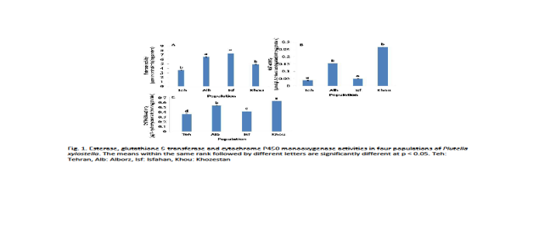
Recent Publications (minimum 5)
- Mikani A, Wang QS, Takeda M (2012) Brain-midgut short neuropeptide F mechanism that inhibits digestive activity of the Ametican cockroach, Periplaneta americana upon starvation. Peptides 34: 135-144.
- Mikani A, Watari Y, Takeda M (2015) Brain-midgut cross-talk and autocrine metabolastat via the sNPF/CCAP negative feedback loop in the American cockroach, Periplaneta americana. Cell and Tissue Research 362: 481-496.
- Saeidi F, Moharramipour S, Mikani A (2017) Rapid Cold Hardening Capacity and Its Impact on Performance of Russian Wheat Aphid (Hemiptera: Aphididae). Environmental Entomology 46: 954–959.
- Mohammadi Gisour V, Mikani A, Moharramipour S (2017) Effect of Silybum marianum methanolic extract on nutritional indices, crustacean cardioactive peptide, á-amylase and protease activities of Helicoverpa armigera (Lep.: Noctuidae). Journal of Entomological Society of Iran 37: 169-180.
- Saeidi F, Moharramipour S, Mikani A (2017) Effect of cold acclimation and rapid cold hardiness on cold tolerance and cryoprotectants of the greenbug Schizaphis graminum(Hemiptera: Aphididae). Journal of Entomological Society of Iran 37: 193-205.

Biography (150 word limit)
Azam Mikani has her expertise in entomology and crop protection. Her researches are about mechanism of insecticide resistance. She also investigate about the effect of biopesticides, insect growth regulators (IGRs) and neuropeptides and their potential application for controlling pests.
Email: a.mikani@modares.ac.ir Contact No: 00989128068494
.

Notes/Comments:

