Effects of fenoxycarb on female reproduction in the cotton bollworm, Helicoverpa armigera (H.) (Lepidoptera: Noctuidae)
Abouzar Izadpanah, *Azam Mikani, and Saied Moharramipour, Department of Entomology, Faculty of Agriculture, Tarbiat Modares University, P. O. Box 14115-336, Tehran, Iran

Abstract
Statement of the Problem: The cotton bollworm, Helicoverpa armigera (Hübner) (Lepidoptera: Noctuidae), is a rapidly reproducing pest that damages several crops and causes economic losses in many countries. Insecticides are the first means of controlling H. armigera but they have harmful effects on the environment and human health. Therefore, alternative means such as exogenous hormone analogous are considered. Fenoxycarb is an insect growth regulator (IGR) that mimics the effects of juvenile hormone applications. The purpose of this study is to describe the effects of fenoxycarb at sublethal concentrations on reproduction in H. armigera. Methodology & Theoretical Orientation: The control insects were treated with acetone. Newly emerge females were topically treated with 30, 60 and 120 µg of fenoxycarb to investigate its effects on reproduction. The effect on vitellogenin synthesis in the fat body and vitellogenin titres in the haemolymph were analysed by using real-time polymerase chain reaction (qRT-PCR) and ELISA. Findings: Fenoxycarb downregulated vitellogenin synthesis and reduced vg titres in the haemolymph. Also the expression level of two hormone receptors, ultraspiracle (USP), and the ecdysone receptor (EcR) using qRT-PCR were examined. It was shown that fenoxycarb down-regulated the expression of USP and EcR. The fecundity of treated groups was significantly lower than control. It was found that fenoxycarb decreased egg laying amount. Also oviposition period was shortened by increasing fenoxycarb doses. 30 and 60 μg of fenoxycarb did not have effect on the females’ longevity but a topical application of 120 μg of fenoxycarb significantly shortened the females’ longevity. Conclusion & Significance: We showed that the topical application of fenoxycarb on newly emerged females can reduce reproduction in H. armigera and may be an alternative mean to the use of harmful insecticides for controlling this polyphagous pest.

Image

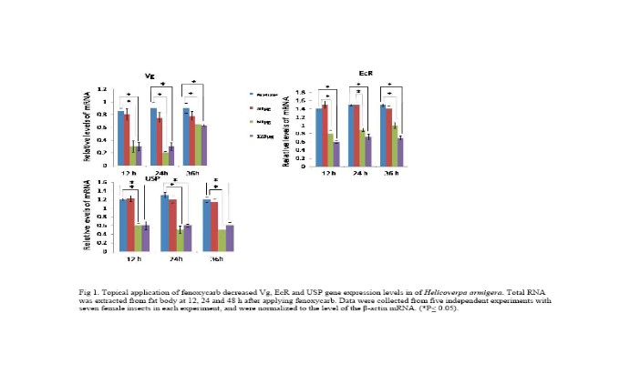
Recent Publications
- Mikani A, Wang QS, Takeda M (2012) Brain-midgut short neuropeptide F mechanism that inhibits digestive activity of the Ametican cockroach, Periplaneta americana upon starvation. Peptides 34: 135-144.
- Mikani A, Watari Y, Takeda M (2015) Brain-midgut cross-talk and autocrine metabolastat via the sNPF/CCAP negative feedback loop in the American cockroach, Periplaneta americana. Cell and Tissue Research 362: 481-496.
- Saeidi F, Moharramipour S, Mikani A (2017) Rapid Cold Hardening Capacity and Its Impact on Performance of Russian Wheat Aphid (Hemiptera: Aphididae). Environmental Entomology 46: 954–959.
- Mohammadi Gisour V, Mikani A, Moharramipour S (2017) Effect of Silybum marianum methanolic extract on nutritional indices, crustacean cardioactive peptide, á-amylase and protease activities of Helicoverpa armigera (Lep.: Noctuidae). Journal of Entomological Society of Iran 37: 169-180.
- Saeidi F, Moharramipour S, Mikani A (2017) Effect of cold acclimation and rapid cold hardiness on cold tolerance and cryoprotectants of the greenbug Schizaphis graminum(Hemiptera: Aphididae). Journal of Entomological Society of Iran 37: 193-205.

Biography (150 word limit)
Azam Mikani has her expertise in entomology and crop protection. Her researches are about the effect of biopesticides, insect growth regulators (IGRs) and neuropeptides and their potential application for controlling pests.
Email: a.mikani@modares.ac.ir Contact No: 00989128068494

Notes/Comment

