The bibliometric based analysis of risk assessment of alien invasive insects from 2007 to 2017
Cong Wang, Agri. Ent M.Sc, Institute of Beneficial Insects,Fujian Agriculture and Forestry University,China
Pumo Cai, Agri. Ent PhD, Institute of Beneficial Insects, Fujian Agriculture and Forestry University, China
Yanchuan Yang, Agri. Ent M.Sc, Institute of Beneficial Insects,Fujian Agriculture and Forestry University,China
Huimin Xia, Agri. Ent M.Sc, Institute of Beneficial Insects,Fujian Agriculture and Forestry University,China
*Jiahua Chen, Prof., Institute of Beneficial Insects,Fujian Agriculture and Forestry University,China

Abstract (300 word limit)
As rapid development of global economic integration, the biological invasion resulted in the severe decrease of global biodiversity and the considerably economic and ecological losses in China. Since insect is a large group of invasive species, the risk assessment of invasive insects have attracted more attention from scientific communities. Based on literatures indexed by the Chinese and English document databases (Web of Science) during 2007-2017, total 885 literatures associated with risk assessment of invasive insects were obtained. The results showed that the number of published papers related to risk assessment of invasive insects is the most in 2014. The journal named ‘Biological Invasions’ has published most papers related to risk assessment of invasive insects among the international journals, while ‘Plant Quarantine’ has published most Chinese articles among the Chinese journals. The number of scientific papers associated with Hymenopteran insects is the most among the international journals, meanwhile the number of scientific papers associated with Coleopteran insects is in majority among the Chinese journals. Nevertheless, the number of papers related to Dipteran insects is most in terms of both Chinese and English journals. Additionally, the numbers of paper related to risk assessment of three invasive insects, such as Linepithema humile, Solenopsis invicta and Bactrocera dorsalis are the most among the English journal. However, the risk assessments of S. invicta, B. dorsalis and Cydia pomonella were implemented most in China over last decade. These results presented objectively research status and orientation on risk assessment of invasive pest over last decade, contribute to providing the reference for establishing effective prevention and control strategies.

Images
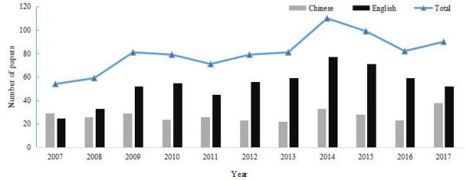
Figure 1. The number of published papers related to risk assessment of exotic invasive insect species during 2007-2017.
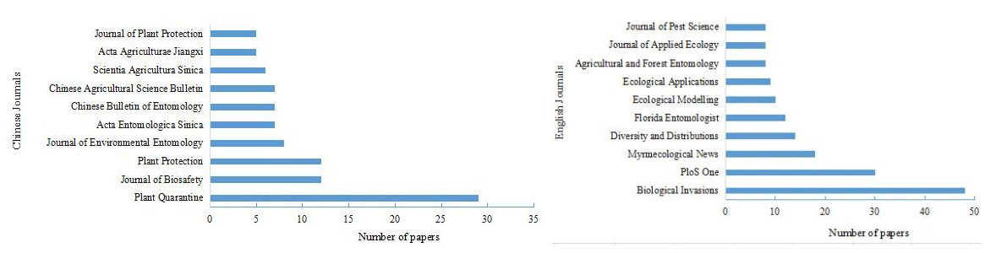
Figure 2. The top 10 journals publishing papers associated with risk assessment of exotic invasive insects species based on Chinese and English bibliographic database during 2007-2017.
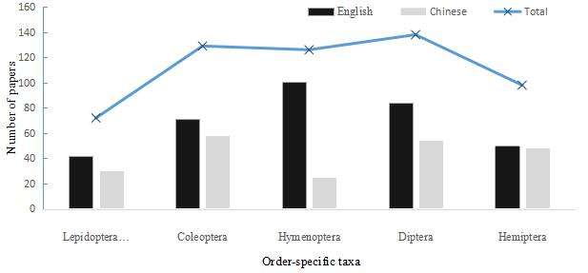
Figure 3. The number of English and Chinese papers related to risk assessment of invasive insect species at different orders.
Recent Publications (minimum 5)
- Chen Y T, Li H, Wang R, et al. (2013). Current status and major progress on the risk analysis of invasive alien insects over last decade. Journal of Biosafety 22(4): 217-228.
- Mesdaghinia A, Younesian M, Nasseri S, et al. (2015). Analysis of the microbial risk assessment studies from 1973 to 2015: a bibliometric case study. Scientometrics 105(1):691-707.
- Mesdaghinia A, Younesian M, Nasseri S, et al. (2015). A bibliometric and trend analysis on the water-related risk assessment studies for Cryptosporidium pathogen. Iranian Journal of Parasitology 10(3): 338-350.
- Zhu F, Du D L. (2013). Research on risk assessment of biological invasion based on literature analysis. Guangdong Agricultural Sciences 40(22): 177-182.
- Wan J, Yang Y F, Peng L, et al. (2017). A bibliometric analysis of research on biological invasions of China and Australia. Journal of Environmental Entomology 39(2): 472-479.

Biography (150 word limit)
Cong Wang has researched the risk assessment of invasive alien pest for two years. The worldwide increase of agricultural trade in economic crops and other plant material, caused increased threats of introduction and establishment of pests, then resulted in the severe decrease of biodiversity and the economic and ecological losses in China. She mainly engaged in the pest risk analysis (PRA), which is a necessary component of plant health policy, minimizing the risk introduction and establishment of new plant pests.
Email: 862538312@qq.com Contact No: 086-15980287558
Notes/Comments:
‘*’ presented that the author was the corresponding author
of this abstract.

