Field survey of Drosophila suzukii and its potential classical biological agents in waxberry orchards from Fujian, China
Pumo Cai, Agri. Ent PhD, Institute of Beneficial Insects, Fujian Agriculture and Forestry University, China
Chuandong, Yi, Agri. Ent M.Sc, Institute of Beneficial Insects,Fujian Agriculture and Forestry University,China
Cong Wang, Agri. Ent M.Sc, Institute of Beneficial Insects,Fujian Agriculture and Forestry University,China
Houjun Xiang, Agri. Ent M.Sc,Institute of Beneficial Insects,Fujian Agriculture and Forestry University,China
Qinge Ji, Prof.,Institute of Beneficial Insects,Fujian Agriculture and Forestry University,China
Jiahua Chen, Prof., Institute of Beneficial Insects,Fujian Agriculture and Forestry University,China

Abstract (300 word limit)
The vinegar fly Drosophila suzukii Matsumura (Diptera: Drosophilidae), spotted wing drosophila (SWD), originally from Southeast Asia, is a relatively new invasive pest in Europe and America attacking a wide range of small and stone fruits. Female D. suzukii possess a highly sclerotized and serrated ovipositor that allows them to successfully infect ripening pre-harvest fruits, unlike most other species of Drosophilidae. The published literature about D. suzukii infesting healthy fruit in China is scarce expect Shandong, Shaanxi and Yunnan province. A specific survey for D. suzukii in four different waxberry (Myrica rubra ) orchards from Fujian province of China during 2017, confirmed that this pest is widespread in these four main berry-producing regions including Fuzhou, Longhai, Changting, Jianyang. During the fruit maturation period, the population dynamics of D. suzukii adults in waxberry orchards from Fuzhou district in 2016 and 2017 was detected. This confirmed that the population peaks of D. suzukii were associated with the maturation of waxberry. The number of D. suzukii catches was highest on middle and late May, when waxberry become ripe. Moreover, potential classical biological agents against D. suzukii, such as parasitoids were detected in homemade traps with SWD-infected bananas suspended in waxberry trees, where traps were placed in four regions mentioned above. Leptopilina japonica females (Hymenoptera: Figitidae) and two species of Alysiinae (Hymenoptera: Braconidae) were collected from Fuzhou and Longhai. Under laboratory conditions, we found that L. japonica can successfully parasitize the D. suzukii larvae, and emerge from D. suzukii pupae. The field survey results demonstrated that L. japonica may be the preponderant parasitoid against D. suzukii in Fujian province of China.

Images
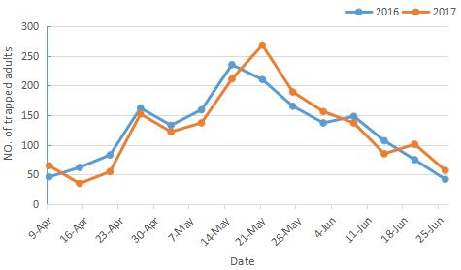
Figure 1. Population dynamics of D. suzukii around waxberry mature stage in Fuzhou, Fujian, 2016-2017.
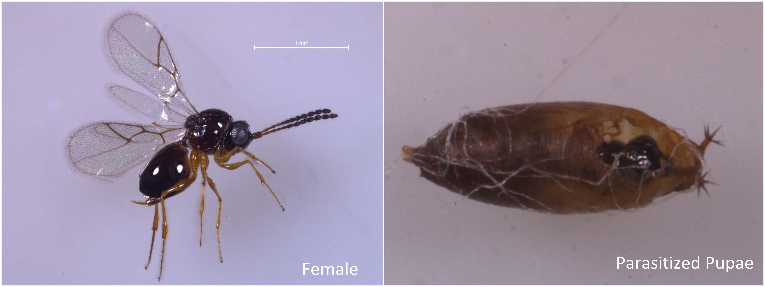
Figure 2. Leptopilina japonica female and parasitized pupae
Recent Publications (minimum 5)
- Matsuura A, Mitsui H, Kimura MT (2017). A preliminary study on distributions and oviposition sites of Drosophila suzukii (Diptera: Drosophilidae) and its parasitoids on wild cherry tree in Tokyo, central Japan. Applied Entomology and Zoology :1-7.
- Antonacci R, Tritto P, Cappucci U, et al. (2017). Drosophilidae monitoring in apulia (Italy) reveals Drosophila suzukii as one of the four most abundant species. Bulletin of Insectology 70(1):139-146.
- Joshi N K, Butler B, Demchak K, et al. (2017). Seasonal occurrence of spotted wing drosophila in various small fruits and berries in Pennsylvania and Maryland. Journal of Applied Entomology 141(1):156-160.
- Antonacci R, Tritto P, Cappucci U, et al. (2017). Drosophilidae monitoring in apulia (Italy) reveals Drosophila suzukii as one of the four most abundant species. Bulletin of Insectology 70(1):139-146.
- Knoll V, Ellenbroek T, Romeis J, et al. (2017). Seasonal and regional presence of hymenopteran parasitoids of Drosophila in Switzerland and their ability to parasitize the invasive Drosophila suzukii. Scientific Reports 7:40697.

Biography (150 word limit)
Pumo Cai has researched the biological control of fruit flies for six years. As the notorious Drosophila suzukii has been reported to have rapidly spread in Europe and America causing significant economic damage to a wide range of fruit, his team started to survey the classical biological agents against D. suzukii in China. Recently, his team found that Leptopilina japonica, were collected from Southern China, can successfully parasitze the D. suzukii under laborotory condition. The field survey of biological control agents against D. suzukii in China where near its origin is ongoing. The exploration of more suitbale natural enemies is of importance to all industries affected by this pest.
Email: caipumo@qq.com Contact No: 086-15080456908

Notes/Comments:

