chinese cabbage production on many kinds and dossages of organic fertilizer in pangalengan, west java, indonesia
Meksy Dianawati, Dr, AIAT West Java, Indonesia
Atin Yulyatin, SP, AIAT West Java, Indonesia
Muhamad P Yufdi, IAARD, Indonesia

Abstract
Pangalengan is a center of vegetables and dairy cows in the province of West Java, Indonesia. Cow dung is generally discharged into waterways and on lands irrigated by the water channels. The low utilization of cow dung in Pangalengan due to breeder do not have time to process cow manure. Therefore, farmers prefer to use chicken manure that is ready to use. Utilization of waste cattle as manure, vermicompost, as well as biogas waste can be an alternative waste processing in situ at the center of a dairy farm Pangalengan, West Java, Indonesia. The purpose of this research was to get the best type and dossage of organic fertilizer that will enhance chinese cabbage production in Pangalengan, West Java. The experiment was conducted in farmers' fields in the village of Pangalengan, West Java from November to December 2014. The study used a randomized completed block design with two treatment factors and three replications. The first factor was six kinds of organic fertilizer, i.e. cow manure, chicken manure, combination of cow and chicken manure (1:1 v/v), vermicompost, wet and dry biogas waste. The second factor was two dossages of organic fertilizer, i.e. 10 and 15 tonner ha⁻¹. The results showed that there was no interaction between kinds and dossage of fertilizer organic. The highest production was on dry biogas waste treatment whose was lowest CN ratio of organic fertilizer, but it was not significantly different from combination of cow and chicken manure treatment and wet biogas waste treatment. It means that the best organic fertilizer was dry biogas, but combinatioan of cow and chicken manure could substitute it. The best dossage of organic fertilizer was 15 tonner ha⁻¹.

Image
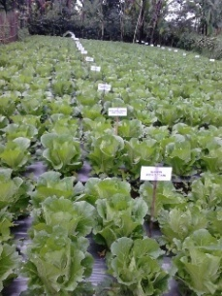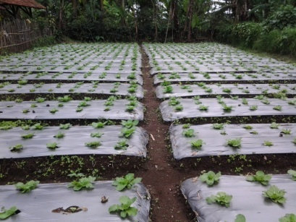
Recent Publications
- Adeniyan N, Ojo O, Akinbode A, Adediran A (2011) Comparative study of different organic manures and NPK fertilizer for improvement of soil chemical properties and dry matter yield of maize in two different soils. J of Soil Scie and Environmental Management 2(1): 9-13.
- Adhikary S (2012) Vermicompost. the story of organic gold: A review. Agricultural Sciences 3(7) : 905-917
- Akhtar S, S Shakeel, A Mehmood, A Hamid, S Saif (2013) Comparative analysis of animal manure for soil conditioning. International J of Agronomy and Plant Production 4 (12): 3360-3365
- Asnawi R, M Mulyanti (2012) Peningkatan produktivitas dan pendapatan petani cabe merah melalui penerapan teknologi pemupukan organik di kabupaten Lampung Selatan. Jurnal Pembangunan Manusia 6 (2)
- Dianawati M (2014) Penggunaan limbah organik biogas sebagai media tanam pada produksi benih kentang (Solanum tuberosum L.) G1. Prosiding Seminar Nasional Pengembangan dan Pemanfaatan IPTEKS untuk Kedaulatan Pangan. Fakultas Pertanian Universitas Gadjah Mada.
- Dikinya O, N Mufwanzala (2010) Chicken manure-enhanced soil fertility and productivity: Effects of application rates. J of Soil Scie Environmental Management 1(3) : 46-54.
- Insam H, M Gomez-Brandon, J Ascher (2015) Manure-based biogas fermentation residues : Friend or foe of soil fertility? Soil Bio & Biochem 84:1-14
- Jannah N, A Patah, Muhtar (2012) Pengaruh pemberian beberapa jenis pupuk kandang dan nutrisi saputra terhadap pertumbuhan dan hasil tomat (Lycopersicum esculentum Mill.) varietas Permata. ZIRAA’AH 35 (3): 169-176
- Nkoa R (2014) Agricultural benefits and environmental risks of soil fertilization with anaerobic digestates: A review. Agron for Sust Dev 34:473-92.
- Nurdiati K, E Handayanta, Lutojo (2012) Efisiensi produksi sapi potong pada musim kemarau di peternakan rakyat daerah pertanian lahan kering Kabupaten Gunungkidul. Tropical Animal Husbandry 1 (1):52-58
- Yang S, Z Zhang, L Cong, X Wang, S Shi (2013) Effect of fulvic acid on the phosphorus availability in acid soil. Journal of Soil Science and Plant Nutrition 13(3) : 526-533
- Zao H, Li Jie, Liu Jing-Jing, Lu Y, Wang X, Cui Z (2013) Microbial community dynamics during biogas slurry and cow manure compost. Journal of Integrative Agriculture 12(6): 1087-1097.

 Biography
Meksy Dianawati is a horticultural researcher in Assessment Institute for Agricultural Technology of West Java, Indonesia. She has expertise in plant physiology and seed production. She also has big concern on friendly technologies including integration of both plant and cattle. Its integration could increase soil fertility, yield, and farmer income. Cattle waste is processed by many methodologies i.e. composting, vermicomposting, and biogas. Her thinking about waste processing is applied on many areas and many vegetables.
Email: meksyd@yahoo.com Contact No: +62812191912065

Notes/Comments:

