Plant Growth and Leaf Morphological Change of Spinacia oleracea Grown under Different Light-emitting Diodes
MyungOk Lee, Department of Agricultural Science, Korea National Open University, Korea
KyungRan Do, National Institute of Horticultural and Herbal Science, Korea
EunYoung Choi, Department of Agricultural Science, Korea National Open University, Korea

Abstract (300 word limit)
This study aimed to determinate effects of light-emitting diodes on leaf morphology and growth of two cultivars (‘World-star’ and ‘Sushiro’) of Spinacia oleracea. Plants were grown for 25 days after transplanting (DAT) under the LEDs (White (W), Red and Blue (RB, ratio 2:1), Blue (B), Red (R) LED) under the same light intensity and photoperiod (130μmol·m⁻²·s⁻¹, 12 hours). Higher fresh and dry leaf weights, leaf number and leaf area were observed in the ‘World-star’ cultivar, in which a 35% increase in leaf dry weight was found in both the RB and R LEDs than the B and W at 25 DAT. In the ‘Sushiro’ cultivar, the leaf dry weight was in the order of RB > R > B > W at 25 DAT. Leaf apinasty symptom was appeared in plants grown under both R and RB LEDS with much more severe degree of symptom under the R LED. Microscope analysis indicates that the cell size of leaf margin region was larger than that in the leaf blade region in the apinasty symptom-developed leaf. The chlorophyll content and photosynthetic activity were lower in the leaves grown under the R LED. All the integrated results suggest that the B or W LED is a proper light condition due to the leaf apinasty symptom for a closed cultivation of Spinacia oleracea.

Image

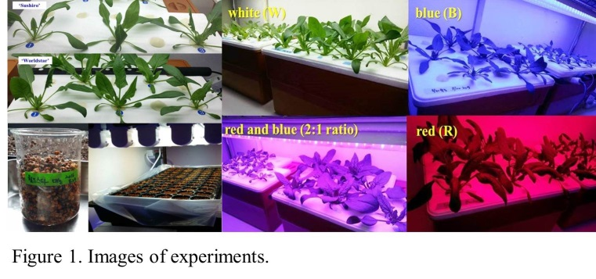
Recent Publications (minimum 5)
- EY Choi, KY Choi and YB Lee (2014) Development of a non-drainage hydroponic system with a coconut coir substrate by a Frequency Domain Refectometry for tomato cultivation. Journal of Plant Nutrition 37(5) 748-764.
- E.Y. Choi, Y.H. Yoon, K.Y. Choi, Y.B. Lee. 2015. Environmentally Sustainable Production of Tomato in a Coir Substrate Hydroponic System using a Frequency Domain Reflectometry Sensor. Hort. Environ. Biotechnol. 56(2) 167-177.
- HJ Yoo, EY Choi, YB Lee (2015) Irrigation Control for Improving Irrigation Efficiency in Coir Substrate Hydroponic System. Protected Horticulture and Plant Factory. 24(3) 153-160.
- KY Choi, EY Choi, IS Kim, and YB Lee (2016) Improving Water and Fertilizer Use Efficiency during the Production of Strawberry in Coir Substrate Hydroponics using a FDR Sensor-Automated Irrigation System. Hortic. Environ. Biotechno. 57(5):431-439.
- EY Choi, YA Jeon, KY Choi, J Stangoulis (2016) Physiological and Morphological Responses to Boron Deficient Chinese Cabbage. Hortic. Environ. Biotechnol. 57(4) 355-363.

Biography (150 word limit)
EunYoung Choi has her expertise in hydroponics, in particular, with automated irrigation system for commercial cultivation of fruit vegetables. Her research was focused on improving irrigation efficiency using a frequency domain reflectometry (FDR) sensor-automated irrigation (FAI) system for hydroponically grown tomato or strawberry. She involved in this project after years of experience in research, and teaching in plant physiology, protected cropping environment and basic horticultural sciences. Recently her study has been also involving in effects of fluorescent light and light-emitting diodes on leaf morphology, growth, and antioxidant capacity of horticultural crops.
Email: ch0097@knou.ac.kr Contact No: 821054377862

Notes/Comments:

