In- vitro antimicrobial properties of carboxymethylcellulose spray coated copper-montmorillonite nanocomposites
Ryan Rienzie MSc, Postgraduate Institute of Agriculture, University of Peradeniya, Peradeniya 20400, Sri Lanka
Nadeesh Madusanka PhD, Center for Advanced Material Research, University of Sri Jayewardenepura, Nugegoda 10250, Sri Lanka
Devika de Costa PhD, Postgraduate Institute of Agriculture, University of Peradeniya, Peradeniya 20400, Sri Lanka

Abstract

Cu²⁺ is one of the major active ingredients which is widely being used in many agricultural biocides due to its relative effectiveness in terms of reduction of inoculum level and lower production cost. However, Cu is known as a heavy metal that pollutes ecosystems, and thereby leading to bioaccumulation. Nanotechnological approaches permit controlled release of active ingredients to retain on the target surface for an extended time and further requires low loading. Erwinia carotovora is a soil borne bacterium that causes soft rot in many cash crops including potato. At present in Sri Lanka, the disease is found to be prevailing in the fields in which the cut tubers are being used as planting material, though not encouraged. In this study, Cu-montmorillonite (Cu-MMT) nanocomposites were prepared and spray coated with carboxymethylcellulose (CMC) at three levels of viscosity (2.5, 5 & 7.5 g/L) as antimicrobial formulations and then characterized using powder X-ray diffraction (PXRD), scanning electron microscopy (SEM) and Fourier transform infrared spectroscopy (FTIR). Furthermore, all three nanocomposites were tested using different weights for their in-vitro antibacterial properties. Accordingly, the PXRD patterns showed a basal value of 1.23 nm which has increased compared to the Na-MMT original nanocomposites used (1.19 nm). SEM images showed that the plate like layered structure is continues to be remaining and FTIR spectra further confirmed the bonding interaction between Cu-MMT and CMC. Nanocomposites coated with CMC with different viscosities were tested using different weights exerted antibacterial activity on E. carotovora at a cell concentration of 2x10⁶ colony forming units /mL, and the level of inhibition was increased with the weight used. When Cu²⁺ ions are intercalated into MMT interlayer space, it enhances slow releasing nature of Cu²⁺ while improving the textural properties while the CMC coating further triggers their slow releasing activity. The outcome of the present study is to be further experimented towards applying as seed/tuber treatments where the problem prevails.

Image
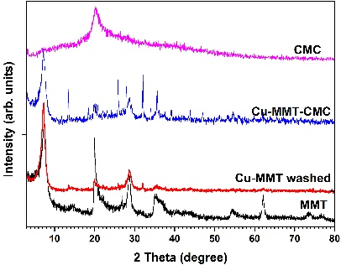  PXRD patterns | 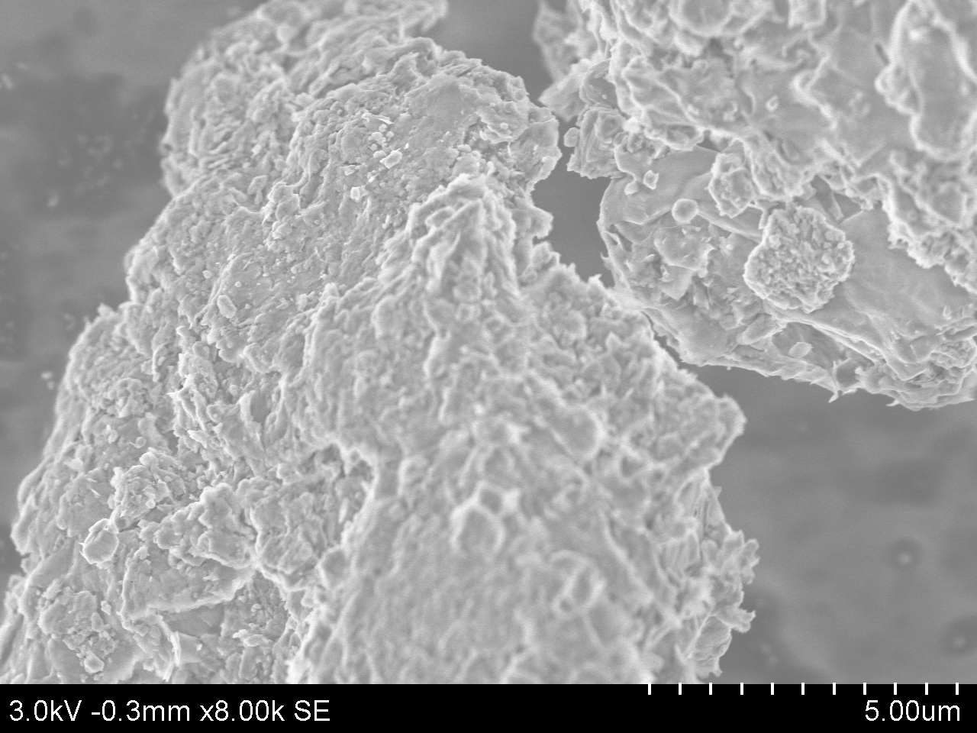  SEM image
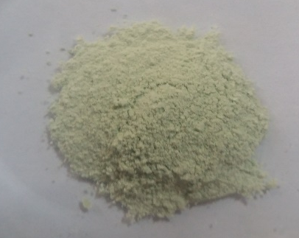  Nanocomposite | 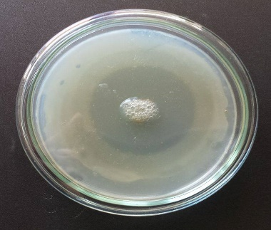  Microbial assay

Recent Publications
- Zhou YH, Xia MS, Ye Y & C.H.Hu (2004) Antimicrobial ability of Cu²⁺⁻montmorillonite. Applied Clay Science 27: 215–218.
- Martucci JF & Ruseckaite RA (2017) Antibacterial activity of gelatin/copper (II)-exchanged montmorillonite films. Food Hydrocolloids 64: 70-77.
- Madusanka N, de Silva KMN, Amaratunga G (2015) A curcumin activated carboxymethyl cellulose–montmorillonite clay nanocomposite having enhanced curcumin release in aqueous media. Carbohydrate Polymers 134: 695-699.
- Hyun SP, & Hayes KF (2015) X-ray absorption spectroscopy study of Cu (II) coordination in the interlayer of montmorillonite”, Applied Clay Science 107:122–130.
- Mills AAS, Platt HWB & Hurta RAR (2006). Sensitivity of Erwinia spp. to salt compounds in vitro and their effect on the development of soft rot in potato tubers in storage. Postharvest Biology & Technology 41: 208–214.



Biography

Ryan Rienzie is a young researcher and academician in the field of plant pathology and pesticide technology. His research focuses on Nanotechnological applications on plant disease control and management. Nanotechnological applications in Sri Lankan agriculture are now been widely experimenting and in such a milieu, the present research would be a milestone in sustainable and controlled release applications of pesticides while providing important insights on possibilities of extending the application into other agricultural applications. The research concept was evolved with the current concerns of human health hazards caused by the chronic kidney disease of unknown etiology (CKDu), of which the origin is believed to be heavy metals in agrochemicals released into the environment. The applications of the present study has to be further researched as seed treatments against not only E.carotovora, but also for a wide range of soil borne pathogens associated with wide range of crops.
Email: ryanrienzie@gmail.com Contact No: +94774347858

Notes/Comments:

