A Pilot Study of Toxic Elements in Cotton Seeds with Instrumental Neutron Activation Analysis (INAA)
Zaijing Sun, PhD, Applied Radiation Sciences Laboratory
South Carolina State University, USA

Abstract (300 word limit)
Cotton has been a major cash crop in South Carolina since revolutionary times to current day. Throughout the growing season, cotton assimilates numerous trace elements from the soil, including the toxic ones. Some of these trace elements are accumulated and enriched in cotton seeds. Therefore, cotton seeds can serve as a biological indicator of heavy metal contamination in local soil. Like other states, South Carolina is subject to the environmental impact of human behaviors. Dozens of heavily-polluted superfund sites are scattered in the state, and some of them are close to cotton plantations. It is conceivable that cotton may be under contamination impact of these sites through ground water movement or other migration paths.
In this study, several cotton seeds and corresponding local soil samples from the Midlands Region of South Carolina were studied by instrumental neutron activation analysis (INAA). After irradiation of the samples with thermal and epithermal neutrons from the PULSTAR Reactor, all of short-lived, medium-lived and long-lived isotopes spectra were collected with HPGe spectrometers. The pilot study indicated that: (1) INAA is a competent tool for conducting multi-element analysis in agricultural products, especially cash crops. It is capable to determine the level of elements in soil and cotton seeds with high accuracy and extreme sensitivity. (2) cotton, as a life form, works like a refining factory which has the ability to not only increase the concentration of essential elements in seeds but also block some elements which it does not need.
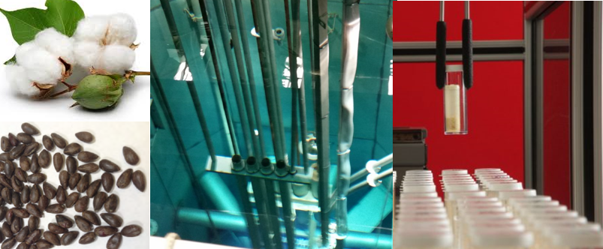

Image
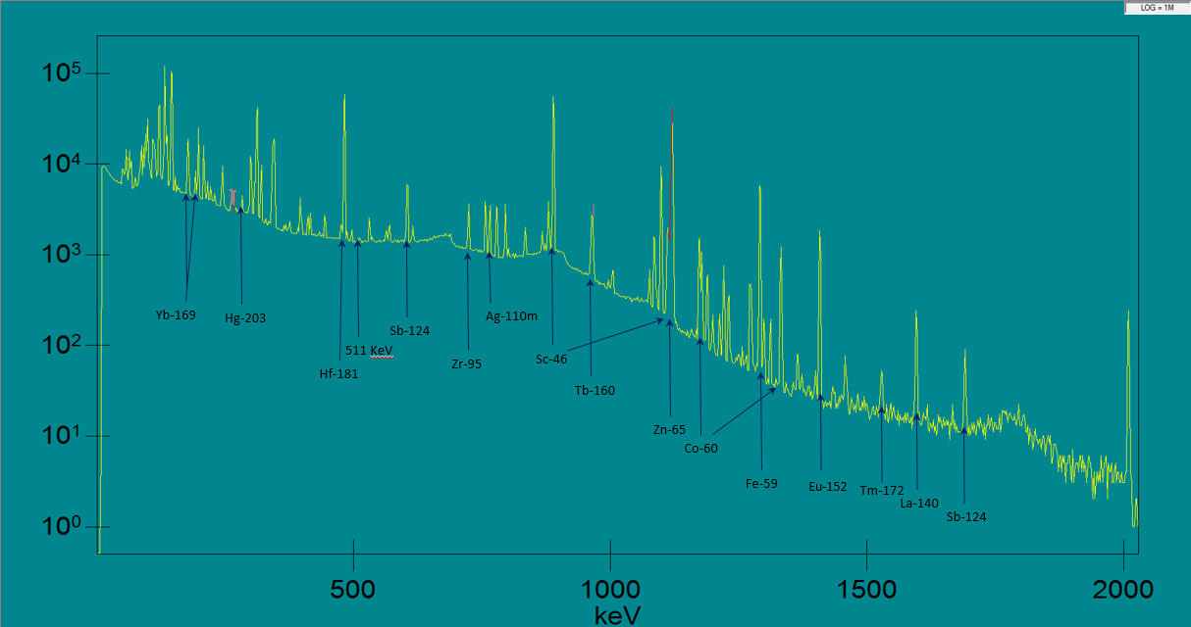
Recent Publications (minimum 5)
- Z.J. Sun, K. Okafor, and S. Isa, "Determination of Elemental Concentrations with Different Reaction Channels in Photon Activation." Applied Radiation and Isotopes, 127:173-178, 2017, doi:10.1016/j.apradiso.2017.06.012.
- Z.J. Sun, F. Martin, Q.S. Cai and S. Lassell, "Instrumental Neutron Activation Analysis (INAA) of Nok Sculptures in I. P. Stanback Museum." Journal of Radioanalytical and Nuclear Chemistry, 313:85-92, 2017, doi:10.1007/s10967-017-5297-8.
- Sun, Z.J., Wells, D., Segebade, C., Quigley K. and Chemerisov, S. , “A Comparison of Various Procedures in Photon Activation Analysis (PAA) with the Same Irradiation Setup.” Nuclear Instruments and Methods in Physics Research Section B, 339:53-57 (2014), doi:10.1016/j.nimb.2014.08.021.
- Sun, Z.J., Wells, D., Segebade C. and Chemerisov, S., “A Study of Quasi-absolute Method in Photon Activation Analysis.” Nuclear Science and Techniques, 25, 050201 (2014).doi:10.13538/j.1001-8042/nst.25.050201.
- Sun, Z.J., Wells, D., Segebade, C., Maschner, H. and Benson, B., “A Provenance Study of Coffee by Photon Activation Analysis.” Journal of Radioanalytical and Nuclear Chemistry, 296:293-299, 2013. doi:10.1007/s10967-012-2021-6.

 Biography (150 word limit)
Dr. Zaijing Sun is an assistant professor in the Applied Radiation Sciences Laboratory (ARSL) at the South Carolina State University (SCSU). Before joining SCSU, he worked in the Nuclear Engineering Division at the Argonne National laboratory. His research focuses on applying photon activation analysis (PAA) and neutron activation analysis (NAA) to environmental, archaeological and agricultural samples. Other research interests include temporal data mining (TDM) in nuclear detections, transportation of nuclear materials, Monte Carlo simulations of nuclear processes, and medical isotopes.
Email: zsun@scsu.edu Contact No: 1-803-536-7924 Website: http://arsl.scsu.edu

Notes/Comments: Oral presentation

