Usefulness of infra-red thermography as a high-throughput tool for rice heat tolerant selection
Giovani G Brito, PhD, Embrapa - Brazilian Agricultural Research Corporation, BRA
Paulo Ricardo Reis Fagundes, PhD, Embrapa - Brazilian Agricultural Research Corporation. BRA
Angela Diniz Campos, PhD, Embrapa - Brazilian Agricultural Research Corporation, BRA
Luís Eduardo Panozzo, PhD, UFPel – Universidade Federal de Pelotas, BRA.
Sidnei Deuner, PhD, UFPel – Universidade Federal de Pelotas, BRA.
Diogo Silva Moura, PhD Student, UFPel – Universidade Federal de Pelotas, BRA.
Italo Lucas de Moraes, PhD Student, UFPel – Universidade Federal de Pelotas, BRA.

Abstract
Rice (Oryza sativa L.) is a sensitive specie to extreme temperatures, especially at reproductive phase. Although their genome has been completely sequenced opening wide opportunities for large-scale studies in mapping and functional genomics, physiological phenotyping under field condition still is the major bottleneck to associate a specific genotype to a phenotypic trait. Thus, a set of 182 accessions involving subspecies indica, japonica and indica/japonica cross were evaluated under field conditions in two sowing date representing contrasting environments temperatures for rice growth. At second time sowing the occurrence of supra-optimal temperatures at the reproductive phase decreased significantly the mean grain yield (12%). A hierarchical clustering analysis highlighted that Cluster VI had outperforming LTB 14033 genotype; the grain per panicle and grain yield per square meter were the most closely related traits by principal components analysis (PCA); the thermography analysis highlighted that this genotype showed lower leaves temperatures, approximately 1 °C less than mean shown by set of evaluated genotypes. In addition, PCA revealed an important role for leaves dissipation capability of thermal energy and its association with grain yield and that the use of non-invasive phenotyping approach via thermography correlated negatively and significantly with grain yield of set evaluated accessions.

Image
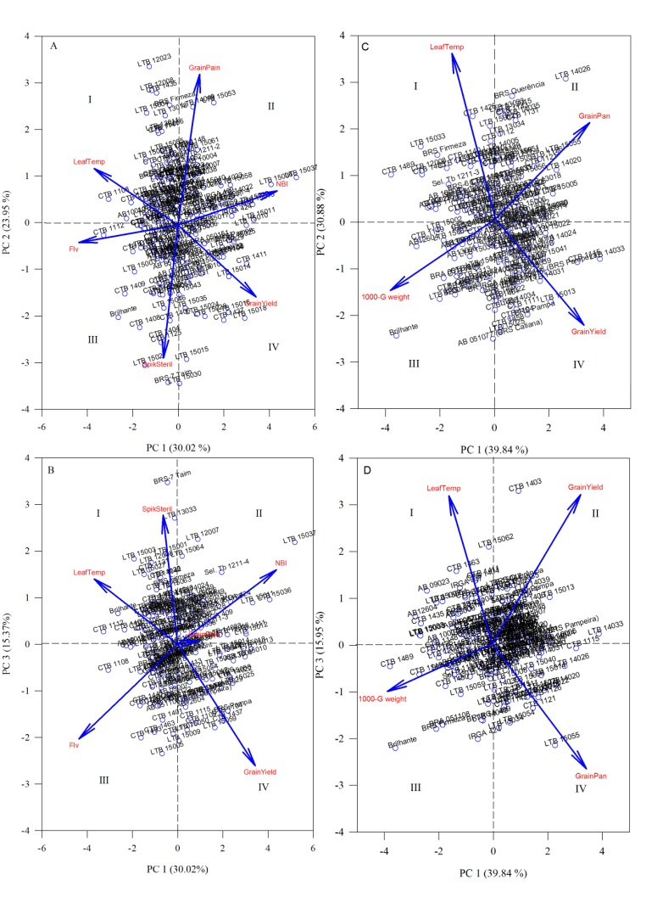
Figure 1: Principal component analysis for the first (A, B) and second sowing date (C, D). Individual contribution of each parameter measured as such LeafTemp (leaf temperatures - °C), GrainPain (grain number per panicle), NBI (nitrogen balance index), Flv (Flavonoids index), SpikSteril (Spikelet sterility - %), 1000-G weight (1000-grain weight – g) and Grain Yield (grain yield – g per square meter).
Recent Publications (minimum 5)
- WeberRL, Wiebke-strohmB, BredemeierC et al. (2014) Expression of an osmotin-like protein from Solanum nigrum confers drought tolerance in transgenic soybean. BMC Plant Biol, 14:343-2014.
- BritoGG, CaixetaET, GallinaAP, et al. (2010) Inheritance of coffee leaf rust resistance and identification of AFLP markers linked to the resistance gene. Euphytica, 173:255–264.
- BritoGG, FagundesPRR, TelóGM et al (2016) Impact of supra-optimal temperatures on physiology and yield in rice field. Journal of Agricultural Science 8:27-37
- BritoGG, SofiattiV, LimaMMA, CarvalhoLP et al (2011) Physiological traits for drought phenotyping in cotton. Acta Scientiarum Agronomy 33:117-125.
- DiolaV, BritoGG, CaixetaET et al (2013) A new set of differentially expressed signaling genes is early expressed in coffee leaf rust race II incompatible interaction. Functional and Integrative Genomics 13:379-389.

Biography (150 word limit)
Dr. Giovani Brito has his expertise focused in the development of tools for non-invasive plant physiological breeding aiming increase the tolerance to biotic and abiotic stress for cultivated species.
Email: giovani.brito@embrapa.br Contact No: +55(53) 32758480

Notes/Comments:

