Developing screening techniques and understanding differences in physiological mechanisms conferring drought tolerance in cultivated (Hordeum vulgare L.) and wild (H. spontaneum) barley genotypes

Amarah Batool, Sergey Shabala, Meixue Zhou
School of Land and Food, University of Tasmania, Australia

Abstract:
Drought is a major abiotic stress affecting crop production and food security worldwide. Developing efficient screening techniques and quantifiable traits would expedite the process of crop improvement for drought stress tolerance. In this work, physiological and agronomical responses of 20 wild and 10 cultivated barley genotypes were compare in glasshouse trails, in two separate experiments. In the first study, plant watering was withdrawn and drought tolerance was estimated as the time at which plants started to wilt and eventually die. Genotypes were classified into four clusters (i.e. tolerant, moderate tolerant, moderate sensitive and sensitive) based on visual damage score (1 = no symptoms; 10 = dead plants) after 3, 5 and 7 weeks of water withdrawal. In the second experiment, plants were watered at three different regimes: control (100% field capacity) and two deficient irrigations (25% and 12% field capacity, respectively). Agronomical (fresh and dry weigh; relative water content) and physiological (stomatal conductance; chlorophyll content; PSII maximum photochemical efficiency) were measured and compared. The differences in the strategies by which wild and cultivated barley genotypes respond to water stress were then analysed based on this data. A range of drought tolerant barley cultivars have been selected and could be recommended to growers, and contrasting parental lines for creating mapping double haploid population for marker-assistant breeding have been identified

Publications:
- Batool A, Noorka IR, Afzal M, Syed AH. Estimation of Heterosis, Heterobeltiosis and Potence Ratio Over Environments Among Pre and Post Green Revolution Spring wheat in Pakistan. Journal of Basic & Applied Sciences. 2013;9:36.
- Noorka IR, Batool A, Rauf S, Teixeira da Silva J, Ashraf E. Estimation of heterosis in wheat (Triticum aestivum L.) under contrasting water regimes. International Journal of Plant Breeding. 2013;7:55-60
- Noorka IR, Batool A, AlSultan S, Tabasum S, Ali A. Water stress tolerance, its relationship to stem reserve mobilization and potence ratio in spring wheat. American Journal of Plant Sciences. 2013a;4:231.

E.mail: Amarah.Batool@utas.edu.au Contact No: +61449723449

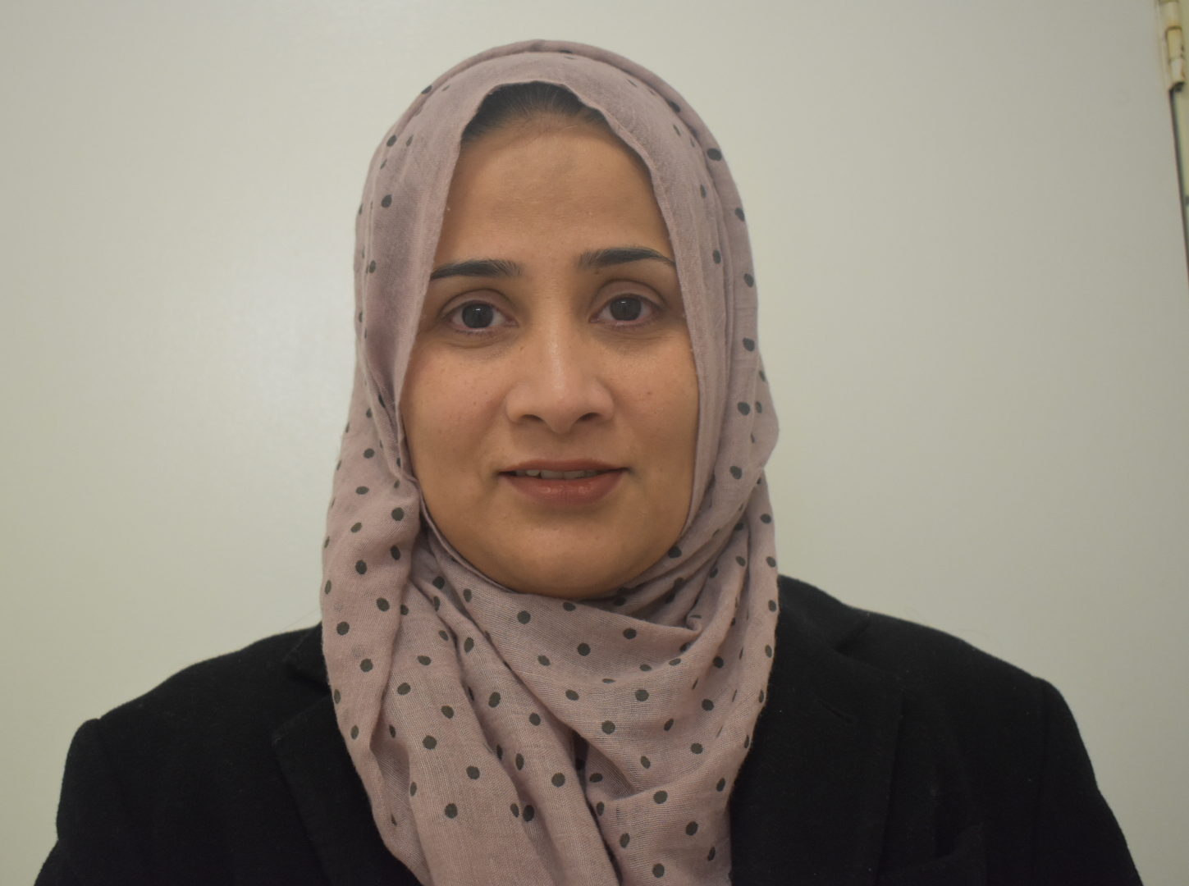

Amarah Batool is a third year PhD candidate at University of Tasmania, Australia. Currently she is working on projects related to drought stress tolerance in Barley. Her main objective is to screen barley genotypes on large scale and to determine physiological mechanisms conferring drought stress tolerance in Barley. She holds a Masters degree in Plant Breeding and Genetics from University of Sargodha, Pakistan and BSc (Hons) from University of Agriculture, Faisalabad, Pakistan.

