Socio-economic characterization of the impact of goat breeding (Capra hircus L., 1758) in breeders. Empirical analysis carried out in the natural conditions of the Ituri Province
Musalizi L Muharabu, Ir & M.sc in Agriculture, University Of Kisangani, DRC

An analysis of the socio-economic impact of local goats was carried out on 96 breeders who were subjected to a closed questionnaire survey. The study was carried out between May 2011 and May 2017 in four territories of five which composed the province of Ituri. The study of this research proves that the incomes obtained from this activity remain in general weak ways; Nevertheless, despite the inconsistency, the breeders are satisfied. Livestock income allows breeders to make long-term investments such as land acquisition with the purchase of plots; It allows them to meet certain basic social needs including food, schooling of children, payment of the dowry, acquisition of certain goods, etc.). The goat offers great opportunities for development through its meat production, its rusticity and its good adaptation in all the edaphic-eco-climatic conditions of Ituri. It is found in all families and saves in all areas and stages of the life of the breeder. In terms of the number of animals raised, statistics show that it comes second after poultry. In short, based on results obtained in this area of ​​the Democratic Republic of Congo, the goat is a saving for the future of the breeder. The summary table below briefly explains the results on the use or allocation of income obtained from livestock.

 Musalizi Lafleur, is an Agronomic Engineer of Orientation Zootechny and Aquaculture from the Faculty of Agronomic Sciences (IFA) of Yangambi. Teacher at the University of Kisangani where he is doing his Doctorate in Tropical Zootechnics. Currently, he is also focusing on the fight against food insecurity in the Democratic Republic of Congo, given the demographic growth that is becoming a scourge.

Table 1. Allocation of income from goat breeding in Ituri
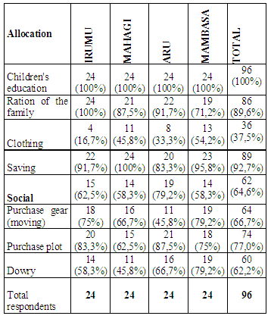
1. Musalizi R.L. et Kisembo K.D., 2016, « Agriculture intégrée et concertée : quid d’accès de petit producteur de l’Ituri ». Revue(Internationale) Shalom de Développement. Vol. 003. 45-58
2. Muliri B.L., Musalizi R.L., Asha B.S. & Bokota N.J., 2017, « Rôles des femmes et des enfants dans la chaîne de production et de distribution des produits agricoles en Ituri ». Revue (Internationale) Shalom de Développement. Vol. 004. 66-79
3. Bibasuya K.P. et Musalizi R.L., 2014, « Inventaire ichtyologique des rivières, des ruisseaux et des ruisselets de Kisangani ». Revue (Internationale) Shalom de Développement. Vol. 002. 79-93
4. Muluba K.P. Musalizi R.L. et Bitijula M.M., 2014, « De l’exploitation de l’énergie-bois et de ses conséquences sur la gestion des ressources forestières en Ituri ». Revue (Internationale) Shalom de Développement. Vol. 002. 46-57
5. Musalizi, R. L., 2014 : Analyse socio-économique de l’impact de l’élevage des chèvres sur la vie des éleveurs en Ituri. Mémoires de D.E.A.
6. Musalizi R.L., Way A. et Bolakonga B., 2013, « Impact socioéconomique de l’élevage des Caprins (Capra hircus) sur la vie des éleveurs périurbains de l'Ituri ». Revue(Internationale) Shalom de Développement. Vol. 001. 13-22

