Evolution of the tomato market in Argentina (Ex aecquo)
Ana M Castagnino, Ing Agr, Mag, CRESCA-FAA-UNCPBA, UCA, Argentina
Karina E Diaz, Ing Agr, PhD, CRESCA-FAA-UNCPBA, Argentina
Oscar Liverotti, Ing. Agr.Ex UCA, Argentina
José Fernandez Lozano, Ing. Agr. UBA, Argentina.
Andrea Guisolis, Lic, CRESCA-FAA-UNCPBA, UCA, Argentina
Mario E Peralta, Ing. Agr. UB, Argentina
Sabrina Mondini, CRESCA-FAA-UNCPBA, Argentina
W John Rogers, MA, PhD, CIC-BIOLAB AZUL, CONICET-INBIOTEC, CRESCA UNCPBA Argentina

Abstract (300 word limit)

Tomato is the principal greenhouse vegetable grown in Argentina. The aim of the current work is to analyse tomato market evolution in this country, based upon volumes received by the Buenos Aires Central Market, the main national point of reference. The following aspects were evaluated: total commercial volumes (CV) 1999-2016, evolution (E) and mean prices (MP), principal varieties (V) commercialised in 2016, origin (O), distribution by province of origin (DP) and the proportion that tomato comprises of the total volume (TV) of the horticultural produce commercialised in the reference period.
For the factors evaluated, one-way analysis of variance was carried out on the tonnage values. The VC was 119,600, with a decrease over the period of 18% compared to the first year (1999: 142,968t and 2016: 117,744 t/year). In 2016, the mean monthly E was 9812t, where the following months exceeded this value, without significant differences between them: October: 14586, December: 11870, September: 11494, November:10865, August: 10446 and January: 10027 t.
The annual MP was 0.62 US$.kg⁻¹, which was exceeded in September (1.03), May (0.82), October (0.80) and November (0.63). For DP, the highest volumes were observed for Buenos Aires: 3936tª, Salta: 2187t and Corrientes: 2081t^{b}, with the remaining origins in the following order of importance, without significant differences between them: Jujuy: 774, Mendoza: 625, Brasil: 72; Tucumán: 48; Entre Ríos: 29; San Juan: 28; Rio Negro: 9.82, Santa Fé: 8; Córdoba: 5.15; Santiago del Estero: 2.82; Misiones: 2; Formosa: 1.4; Chubut: 0.75 and San Luis: 0.2 t^{c}.
Overall, tomato represented 14% of the TV (850240t) commercialised (16.7% in 1999 and 13.8% in 2016). For V, the monthly volumes gave differences for Larga Vida (Octoberª , November, July, February, September, August and June^{ab}); for Platense (January and Decemberª, April and February^{ab}) and the rest^{b}. For origin, differences were found for all varieties: Larga Vida: Corrientesª and the rest^{b}; Perita: Saltaª, Jujuy and Buenos Aires^{b} and Mendoza^{bc}; Cherry: Buenos Airesª, Salta and Corrientes^{b}, Jujuy^{bc}; and Redondo: Buenos Airesª, Corrientes^{b} and Salta^{ab}. These results provide evidence of the positioning of tomato throughout the year in the Argentinean market.
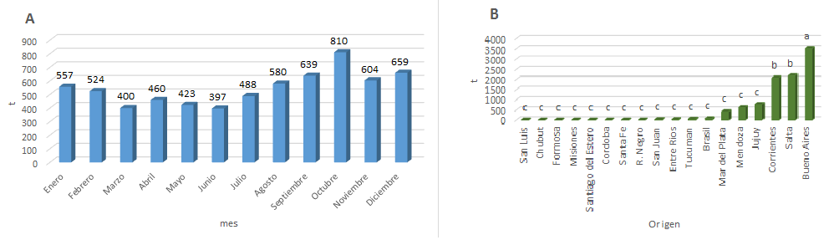

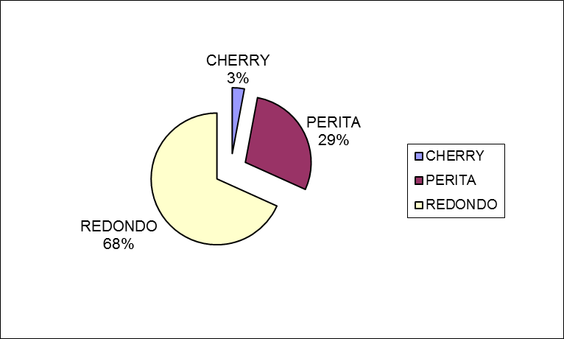
Figure 1: Evolution of volume of tomato commercialised (A) and origin (B) during year 2016 in the Argentinean market. The x-axis of A gives months from January (Enero) to December (Diciembre).

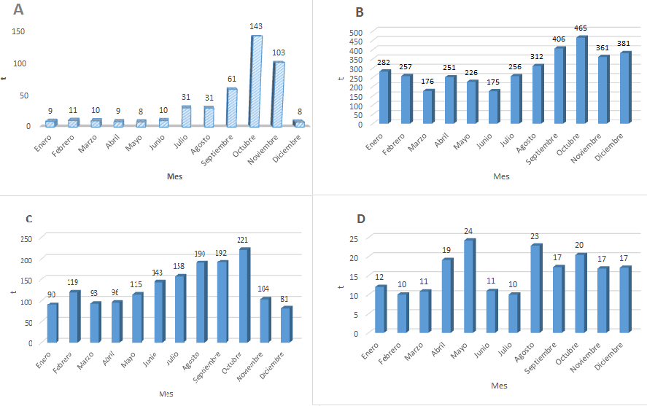

Figure 2: Varietal types of tomato commercialised in the internal Argentinean market A) Larga vida; (B) Redondo, (C) Perita; (D) Cherry. The x-axis of the graphs gives months from January (Enero) to December (Diciembre).

References
- Castagnino, A. M.; Diaz, K. E.; Rosini, M. B. et al. 2009. Manual de cultivos hortícolas innovadores. Editorial Hemisferio Sur. Pag. 25 – 38.
- Fernández Lozano, J.; Liverotti, O.; Peralta, M.; Castagnino, A.; Díaz, K. y Rosini, M. Tendencias de la producción y comercialización de espárrago (Asparagus officinalis L.) en Argentina. Horticultura Argentina 34(85): Sep.-Dic. 2015. Pag. 32.
- Liverotti, O.; Fernández Lozano, J.; Peralta, M.; Sangiácomo, M.; Szczesny, A. y Nakama, M. Evaluación de la calidad comercial de tomate tipo redondo ingresado al Mercado Central de Buenos Aires (2010-2011). Horticultura Argentina 32(79): Sep.-Dic. 2013. Pag. 67.
- Rodriguez, G.; Pérez, D. y Paredes, V. Análisis del precio de la papa, pimiento y tomate en el Mercofruty MCBA durante el año 2012. Horticultura Argentina 32(79): Sep.-Dic. 2013. Pag. 51.
- http://www.alcentral.com.ar/

Biography (150 word limit)
Ana María Castagnino is a Horticulture Specialist (UNIPI, Italy) with a Master's Degree in Business Management (UNCPBA, Argentina), and is Professor of Horticulture at UCA, Buenos Aires and Associate Professor at UNCPBA. She is a member of CRESCA (Regional Centre for the Systemic Study of Agro-Food Chains) and directs the programme "Promotion of the production and consumption of asparagus and other non-traditional vegetables".

Email: amc@hotmail.com Contact No: 123456xxxxx

Notes/Comments:

