Molecular characterization of cytosolic OASTL switch cysteine and mimosine production in Leucaena leucocephala
Md. Harun-Ur-Rashid ^{1,4)}, Fukuta Masakazu²⁾, Md. Amzad Hossain²⁾, Hironori Iwasaki³⁾, Hirosuke Oku³⁾
¹⁾ The United Graduate School of Agricultural Sciences, Kagoshima University, Kagoshima, Japan
²⁾ Graduate School of Agriculture, University of the Ryukyus, Okinawa, Japan
³⁾ Tropical Biosphere Research Center, University of the Ryukyus, Okinawa, Japan
⁴⁾ Faculty of Agriculture, Sher-e-Bangla Agricultural University, Dhaka, Bangladesh

Abstract
Mimosine (Mim) is an iron chelator and block mammalian cell cycle at G1/S phases. Cysteine (Cys) is considered as sulfur grantor for many sulfur-containing secondary products. Cys biosynthesis includes consecutive two steps using two enzymes-serine acetyl transferase (SAT) and O-acetylserine (thiol)lyase (OASTL). In the first half, the acetylation of L-serine by acetyl-CoA in presence of SAT and finally, OASTL triggers α, β-elimination from OAS and bind H₂S to catalyze Cys. OASTL is able to synthesize Mim with 3-hydroxy-4-pyridone (3H4P) instead of H₂S in the last step. The aim of this study was to characterize the cytosolic (Cy) OASTL from L. leucocephala and compare its performance between Cys and Mim production. Cy-OASTL was obtained through both directional degenerate primers corresponding to conserved amino acid region among plant Cys synthase family and the purified protein was 34.3KDa. Kinetics studies showed pH optima of 7.5 and 8.0, while temperature optima of 40⁰C and 35⁰C, respectively for cysteine and mimosine. The measured Km, kcat and kcat/Km values were 148±22 µM OAS, 43.52 sec⁻¹ and 0.294 μM⁻¹sec⁻¹ for OAS and 78±10 µM Na₂S, 32.65 sec⁻¹ and 0.419 μM⁻¹sec⁻¹ for Na₂S for cysteine assay and 553±103 µM OAS, 6.87 sec⁻¹ and 0.0124 μM⁻¹sec⁻¹ for OAS and 517±82µM 3H4P, 16.04 sec⁻¹ and 0.031 μM⁻¹sec⁻¹ for 3H4P for mimosine assay subsequently. OAS for Mim production is 3.7 times higher than Cys production indicating that Cy-OASTL has higher OAS affinity for Cys. Inter fragment interaction energy (IFIE) of OAS-Cy-OASTL complex showed that Lys49, Thr81, Thr77 and Gln150 demonstrated higher attraction force for Cys but 3H4P-mimosine synthase-APE complex showed that Gly230, Tyr227, Ala231, Gly228 and Gly232 might provide higher attraction energy for Mim. Thus Cy-OASTL demonstrates a dual role in biosynthesis both Cys and Mim and extending the knowledge on the biochemical regulatory mechanism of mimosine and cysteine.
Image
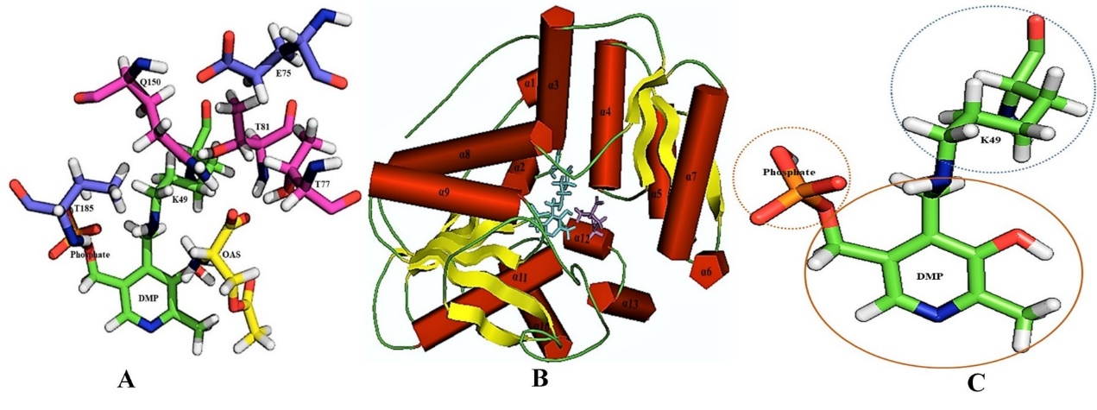

Fig. 1. The three dimensional structure of the active site of cysteine synthase (OASTL) with ligand OAS from L. leucocephala A. Coordination geometry of amino acids at the active site of OASTL as in sticks form. The carbon skeleton along with the attraction and repulsion force amino acids listed in Table 2 is shown in pink and blue colour, respectively. Carbon skeleton of Lys-PLP in green and the substrate OAS are shown in yellow sticks. B. α-helix surrounded by the active site of OASTL. C. Active site of Cy-OASTL is divided in three parts for PAICS calculation such as Lysine 49, 2, 5-dimethyl-3-pyridinol (DMP) and phosphate. All figures were generated by PyMol.
Recent Publications
- Molecular characterization and expression of chloroplastic OASTL control cysteine metabolism in Leucaena leucocephala. The 80th Annual meeting of the Botanical Society of Japan. 16-19 September, 2015, Okinawa Convention Center, Okinawa, Japan. (Poster)
- Molecular characterization and expression of cytosolic OASTL control cysteine metabolism in Mimosa pudica L. The 9th Asian Crop Science Association conference. 4-7 June, 2017, ICC, Jeju, Korea. (Poster)
- Md. Akkas Ali, Md. Shahidur Rashid Bhuiyan, Md. Harun-Ur-Rashid, Shahanaz Parveen, Md. Golam Robbani and Monika Sonom. 2016. Breeding for an ideal plant type in Brassica rapa L. Plant Knowledge Journal. 5(1): 36-41.
- Abu Yousuf Hossin, Md.Harun-Ur-Rashid, Shahanaz Parveen, Md.Salehur Rahman, Runa Akter and Md. Abdur Rahim. 2016. Evaluation of Breeding potential of tomato germplasm using D² analysis. Advances in Bioresearch. 7(4): 217-222.
- Taiaba Afrin, Md. Shahidur Rashid Bhuiyan, Md.Harun-Ur-Rashid and Shahanaz Parveen. 2016. Variability and comparative analysis among advanced generations of Brassica rapa L. Plant Knowledge Journal. 5(1): 18-26.
- Taiana, T., Rashid, H. M., Parveen, S., Hossain M. S. and Haque, M.A. 2015. Selection strategies for better parents in tomato using genetic parameters. Plant Knowledge Journal. 4(1): 33-39.
- Rashid, H.M., Parveen, S. and Bhuiyan, M.S.R. 2015. Morphological attributes species identification of oleiferous Brassica species and better parent’s selection criteria for Brassica juncea. International Journal of Current Research. International Journal of Current Research. 7 (9): 19847-19854.
- Sarwar, G., Rashid, H. M., Parveen, S. and Hossain M. S., 2015. Correlation and Path Coefficient Analysis for Agro-morphological Important Traits in Aman Rice Genotypes (Oryza sativa L.). Advances in Bioresearch. Vol 6 (4): 40-47.
- Parveen, S., Rashid, H.M. and Bhuiyan, M.S.R. 2015. Assessment of breeding potential of rape seed germplasm using D² analysis. J. Exp. Bio Sci., 6(1): 59-64.
- Rahman, S. M., Parveen, S., Rashid, H. M., Akter, R, Hossin, Y. A and Rabbani, G, M. 2015. Correlation and path coefficient analysis of tomato germplasm. International Journal of Applied Sciences and Biotechnology. Vol-3 (2): 223-226.
- Sarwar, G., Rashid, H. M., Parveen, S. and Hossain M. S., 2015. Evaluation of Genetic Diversity in Agromorphological Traits of Forty Two Aman Rice Genotypes (Oryza sativa L.) Using D² Analysis. American Journal Experimental Agriculture. Vol-8(5): 280-288.
- Sarwar, G., Hossain M. S., Rashid, H. M. and Parveen, S. 2015. Assessment of genetic variability for agro-morphological important traits in aman rice (Oryza sativa L.). International Journal of Applied Sciences and Biotechnology. Vol-3 (1): 73-79.
- Parveen, S., Rashid, H.M. and Bhuiyan, M.S.R. 2013. Genetic variation and selection criteria for seed yield related traits in rape seed (Brassica napus L.). Bangladesh Journal of Plant Breeding and Genetics. 26(2):15-22.
Biography of Md. Harun-Ur-Rashid
Md. Harun-Ur-Rashid was born in Dinajpur, Bangladesh, in 1980. He received the B.Sc. (Honours) in Agriculture from Sher-e-Bangla Agricultural University, Bangladesh in 2004 and the Master of Science in Genetics and Plant Breeding from the same University with the CGPA 4.0 out of 4.0.
In 2010, Mr. Rashid joined in the Department of Genetics and Plant Breeding, Sher-e-Bangla Agricultural University, as a Lecturer, and an Assistant Professor in 2012 to till now. His current research interests include Plant Breeding, Plant Genetics, Molecular Biology and Tissue Culture. Currently he is conducting his Ph.D. study in the field of Molecular Biology at the United Graduate School of Agricultural Sciences, Kagoshima University, Japan as a MEXT Fellow. He is the life member of Plant Breeding and Genetics Society of Bangladesh and member, Plant Biotechnology Society of Bangladesh and The Botanical Society of Japan. He served as a reviewer of different journals of Plant Science.
- Email: sumonsau@gmail.com Contact No: +81-80-2708-5755

