Non-chemical pest control of Blossom feeder scarab (Epicometis hirta) in Rapeseed (Brassica napus)
Mojtana Hatami MSC Deptartment of Agronomy, Jihad-Agricultural organization of Kermanshah. 6714548333
Shahryar Sasani MSC Research Centre of Agriculture and Natural Resources, Kermanshah. 6714548333.
Sayed Mohammad Reza Hassani, PhD student, Dryland Agricultural Research Institute, Sararood,Kermanshah, Iran

Abstract

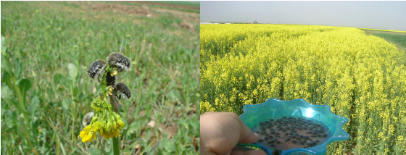
Environmental health is one of the main goals in sustainable agriculture. Blossom feeder scarab has considered as a polyphage pest, damage flowers and buds of many crops and spring-blossoming fruit trees; hence affect directly on yield potential in field and orchards. Rapeseed covers more than 90 thousand hectares in Iran as the main oilseed crop. To study non-chemical pest control in rapeseed fields of Kermanshah an experiment was carried out in 2015-2107. Thirty flat water-containers (25cm diameter) were filled by tap-water and distributed per hectare on field area during the blossom and flowering period of rapeseed. The high activity of these insects and attraction of the water containers, caused drown the blossom feeder scarab, therefore, water containers were emptied and re-filled many times per week. In comparison to chemical pest control, it seems that current method was more effective to Blossom feeder scarab control and helps to protect the beneficial insect population and predators. More results showed that this method covers higher efficiency in drought years, on the other hand, the color of water containers were impressive, blue and white colors showed better results in this case. In broader terms, this method works to provide adequate and dependable farm incomes, to minimize adverse impacts on health, safety, wildlife, water quality and the environment.
Image

Recent Publications

- Vuts J, Szarukán I, Subchev M, Toshova T, Tóth M (2010) Improving the floral attractant to lure Epicometis hirta Poda (Coleoptera: Scarabaeidae, Cetoniinae) Journal of Pest Science 83: 15–20.

- Sivcev I, Tóth M, Tomasev I (2006) Application of attractants in control of the sugar-beet weevil and the blossom feeder scarab (Bothynoderes punctiventris, Epicometis hirta). Poljoprivedni Kalendar 2006:138–140
- Capinera J, Handbook of vegetable pests(2001) Academic press, New York.
- Adkins C, Armel G, Chappell M, Chong J.C., Frank S, Fulcher A, Hale F, Klingeman W, Ivors K, LeBude A, Neal J, Senesac A, White S, Williams-Woodward J, Windham A, (2009) Workshop on Pest Management Strategic Plan for Container and Field-Produced Nursery Crops, July 30-31, University of Kentucky Department of Horticulture N318 Ag Science North Lexington, KY 40546-0091 859-257-1273
- Dreistadt SH ( 2016) Pests of landscape trees and shrubs: an integrated pest management guide, Publication 3359, Okland, California.


Mojtaba Hatami has his expertise in evaluation Non-chemical and natural pest control of Blossom feeder scarab (Epicometis hirta) in Rapeseed (Brassica napus). He works on Weed science especially in oilseed crops such as rapeseed and safflower.He got his MSC degree in Weed Science at Universityi of .
Email: mhatami.crop@gmail.com Contact No: +98 918 385 3664

Notes/Comments:

