Germination response to temperature of basil (Ocimum basilicum L)
Sahar Binesh¹, gholamabas akbari*², elias soltani³, fateme amini⁴
¹ MSc. Student of Agronomy, Department of Crop Science and Plant Breeding, Aboureyhan Faculty, University of Tehran, Pakdasht, Tehran
² Associate professor, Department of Crop Science and Plant Breeding, Aboureyhan Faculty, University of Tehran, Pakdasht, Tehran
^{3,4} Assistant professor, Department of Crop Science and Plant Breeding, Aboureyhan Faculty, University of Tehran, Pakdasht, Tehran

Abstract (300 word limit)
Germination is considered of the most sensitive, crucial stages during plants’ life cycle Germination response to temperature is different among plant seeds. Germination rate and percentage is maximal at optimum temperature (s), and then reach to zero at base and ceiling temperatures. The objective of this research was (1) to evaluate germination response of snail medic seeds to temperature and (2) to determine cardinal temperatures of germination rate and percentage. In order to, germination tests were conducted in fixed temperatures incubators with 8, 15, 20, 25, 30 and 35 ºC on 22 Ocimum basilicum cultivars, in 4 replications with 50 seeds. Results indicated that response of germination percentage and rate adequately described with dent-like and segmented functions, continually. Base and ceiling temperatures were obtained 5.26- 9.22 and 20.32-29.89 oC for germination rate. Optimum temperatures were for and 35.79-45 oC for germination rate.

Image
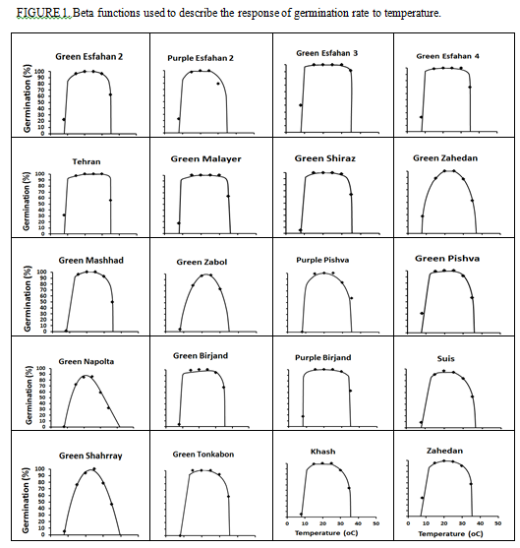
Recent Publications (minimum 5)
- -Soltani A, Robertson M J, Torabi B, Yousedi-Daz M and Sarparast R (2006) Modeling seedling emergence in chickpea as influenced by temperature and sowing depth. Agricultural and Forest Meteorology. 138: 156-167.
- -Soltani E, Galeshi S, Kamkar B and Akramghaderi F (2008) Modeling seed aging effects on the response of germination to temperature in wheat. Seed Science and Biotechnology. 2: 32-36.
- -Soltani E, Soltani A, Galeshi S, Ghaderi-Far F and Zeinali E (2013) Seed Bank Modelling of Volunteer Oil Seed Rape: from Seeds Fate in the Soil To Seedling Emergence. Planta Daninha. 31: 267-279.
- Seefeldt S S, Kidwell K K and Waller J E (2002) Base growth temperatures, germination rates and growth response of contemporary spring wheat (Triticum aestivum L.) cultivars from the US Pacific Northwest. Field Crops Res. 75: 47-52.
- -SadrabadiHaghighi R and Sazevari G (2011) Evaluation of effect on Alhajipseudlhaji germination response to salinity and temperature. World Applied Sciences Journal. 13 (1): 157-164.

Biography (150 word limit)
Deanna Mulvihill has her expertise in evaluation and passion in improving the health and wellbeing. Her open and contextual evaluation model based on responsive constructivists creates new pathways for improving healthcare. She has built this model after years of experience in research, evaluation, teaching and administration both in hospital and education institutions. The foundation is based on fourth generation evaluation (Guba& Lincoln, 1989) which is a methodology that utilizes the previous generations of evaluation: measurement, description and judgment. It allows for value-pluralism. This approach is responsive to all stakeholders and has a different way of focusing.
Email: sahar.binesh@ut.ac.ir Contact No: 09184686238

Notes/Comments:

