One-step multiplex reverse transcription-polymerase chain reaction for the simultaneous detection for barley virus diseases

Bong Choon Lee PhD, National Institute of Crop Science, RDA. Korea
Ju Young Bae, National Institute of Crop Science, RDA. Korea
Sang Min Kim, National Institute of Crop Science, RDA. Korea
Ji-Eun Ra, National Institute of Crop Science, RDA. Korea
Nak Jung Choi, National Institute of Crop Science, RDA. Korea
Man Young Choi PhD, National Institute of Crop Science, RDA. Korea
Ki Do Park PhD, National Institute of Crop Science, RDA. Korea

Abstract
Virus disease surveys on barley cultivation areas were conducted during 2014-2015 in Korea. In this result, we detected Barley yellow mosaic virus (BaYMV), Barley mild mosaic virus (BaMMV) and Barley yellow dwarf virus(BYDV) by RT-PCR from barley leaves. These viruses are of great economic importance for wheat and barley, causing significant quantitative and qualitative losses in yield. In this study, a multiplex reverse transcription polymerse chain reaction(mRT-PCR) method was developed for the silmultaneous detection of these three viruses . Virus-infected barley leaves were collected from naturally infected barley in several provinces of Korea. Primers were designed from conserved regions of the capsid protein (CP) gene of viruses and the Genbank accession numbers for the CP coding genes are as follows: D01091(BaYMV), L49381(BaMMV), and NC021481(BYDV). Three sets of specific primers targeted to the CP coding genes of BaYMV, BaMMV and BYDV were used to amplify fragments that were 594 bp, 461 bp, and 290 bp, respectively. The one-step mRT-PCR assay proved to be a rapid and specific barley virus diagnostic tool. The diagnosis of mixed infections with barley viruses in one single reaction will reduce the cost, significantly increase the number of samples that can be analyzed, which will allow an examination of the viral disease epidemiology in barley.

Image
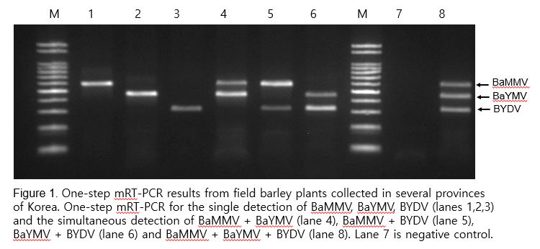
Recent Publications
1. Fumei Zhao, Seungmo Lim, Ran Hee Yoo, Davaajargal Igori, Sang-Min Kim, Do Yeon Kwak, Sun Lim Kim, Bong Choon Lee, Jae Sun Moon (2016) The complete genomic sequence of a tentative new polerovirus identified in barley in South Korea. Arch Virol. 161:2047–2050.

2. Lee Bong-Choon, Kim Sang-Min, Bae Ju-Young, Ra Ji-Eun, Kim Sun-Lim, Kim Kang-Min, Lee Joon-Hwan (2016) Detection and Distribution of Fungal Vector P. graminis of BaYMV
Korean J. Org. Agric. 24(3) : 427-433.

3. Bong Choon Lee, Sang-Yun Cho, Ju Young Bae, Sang Min Kim,Dong Bum Shin, and Sun Lim Kim (2016) In Vitro Expression and Antibody Preparation of Rice black-streaked dwarf virus Coat Protein Gene. Res. Plant Dis. 22(1): 32-37.

4. Sang-Yun Cho, Rae-Dong Jeong, Young-Nam Yoon, Dong Bum Shin, Hang-Won Kang, Bong Choon Lee (2015) A nationwide survey and genetic analysis of rice stripe virus in South Korea during 2012–2013. J Gen Plant Pathol. 81 : 390–398.

5. Sang-Yun Cho, Rae-Dong Jeong, Young-Nam Yoon, Su-Heon Lee, Dong Bum Shin, Hang-Won Kang, Bong Choon Lee(2013) One-step multiplex reverse transcription-polymerase chain reaction for the simultaneous detection of three rice viruses. Journal of Virological Methods 193 : 674– 678.



Biograph
BC Lee has completed PhD at the age of 32 years from Hokkaido University in Japan and postdoctoral studies from Chonnam National University in Korea. She is the senier researcher of National Institute of Crop Science, RDA, Korea. She has published more than 50 papers in journals and has been serving as an editorial board member of Research in Plant Disease Journal in Korea.
Email: leebc21@korea.kr Contact No: 82-10-2672-0933

