The imbalance between technology and food waste
Neil Hamilton, VP of Business Development at Thingstream

Abstract (300 word limit)

It is estimated by the United Nations Organisation for Alimentation and Agriculture that almost one third of worldwide food production is lost. This accounts for 1.3 billion tons a year, enough to cover an area as big as Canada in farmed land. Food will inevitably sometimes go off in the supply chain, but an awareness of when this is happening could dramatically help to alleviate some waste. Issues with things like storage temperature and spoilage could easily be identified in transit and dealt with.

The sad fact is that we’ve had the technology to do this for a number of years. However, it simply hasn’t been applied due to issues around cost, connectivity and installation. Explaining the issues and why this hasn’t happened to date, this talk will seek to explain how the imbalance between technology and food waste can be addressed and ultimately removed. Myriad’s mission is to reduce the cost of getting sensor based devices into the field, improving access, processing, and applying IoT connectivity to reduce waste.

Image
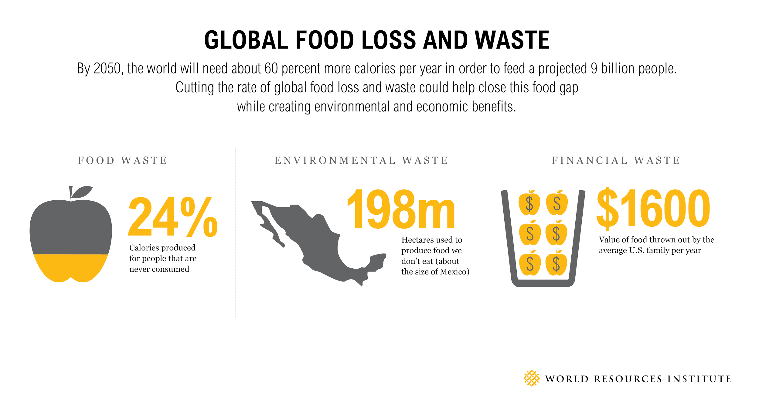
Recent Publications (minimum 5)
- Could affordable remote monitoring be the key to unlocking farming inefficiencies. Due to be published in Agriculture media: https://docs.google.com/document/d/1cZFP7vTA6VmD8YpzHUndRhKsGCTd-DKXind6GuF7g8g/edit
- Automotive Logistics, A back to the future approach to logistics: http://automotivelogistics.media/opinion/back-future-approach-connectivity
- IoT Now: In the land of IoT, coverage is king: https://www.iot-now.com/2017/04/14/60583-land-iot-coverage-king/
- Digital Trends: Pressto button will change IoT: http://readwrite.com/2017/04/23/can-make-iot-more-affordable-dl1/
- Packaging Europe: From supply pain to supply change: http://packagingeurope.com/from-supply-pain-to-supply-change-making-iot-simple/

Biography (150 word limit)
Neil is a technology evangelist who has been a founding member of a number of successful technology start-ups involved with mobile and commerce technologies. He is passionate about demystifying complex technology and evangelising the business benefits and new revenue opportunities such technology presents. He has been invited to speak at numerous events in Europe, US and Asia during his career and has a core interest in agriculture and how technology can improve processes for the greater good.

Email: neil.hamilton@myriadgroup.com Contact No: +44 7900 167707

Notes/Comments:

