Determination of nutrient and mineral contents of some selected cowpea lines for better quality trait improvement
Asiwe JAN
University of Limpopo, Department of Plant Production, Soil Science and Agricultural Engineering, Private Bag X1106, Sovenga 0727, South Africa
Abstract
Problem statement: Cowpea is an important grain legume. It is cultivated because it is rich in protein (20-24%), minerals and vitamins which are important for human and animal nutrition. One of the major cowpea production constraints in South Africa is lack of improved varieties. To fast track the development of improved cowpea varieties to meet the needs of farmers, improved varieties were introduced and multiplied to increase seeds for further field assessments. The objective of this study was to determine the nutrient, mineral contents and other quality traits of thirty two cowpea lines obtained from Genebank collections of University of Limpopo. This will assist the breeder in ascertaining their usefulness and plan on how to deploy their quality traits in breeding programme. Materials and methods: Dry seeds of varieties obtained from the seed multiplication programme were milled to fine powder, arranged in complete randomized design and analysed in three replications. Nutrient and mineral contents determined included (Crude protein (CP), Ca, Na, Mg, Fe, Cu, Zn, P, K and moisture. Findings: Results showed that the varieties exhibited significant (P<0.05) variations for the nutrients and mineral determined except for P, Cu and moisture. Ten lines performed better than two local control varieties (Glenda (24%) and Bechuana white (20%) in crude protein content with a range of 25-30%. Similarly, many varieties exhibited higher mineral content than the two local controls. Quality of grains of the varieties in terms of seed coat colour, texture, eye-colour and size also varied significantly. Conclusions and significance: The study not only demonstrated that many of the improved cowpea lines are better than local checks in nutrient contents and other quality traits, but has provided data base for utilizing the promising lines in breeding programme for the development of new cowpea germplasm with better quality traits and consumer preference.

Recent Publications:
Belane AK, Asiwe JAN and Dakora, FD (2011) Assessment of N2 fixation in 32 cowpea (Vigna unguiculata L. Walp) genotypes grown in the field at Taung in South Africa, using 15N natural abundance. African Journal of Biotechnology 10 (55): 11450-11458.

Kutu FR, Deale W, Asiwe JAN (2010) Assessment of maize and dry bean productivity under different intercrop systems and fertilizer regimes. African Journal of Agricultural Research 5 (13): 1627-1631.

Moalafi AI, Asiwe JAN, Funnah, SM (2010) Germplasm evaluation and enhancement for the development of cowpea Vigna unguiculata (L.) Walp dual-purpose F2 genotypes. African Journal of Agricultural Research 5 (7): 573-579.

Dzemo WD, Niba AS, Asiwe JAN (2010) A comparative study of the bionomics of Clavigralla tomentosicollis Stäl (Hemiptera: Coreidae) on three varieties of cowpea, Vigna unguiculata (L.) Walp. African Journal of Agricultural Research 5 (7): 567-572.

Dzemo WD, Niba AS, Asiwe JAN (2010) Effects of insecticide application on pest complex and yield of cowpea (Vigna unguiculata (L.) Walp.) varieties in the Transkei, South Africa. African Journal of Biotechnology 9 (11):1673-1679.

Asiwe JAN (2009) Insect mediated outcrossing and geneflow in cowpea Vigna unguiculata (L.) Walp): implication for seed production and provision of containment structures for GT Cowpea. African Journal of Biotechnology 8 (2):226-230.

Asiwe JAN (2009) The impact of phosphate fertilizer as a pest management tactic in four cowpea varieties. African Journal of Biotechnology Vol. 8 (24):7182-7186.

Asiwe JAN (2009) Needs assessment of cowpea production practices, constraints and utilization in South Africa. African Journal of Biotechnology Vol (8):5383-5388.

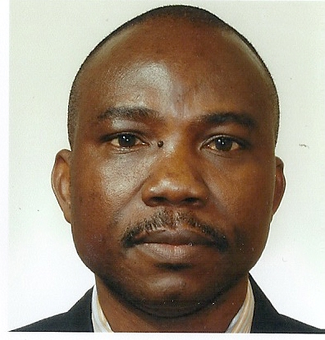
Biography
I am currently a Plant breeder and an Integrated Pest Management Specialist at the University of Limpopo, South Africa. I have several years of experience with successful track record in different aspects of commercial Agriculture, food security, Research and Development in sub Saharan Africa (SSA): with significant impacts on legumes (cowpea, Bambara groundnut and soybeans), root and tuber crops (cassava and yam), Cereals (maize, wheat and barley), intercropping systems (legumes with maize, sorghum/millet) in cross-setting professional areas (Plant breeding, Entomology and pest management, biotechnology and technology dissemination).
I also possess strong management and leadership skills in the following areas: strategic planning and implementation for distinctive competitive advantage and project management. Others include training and human capital development, financial management, sourcing funds for projects. Furthermore, I possess traceable wealth of experience in networking and collaborative research with International CGIAR institutes, Universities, National Agricultural Research Systems (NARS) and Non-Governmental Organizations in SSA.
Email: joseph.asiwe@ul.ac.za Contact No: +27738324692

