Non-thermal plasma: new technology for pathogen control and improvement on the quality of soybean seeds

Cecilia Pérez Pizá, FAUBA, Argentina
Leandro Prevosto, PhD, UTN, CONICET, Argentina
Carla Zilli, PhD, FAUBA, CONICET, Argentina
Celeste del Amo Hospital, FAUBA, CONICET, Argentina
Guillermo Noriega, UBA, CONICET, Argentina
Hector Kelly, PhD, UTN, CONICET, Argentina
Karina Balestrasse, FAUBA, CONICET, Argentina

Abstract (300 word limit)
Statement of the Problem: Soybean (Glycine max L.) is one of the most important crops worldwide. Diaporthe/Phomopsis complex is one of the causal agents of soybean stem canker and pod and stem blight. It is well known that agrochemicals remain in the harvested products as in the fields and they disrupt the natural state of the microbiological flora leading to the formation of resistant strains. Taking into account the fact that storage provokes a deterioration of the biological quality of the seeds, the reduction of fungal contamination is of great interest. Methodology & Theoretical Orientation: Non-thermal plasma is a fast, economic and pollution-free method. It is based on non-ionizing low-level radiation, which can activate the vitality of seeds but without causing gene mutations. Soybean seeds were exposed to a multi filamentous dielectric barrier (Pertinax – Mylar (P-M) and Thernophase (T)). Different gases (O₂ and N₂) were used to transport the active agents of the plasma. In this work we focus on the ability of the plasma to control Diaporthe/Phomopsis in soybean seed. Findings: The results showed a decreased in the presence of the pathogen and an increase of the germination percentage and vigour test on the seeds with plasma treatment (P-M: O₂ 2 min and N₂ 3 min and T: O₂ 3min and N₂ 3min) respect to the pathogen control. We evaluated different oxidative enzymes as well as lipid peroxidation in seeds. These results demonstrated an activation of the antioxidant defenses in soybean seeds reversing the oxidative damage caused by the fungi. Changes in the lipid composition of the seed membranes were evaluated. Conclusion & Significance: Plasma treatments were efficient in controlling Diaporthe/Phomopsis infection in soybean seeds. Therefore this innovative technology would allow a reduction of environmental contamination by agrochemicals in soil and water.

Image

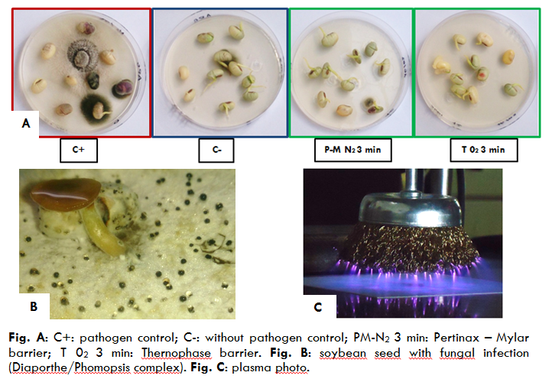
Recent Publications (minimum 5)
- Santa-Cruz D, Pacienza N, Zilli C, Pagano E, Balestrasse K*, Yannarelli G* (2017) Heme Oxygenase Up-Regulation under Ultraviolet-B Radiation is not Epigenetically Restricted and Involves Specific Stress-Related Transcriptions Factors. Redox Biology 12:549-547.
- Prevosto L.,Kelly H,Mancinelli B. (2016) Modelling of an Atmospheric Pressure Nitrogen Glow Discharge Operating in High-Gas Temperature Regimes Plasma, Chemistry and Plasma Processing, 36(4): 973-992.
- Prevosto L, Kelly H, Mancinelli B, Chamorro J, Cejas E (2015) On the physical processes ruling an atmospheric pressure air glow discharge operating in an intermediate current regime, Physics of Plasmas 22: 023504.
- López Lecube M, Noriega G, Santa Cruz D, Tomaro M, Batlle A, Balestrasse K (2014) Indole acetic acid is responsible for the protection against oxidative stress caused by drought in soybean plants: The role of heme oxygenase induction. Redox Report. 19 (6): 242-250.
- Noriega G, Caggiano E, López Lecube M, Santa Cruz D, Batlle A, Tomaro M, Balestrasse K (2012) The role of salicylic acid in the prevention of oxidative stress elicited by cadmium in soybean plants. Biometals. 5 (6): 1155-1165.
- -Simonetti E, Carmona M, Scandiani M, García A, Luque A, Correa O,Balestrasse, K (2012) Evaluation of indigenous bacterial strains for biocontrol of the frogeye leaf spot of soya bean caused by Cercospora sojina. Letters in Applied Microbiology. 55: 170-173.

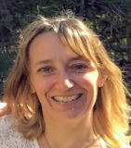Biography (150 word limit)
Karina Balestrasse: She graduated of biochemical in 1998 from Buenos Aires University, Argentina. She finished her doctoral thesis in the area of vegetal biological chemistry in 2003. She is professor of Buenos Aires University and independent investigator of The National Scientific and Technical Research Council (CONICET). She works in Agronomy Faculty of Buenos Aires University and Institute for Research in Agricultural and Environmental Biosciences (INBA) Argentina. Her expertise is oxidative stress and metabolism vegetal. Actually her current research program focuses on the use cold plasma to pathogen control in seed. She leads an interdisciplinary group of engineers, biotechnology physicists and biochemists. In the last year received two awards for his innovative work. She carries out research in collaboration with the CSIC of Granada through the program I-Links 2015. She has published more than 40 research papers in national & international journals. She currently directs doctoral thesis and grants.
Email:kbale@agro.uba.ar Contact No: +5491131437963

Notes/Comments:

