Beneficial root endophytic fungi change growth and oil composition of sweet basil in heavy metal contaminated soil
Mayada Sabra, Faculty of Agriculture, Alexandria University, Egypt
Philipp Franken, and Iris Camehl, Leibniz-Institute of Vegetable and Ornamental Crops (IGZ), Erfurt, Germany

Abstract
Heavy metal pollution in the soil is toxic to animals, humans and aquatic life. Their tendency to accumulate in the food chain has led to stricter environmental regulations in the past decades. Little is known about the interaction between contaminated soil, plants and the rhizosphere. Root endophytic fungi such as arbuscular mycorrhiza (AM) fungi and Piriformospora indica belong to the rhizosphere and are associated with a huge variety of plant species. Both symbioses improve plant productivity by enhancing nutrient supply and conferring resistance and tolerance to biotic and abiotic stresses. The effect of the AM fungus Rhizophagus irregularis and the beneficial fungus P. indica on sweet basil was tested in a pot experiment with soil contaminated with lead (Pb) and copper (Cu) under defined greenhouse conditions. The AM fungus R. irregularis mediates an increase in shoot and root dry weight of sweet basil plants when the soil is contaminated with Pb or Cu, as well. Mycorrhization of sweet basil roots decreases in contaminated soil with Cu, but not with Pb. The Pb content in the shoot is decreasing with AMF, but not the Cu content. In contrast, sweet basil inoculated with P. indica shows a decrease in shoot Cu content. Furthermore, AMF have a dramatic effect on the content of the essential oils linalool and eucalyptol even on contaminated soils. Therefore, we conclude that beneficial fungi can be used to improve the quantity and quality of sweet basil also under conditions, which are stressful for the plant, such as heavy metal contaminated soils.

Image
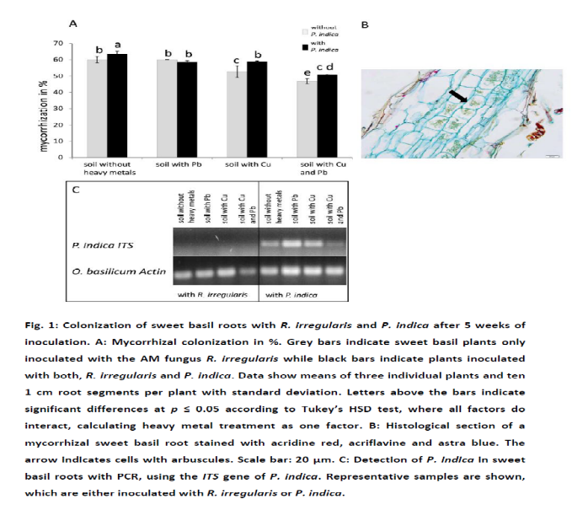
Recent Publications
- Battini F, Bernardi R, Turrini A, Agnolucci M, Giovannetti M (2016) Rhizophagus intraradices or its associated bacteria affect gene expression of key enzymes involved in the rosmarinic acid biosynthetic pathway of basil Mycorrhiza 26:699-707 doi:10.1007/s00572-016-0707-2
- Chibuike GU, Obiora SC (2014) Heavy Metal Polluted Soils: Effect on Plants and Bioremediation Methods Applied and Environmental Soil Science 2014:1-12 doi:10.1155/2014/752708
- Copetta A, Lingua G, Berta G (2006) Effects of three AM fungi on growth, distribution of glandular hairs, and essential oil production in Ocimum basilicum L. var. Genovese Mycorrhiza 16:485-494 doi:10.1007/s00572-006-0065-6
- Dolatabadi HK, Goltapeh EM, Jaimand K, Rohani N, Varma A (2011) Effects of Piriformospora indica and Sebacina vermifera on growth and yield of essential oil in fennel (Foeniculum vulgare) under greenhouse conditions Journal of basic microbiology 51:33-39 doi:10.1002/jobm.201000214
- Ghanem G, Ewald A, Zerche S, Hennig F (2014) Effect of root colonization with Piriformospora indica and phosphate availability on the growth and reproductive biology of a Cyclamen persicum cultivar Scientia Horticulturae 172:233-241 doi:http://dx.doi.org/10.1016/j.scienta.2014.04.022
- Hristozkova M, Geneva M, Stancheva I, Boychinova M, Djonova E (2015) Aspects of mycorrhizal colonization in adaptation of sweet marjoram (Origanum majorana L.) grown on industrially polluted soil Turkish Journal of Biology 39:461-468 doi:10.3906/biy-1408-47.
- Karimi FS, Mozhgan; Afyuni, Majid; Hajabbasi, M.A. (2011) Role of Piriformospora indica in barley (Hordeum vulgare L.) resistance to cadmium, lead and copper Proceedings of the 12th International Conference on Environmental Science and Technology, Rhodes, Greece 8-10. September


Mayada sabra has her expertise in Agricultural microbiology to improve the environment and crop production. Her publication takes place to investigate that some kind of beneficial microorganisms could reduce pollution from agricultural soil. She has done this paper after years of experience in research, teaching and administration both in the Leibniz-Institute of Vegetable and Ornamental Crops (IGZ),Germany and Alexandria university, Eygpt.
Email: mayada555@yahoo.com

Notes/Comments:

