REFORESTATION OF ALEPPO PINE’S FORESTS IN THE NORTHERN PARTS OF EL KEF: ECOLOGICAL RESTORATION AND ECONOMIC OPPORTUNITIES
AYARI Hamza
Department of geography
Tunis Faculty of Human and Social Sciences
University of Tunis

Abstract:
The Aleppo pine’s forests in the northern parts of El Kef governorate in Tunisia were under a situation of severe degradation during the colonial period. This degradation is related to the poverty of local population excluded to the slopes by the colonization. The different forms of pressure on the ecosystems were very destructive to the ecosystems components, essentially soils and forests.
To restore ecosystems, the Tunisian State launched many DRS programs (defense and restoration of soils) in cooperation with many international organisms. These programs included plantation of the many woody species, essentially Aleppo pine and eucalyptus in the infiltration benches created in the mountainous slopes. The plantations are arranged in parallel to spot elevations in order to prevent against erosive dynamics.
These actions of reforestation leaded to a reconstruction of extended and homogeneous forests of Aleppo pine. The employment of the rural population in plantation and conservation during three decades creates reconciliation between man and forest after a long history of destructive practices. Nowadays, plantations are in maturity and offer many potentialities in seeds of Aleppo pine which are named “zgougou” in Tunisia. These seeds used as nutriment are introduced in many agrifood industries. The incomes of the rural population are increased. These ameliorations participate in braking rural emigration to littoral towns.
In this communication I will present the Tunisian experience in reforestation and conservation, its effects on the rural development and its benefits to the rural population.

Image
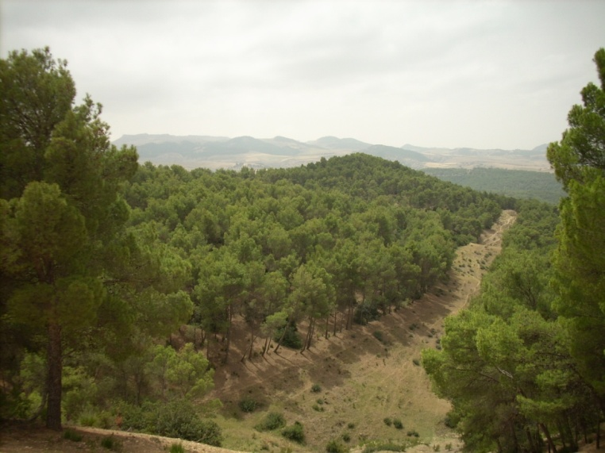
Recent Publications (minimum 5)
- Participation aux travaux des ateliers de lancement du projet Medd-Inn-Local tenus à Tahanaout au Haut Atlas (Province d’El Haouz) au Maroc en février 2014.
- Une communication orale intitulée : « Stagnation Du Système Céréalier Et Crise Des Campagnes Telliennes : Étude De Cas Du Nord D’el Kef » au colloque international de l’Association Tunisienne des Études Historiques Économiques et Sociales tenus à Monastir en octobre 2015.
- Une communication orale sous le titre « réflexions sur la méthodologie de valorisation d’un produit de terroir dans le Haut Tell tunisien: le zgougou » au workshop IV du projet Medd-Inn-Local tenus à la Faculté des Sciences Humaines et Sociales au campus universitaire Qadi Yiadh à Marrakech au Maroc en novembre 2015.
- Une communication orale intitulée « maturité des reboisements et valorisation des graines du pin d’Alep dans le haut tell tunisien » au colloque internationale sur « les espaces forestiers et périforestiers : dynamiques et défis » tenu au Campus Universitaire Ait Melloul-Université IBN Zohr-Agadir au Maroc en novembre 2016.
- Une communication orale intitulée « originalité et dynamique des villages montagneux au Haut Tell tunisien : étude du cas des dachras » au colloque international « la montagne : espace d’innovation » organisé par LABEX ITEM à la Cité des Territoires à Grenoble en janvier 2017.

 Biography
AYARI Hamza, PhD in biogeography. I am member of the Research Unity BiCADE in the Manouba’s faculty of Letters, Arts and Humanities. I prepared a thesis in biogeography, deposed in the Faculty of Human and Social Sciences of Tunis, about “rural development and dynamics of vegetation in Western Friguian High Tell” (Northern Tunisia). Actually, I am an associate professor in geography.
Email: ayari.hamza@yahoo.fr Contact No: 0021697655658

Notes/Comments:

