Global, regional and small-scale drivers of carnivore-livestock conflicts: comparative approaches enhance mitigation strategies

Thomas Göttert, Dr., Humboldt-Universität zu Berlin, Germany
Nicole Starik, Dr., Humboldt-Universität zu Berlin, Germany
Ulrich Zeller, Prof. Dr., Humboldt-Universität zu Berlin, Germany

Abstract (300 word limit)

Carnivores (Carnivora) are monophyletic, globally distributed and highly diverse in form and function. Carnivores share similar ecological adaptations associated with their ecological function as predators. Large carnivores require large areas and are typical predators of ungulates. Owing to human population growth, increasing livestock numbers and intensifying agricultural practices on the one hand and ecotourism and an increasing awareness of the importance of nature conservation on the other hand, carnivore-livestock conflicts are a global phenomenon. Comparative approaches seem effective to better understand and mitigate such conflicts on a transnational or even global scale. We introduce a comparative framework in order to differentiate between case-specificity and common applicability of the underlying ecological processes and the resulting management strategies of carnivore-livestock conflicts in different regions.

In Europe for example, wolves (Canis lupus) are recolonizing areas, where the species was formerly extinct. The emergence of this top predator in parts of Europe forces wildlife managers to develop appropriate strategies. In order to better understand the recovery of the wolf in Europe, it is important to investigate regions, where the same species causes comparable conflicts. Given the large distribution range of Canis lupus throughout large parts of the Holarctic, comparable investigations on similar longitudinal levels seem feasible. The experience from regions, where other carnivore species cause conflicts with livestock, is also part of the comparative framework. In Africa, for example, pastoralists manage to coexist with large predators since more than 10,000 years. This knowledge might contribute to a common understanding of carnivore-livestock conflicts and mitigation strategies. Besides distinguishing between case-specific and species-specific patterns, the detection of generally applicable practices is needed to achieve the coexistence of ecologically highly relevant faunal elements, as well as human well-being.
Image
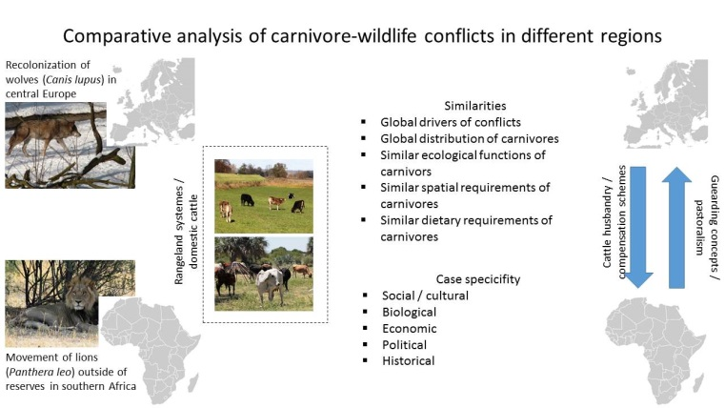
Recent Publications
- Fechter, D., Storch, I. (2014). How many wolves (Canis lupus) fit into Germany? The role of assumptions in predictive rule-based habitat models for habitat generalists. PloS one, 9(7), e101798.
- Rottstock, T., Zeller, U. (2016). Comparative study of interrelations between grazing systems of domestic cattle and agrobiodiversity in Europe and southern Africa - concept of a proposed dissertation. In: Zeller, U., Starik, N., Göttert, T. (eds.). Biodiversity and land use – a comparative approach. Workshop proceedings, Systematic Zoology Division, Berlin.
- Trinkel, M., & Angelici, F. M. (2016). The Decline in the Lion Population in Africa and Possible Mitigation Measures. In Problematic Wildlife (pp. 45-68). Springer International Publishing.
- Zeller, U., Starik, N., Göttert, T. (2016). Biodiversity and land use – a comparative approach. Workshop proceedings, Systematic Zoology Division, Berlin.
- Zeller, U., Starik, N., Göttert, T. (2017). Biodiversity, land use and ecosystem services – a comparative and organismic approach to different geographical regions. Global Ecology and Conservation 10: 114-125.

Biography
Dr. Thomas Göttert is working at the Systematic Zoology Division of Humboldt-Universität zu Berlin for ten years. He has been involved in developing, coordinating and teaching within several international postgraduate programs, such as the DAAD-funded MSc program ‘Biodiversity Management and Research’ at the University of Namibia or the EU-Atlantis MSc program ‘Arid Land Studies’. Dr. Göttert has been involved in the establishment of an academic network in Sub-Sahara Afrika. His main research interest is on wildlife ecology and nature conservation.
Email: thomas.goettert@agrar.hu-berlin.de Contact No: 0049 30/ 2093-8563

Notes/Comments:

