Identification and diversity analysis of the four major host-defense peptide families in quail
Kei Hanzawa PhD, Tokyo university of Agriculture, JPN

Abstract
Statement of the Problem: Quails are bred for their meat and eggs in East Asia, and are widely used as experimental model animals at research institutes around the world. We are currently focusing on subclinical infection in quail with infectious diseases, such as influenza. Utilization of innate immunity has the potential to reduce the use of antibiotics and to control the emergence of drug-resistant bacteria. We identified the gene families of four quail host-defense peptides (HDPs): NK-lysin, liver expressed antimicrobial peptide 2 (LEAP-2), cathelicidin (CATH) and β-defensin (AvBD), and investigated their genetic diversity. Materials & Methods: Genome information was obtained from DNA derived from blood samples collected from 99 quails in 6 lines. Nucleotide sequences were determined by capillary sequencing and next-generation sequencing. The obtained base sequence was analyzed by Genetyx Mac and CLC Genomics Workbench software packages. Findings: Quail NK-lysin consisted of a single locus¹⁾, suggesting that amino acid substitution in the antibacterial active region is closely related to antibacterial activity²⁾. LEAP-2 also consisted of a single locus, no polymorphisms were observed in the amino acid sequence, and the amino acid sequence of mature peptides was consistent with that found in chicken⁴⁾. CATHs consisted of four loci homologous to those found in chicken, with amino acid substitutions in two loci⁵⁾. AvBDs were basically composed of 12 loci³⁾; 1 to 5 copy number variation (CNV) associated with gene duplication was observed at one locus with numerous amino acid substitutions⁶⁾. Conclusion & Significance: The gene structure of major quail HDPs and their DNA polymorphisms were clarified. Future studies will examine the effects of DNA polymorphisms in HDPs on antibacterial activity in vitro, and clarify the relationship between HDPs, innate immunity receptors (Toll like receptor: TLR) and enterobacterial flora.

Image
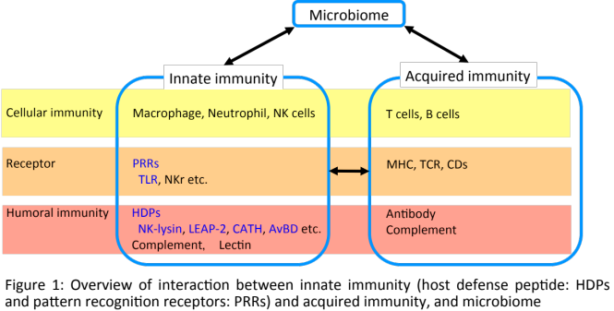
Recent Publications
- Ishige T & Hanzawa K et al. (2014) Basic characterization of avian NK-lysin (NKL) from the Japanese quail, Coturnix japonica. Animal Science Journal 85:90-95.
- Ishige T & Hanzawa K et al. (2016) Effect of single polymorphism in the Japanese quail NK-lysin gene on antimicrobial activity. Animal Science Journal 87: 143-146
- Ishige T & Hanzawa K et al. (2016) Basic characterization of avian β-defensin genes in the Japanese quail, Coturnix japonica. Animal Science Journal 87: 311-320.
- Ishige T & Hanzawa K et al. (2016) Characterization and expression of non-polymorphic liver expressed antimicrobial peptide 2: LEAP-2 in the Japanese quail, Coturnix japonica. Animal Science Journal 87: 1182-1187.
- Ishige T & Hanzawa K et al. (2017) Characterization of the cathelicidin cluster in the Japanese quail, Coturnix japonica. Animal Science Journal 88: In press.
- Ishige T & Hanzawa K et al. (2017) Genetic diversity of avian β-defensin gene region in Japanese quail, Coturnix japonica. Unpublished data.

Biography
Dr Kei HANZAWA is a professor of Department of Animal science, Faculty of Agriculture, Tokyo University of Agriculture. He researches animal physiological genetics: particularly identification and diversity analysis of quail major histocompatibility complex gene region and host defense peptides genes, gene identification and analysis of heat shock response of quail heat shock protein 70s and 90s, and equine membrane transporters and exercise physiology of erythrocytes. He is the vice president of the Japan Society of Animal Science and the Auditor of the Japanese Society of Poultry Science.
.
Email: khanzawa@nodai.ac.jp Contact No: 123456xxxxx

Notes/Comments:

